# System Tests

|  |  |  |  |  |
| --- | --- | --- | --- | --- |
| Test ID | Action | Expected outcome | Status | Evidence |
|  | Localhost:5000  (Live version: <https://web-dev-2-restaurant-app.herokuapp.com/> ) | About page loads | Ok | Figure 1 |
|  | /lunch | Lunch page loads | Ok | Figure 2 lunch page |
|  | /dinner | Dinner page loads | Ok | Figure 3 dinner page |
|  | /contact | Contact page loads | Ok | Figure 4 contact page |
|  | /about | About page loads | Ok | Figure 5 about page |
|  | /login | Login page doesn’t load | Ok | Figure 6 /login |
|  | /register | Register page inaccessible | Ok | Figure 7 /register |
|  | /staff-portal | Staff portal inaccessible | Ok | Figure 8 /staff-portal |
|  | /JGyyx5Eyj3 | Staff portal loads | Ok | Figure 9 /JGyyx5Eyj3 |
|  | /JGyyx5Eyj3Re | Register page loads | Ok | Figure 10 /JGyyx5Eyj3Re |
|  | /JGyyx5Eyj3Ln | Login page loads | Ok | Figure 11 /JGyyx5Eyj3Ln |
|  | Click Register on staff portal | Takes users to registration form | Ok | Figure 12 click register on staff portal |
|  | Click Login on staff portal | Takes users to login form | Ok | Figure 13 click login on staff portal |
|  | Login on login screen |  | Ok | Figure 14 Logging in landing |
|  | Register user on staff portal | Registers users correctly | Ok | Figure 15 Registering non-existing user |
|  | Register existing user on staff portal | Error page will show up | Ok | Figure 16 registering existing user |
|  | Login without credentials on staff portal | Error page will show up | Ok | Figure 17 login without credentials |
|  | Login with incorrect credentials on staff portal | Error page will show up | Ok | Figure 18 login with incorrect credentials |
|  | Sign out from website | User lands on the about page | Ok | Figure 19 sign out of website |
|  | Update button | Update form will show up on the corresponding dish | Ok | Figure 20 Update button and fields |
|  | Update fields | Database will save any entered detail | Ok |
|  | Change Menu | Changing the menu will shift the dish from one page to another | Ok | Figure 21 change menu 1 Figure 22 change menu 2: on top the link changed from JGyyx5Eyj3L (lunch menu page) to JGyyx5Eyj3D (dinner menu page) |
|  | Change Availability | Availability shows for users, and only available dishes show up for visitors | Ok | Figure 29 Availability 1 Figure 30 Availability 2 Figure 31 Availability 3 |
|  | Reset Form | The reset form button resets the form | Ok | Figure 25 reset form 1 Figure 26 reset form 2: on reset, fields load up the default values saved in database |
|  | Submit Form | Submit form sends the data to the database | Ok | Figure 27 update before Figure 28 update after |
|  | Delete button clicked | Entry is deleted | Ok | Figure 32 Delete |
|  | New Entry button clicked | New entry form shows | Ok | Figure 33 new entry 1  Figure 34 new entry 2 |
|  | New entry fields | Any data entered here will be saved as entered | Ok |
|  | New entry menu | The dish will show up at the corresponding page | Ok |
|  | New entry availability | Availability shows for users, only available dishes show up for visitors | Ok |
|  | New entry submit button | Submits data to the database | Ok |
|  | New entry shows up for regular users | New entry shows up for regular users | Ok | Figure 35 new entry for regular users |
|  | Unavailable dish doesn’t show up for users | Unavailable dish doesn’t show up for users | Ok | Figure 24 fresh fish 2 doesn't show for users |

## View tests

|  |  |  |  |  |
| --- | --- | --- | --- | --- |
|  | About page responsive view | Large, medium, and small screens show up fine | Ok | Figure 36 about pc view Figure 37 about tablet view Figure 38 about phone view |
|  | Contact us page responsive view | Large, medium, and small screens show up fine | Ok | Figure 45 contact phone view  Figure 46 contact tablet view Figure 47 contact large screen view |
|  | Dinner menu page responsive view | Large, medium, and small screens show up fine | Ok | Figure 42 dinner large screen Figure 43 dinner tablet screen Figure 44 dinner phone view |
|  | Lunch menu page responsive view | Large, medium, and small screens show up fine | Ok | Figure 39 lunch phone view  Figure 40 lunch tablet view Figure 41 lunch large screen view |
|  | Staff portal responsive view | Large, medium, and small screens show up fine | Ok | Figure 51 staff phone view  Figure 52 staff tablet view  Figure 53 staff large view |
|  | Login page responsive view | Large, medium, and small screens show up fine | Ok | Figure 57 login phone view  Figure 58 login tablet view  Figure 59 login full view |
|  | Register page responsive view | Large, medium, and small screens show up fine | Ok | Figure 54 register full view  Figure 55 register tablet view  Figure 56 register phone view |
|  | Forms to change dishes responsive view | Large, medium, and small screens show up fine | ok | Figure 60 form full view  Figure 61 form tablet view  Figure 62 form phone view |

## Odd tests

|  |  |  |  |  |
| --- | --- | --- | --- | --- |
| Test ID | Action | Expected outcome | Status | Evidence |
|  | /update | Update function page doesn’t load without sign-in | ok | Figure 63 /update |
|  | /new | New entry function page only loads with signed in user | ok | Figure 64 /new |
|  | Localhost:5000/delete without logging in | Error page will show  (Actual outcome: verify was missing from this page, this has been fixed now.) | Fixed | Figure 65 /delete |
|  | /JGyyx5Eyj3D without login | Error page shows | ok | Figure 66 /JGyyx5Eyj3D without login |
|  | /JGyyx5Eyj3L without login | Error page shows | ok | Figure 67 /JGyyx5Eyj3L without login |
|  | /about after logging in | About page loads  (It however logs out already logged in users) | Needs approval | Figure 68 about after login |
|  | /contacts after logging in | Contacts page loads  (It however logs out already logged in users) | Needs approval | Figure 69 contact after login |
|  | Creating a new dish for the other menu than the currently opened one | The dish will show up on the other page | ok | Figure 70 creating dish to other menu 1  Figure 71 creating dish to other menu 2 |

Figure 1 landing page 7

Figure 2 lunch page 8

Figure 3 dinner page 9

Figure 4 contact page 10

Figure 5 about page 11

Figure 6 /login 12

Figure 7 /register 13

Figure 8 /staff-portal 14

Figure 9 /JGyyx5Eyj3 15

Figure 10 /JGyyx5Eyj3Re 16

Figure 11 /JGyyx5Eyj3Ln 17

Figure 12 click register on staff portal 18

Figure 13 click login on staff portal 18

Figure 14 Logging in landing 19

Figure 15 Registering non-existing user 20

Figure 16 registering existing user 21

Figure 17 login without credentials 22

Figure 18 login with incorrect credentials 23

Figure 19 sign out of website 24

Figure 20 Update button and fields 25

Figure 21 change menu 1 26

Figure 22 change menu 2: on top the link changed from JGyyx5Eyj3L (lunch menu page) to JGyyx5Eyj3D (dinner menu page) 27

Figure 23 Fresh fish 2 unavailable shows in admin 28

Figure 24 fresh fish 2 doesn't show for users 29

Figure 25 reset form 1 30

Figure 26 reset form 2: on reset, fields load up the default values saved in database 31

Figure 27 update before 32

Figure 28 update after 32

Figure 29 Availability 1 33

Figure 30 Availability 2 34

Figure 31 Availability 3 35

Figure 32 Delete 36

Figure 33 new entry 1 36

Figure 34 new entry 2 37

Figure 35 new entry for regular users 37

Figure 36 about pc view 38

Figure 37 about tablet view 38

Figure 38 about phone view 39

Figure 39 lunch phone view 39

Figure 40 lunch tablet view 40

Figure 41 lunch large screen view 40

Figure 42 dinner large screen 41

Figure 43 dinner tablet screen 41

Figure 44 dinner phone view 42

Figure 45 contact phone view 42

Figure 46 contact tablet view 43

Figure 47 contact large screen view 43

Figure 48 about large screen view 44

Figure 49 about tablet view 44

Figure 50 about phone view 45

Figure 51 staff phone view 45

Figure 52 staff tablet view 46

Figure 53 staff large view 46

Figure 54 register full view 47

Figure 55 register tablet view 47

Figure 56 register phone view 48

Figure 57 login phone view 48

Figure 58 login tablet view 49

Figure 59 login full view 49

Figure 60 form full view 50

Figure 61 form tablet view 50

Figure 62 form phone view 51

Figure 63 /update 51

Figure 64 /new 52

Figure 65 /delete 52

Figure 66 /JGyyx5Eyj3D without login 53

Figure 67 /JGyyx5Eyj3L without login 53

Figure 68 about after login 54

Figure 69 contact after login 54

Figure 70 creating dish to other menu 1 55

Figure 71 creating dish to other menu 2 55

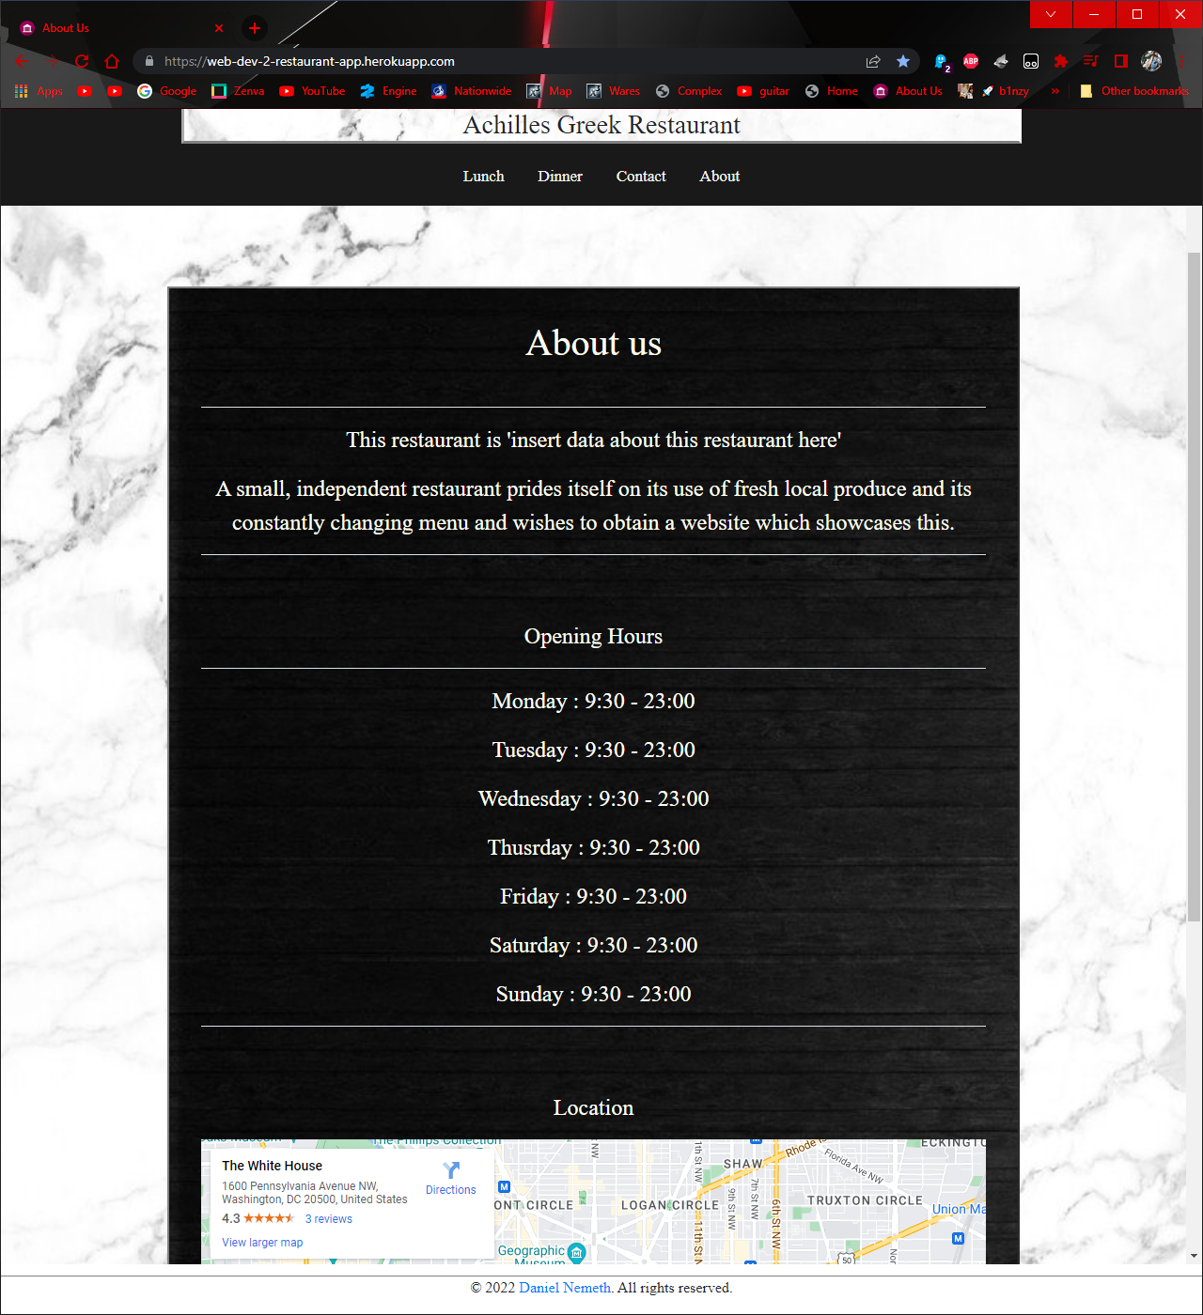

Figure landing page

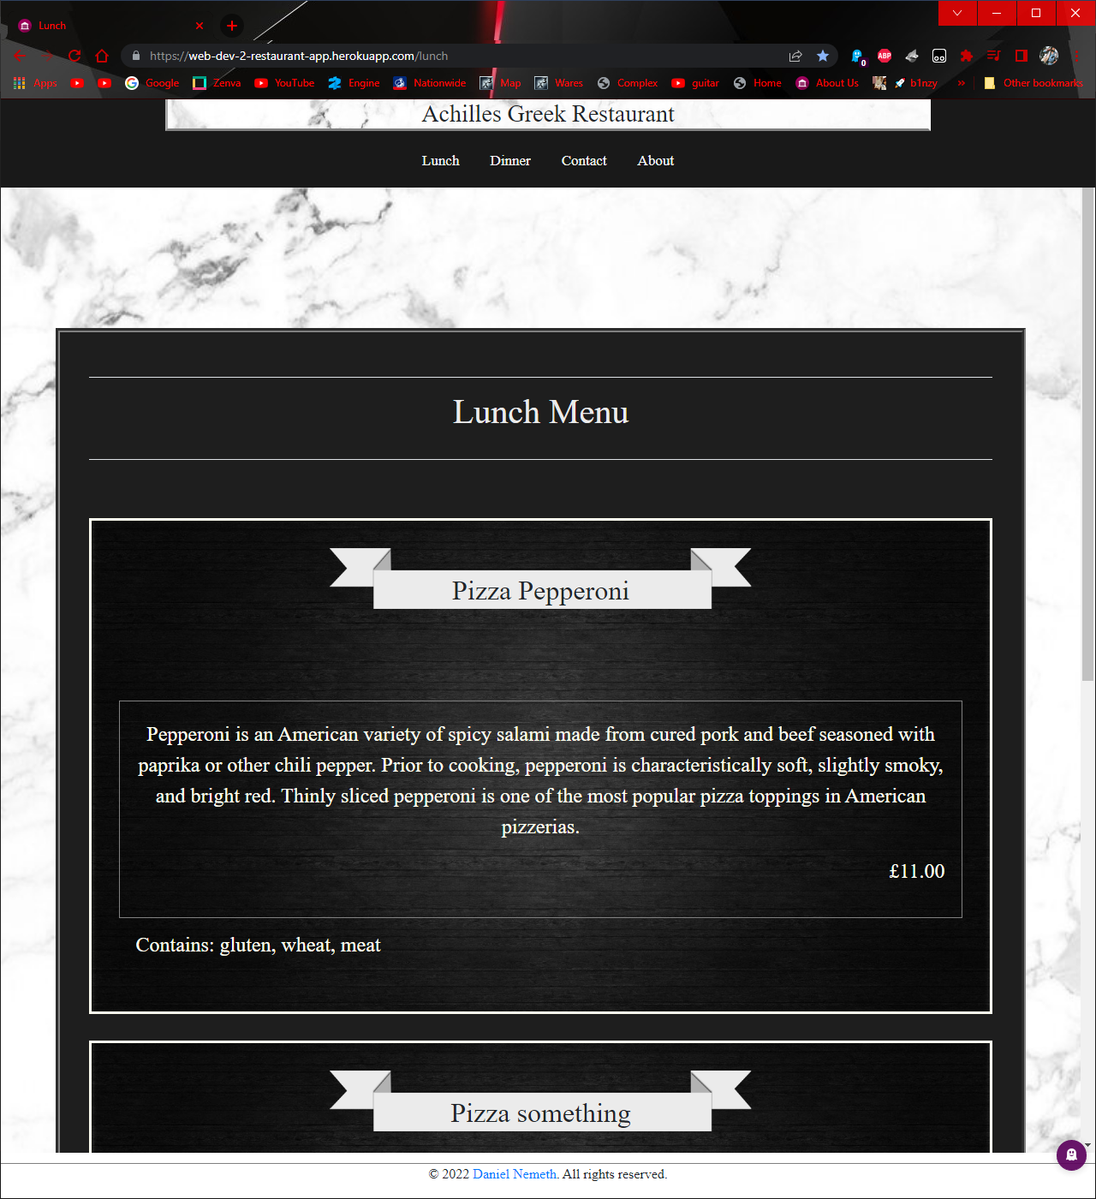

Figure lunch page

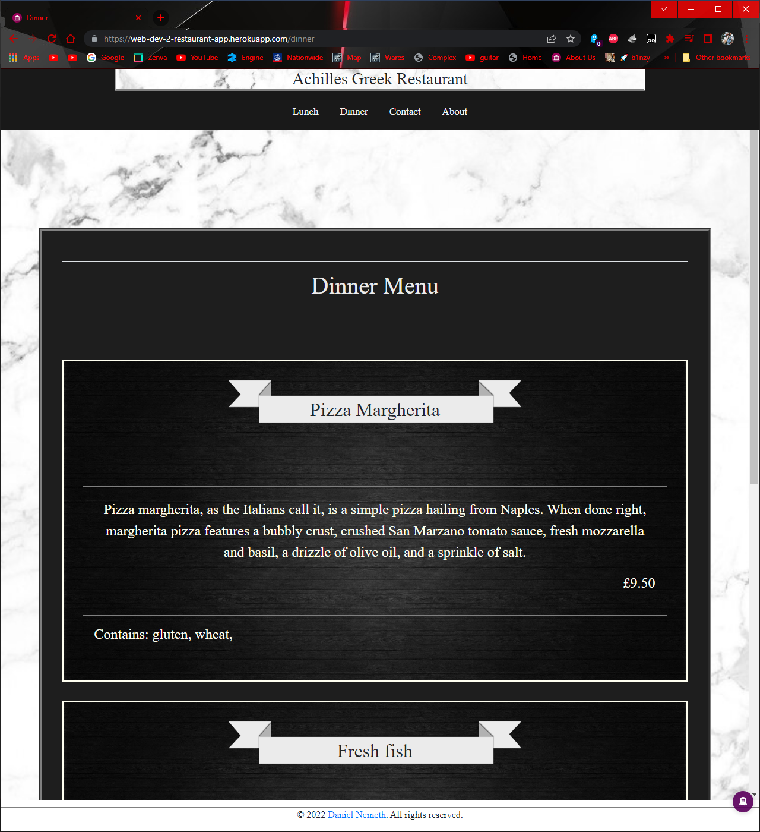

Figure dinner page

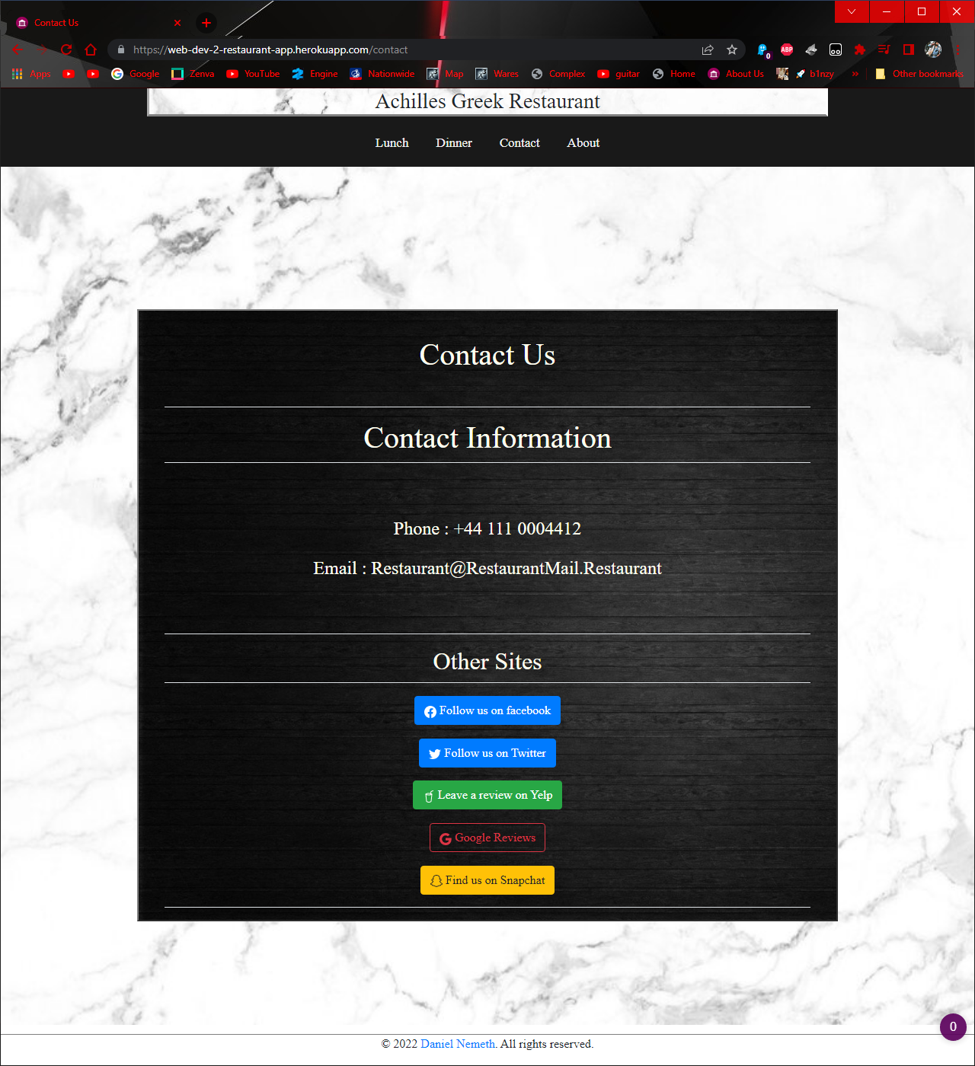

Figure contact page

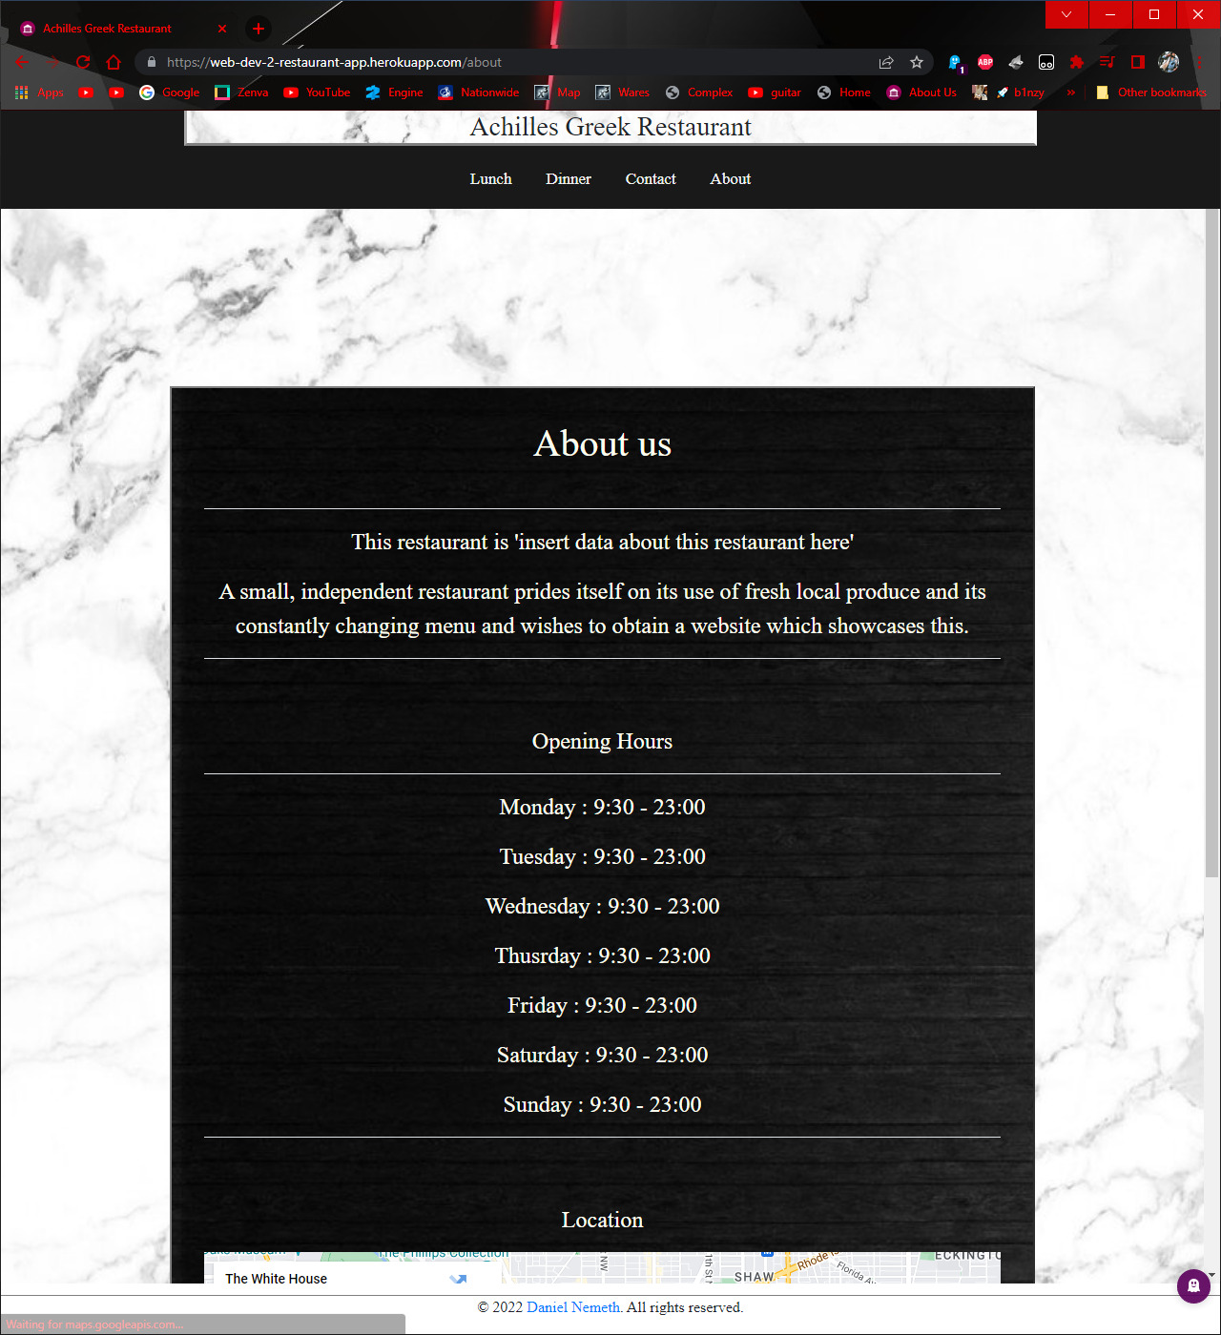

Figure about page



Figure /login



Figure /register



Figure /staff-portal

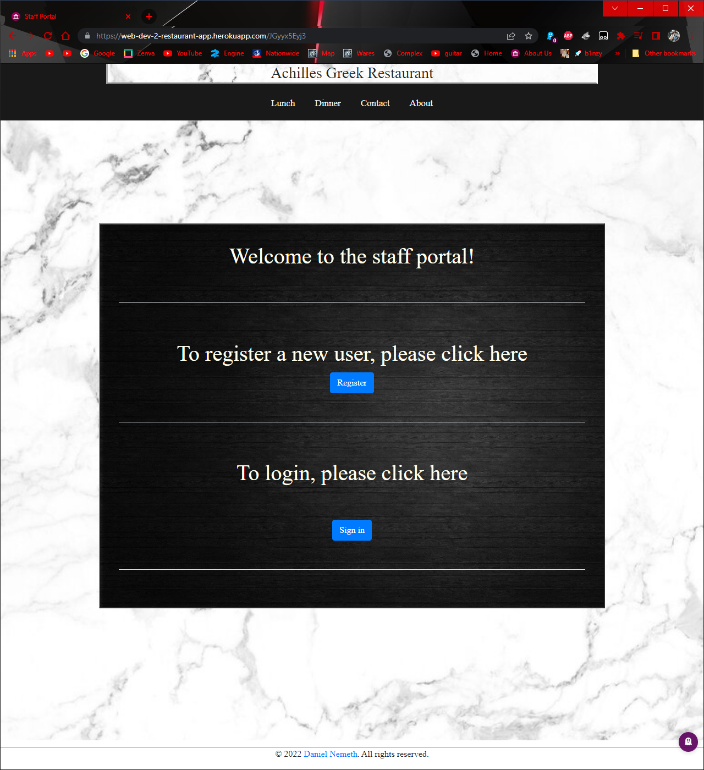

Figure /JGyyx5Eyj3

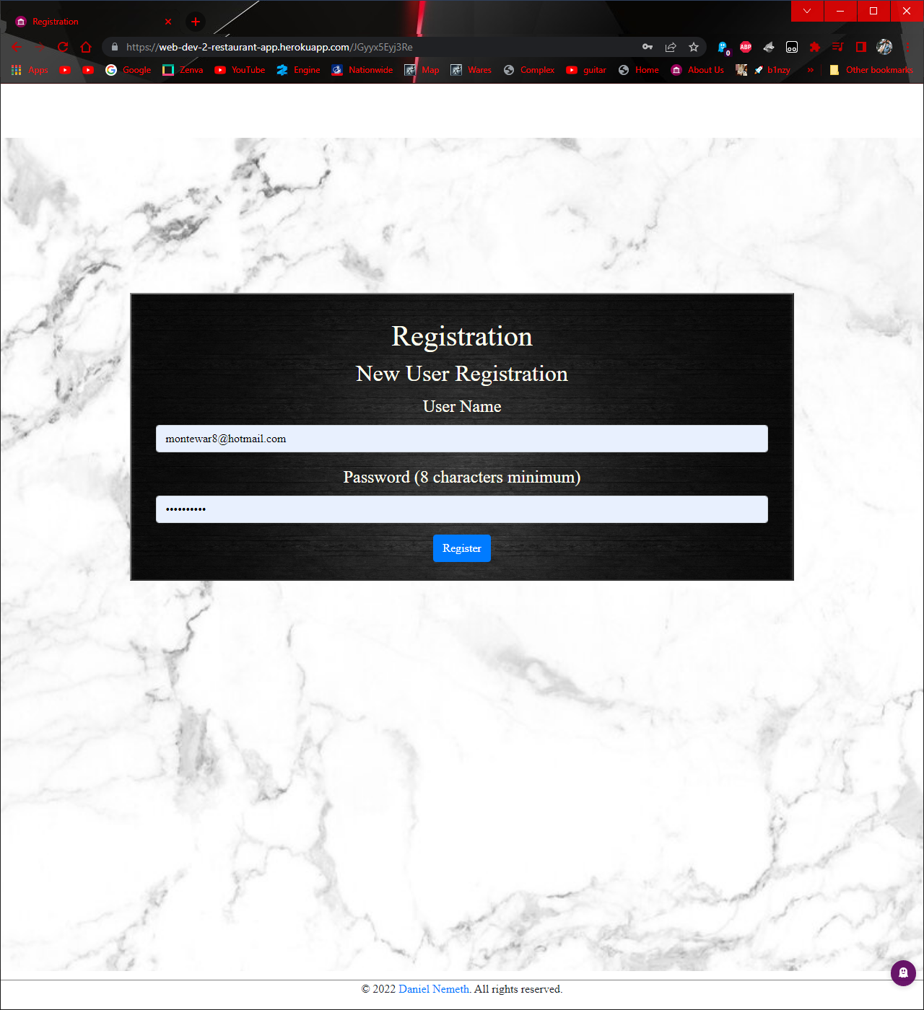

Figure /JGyyx5Eyj3Re

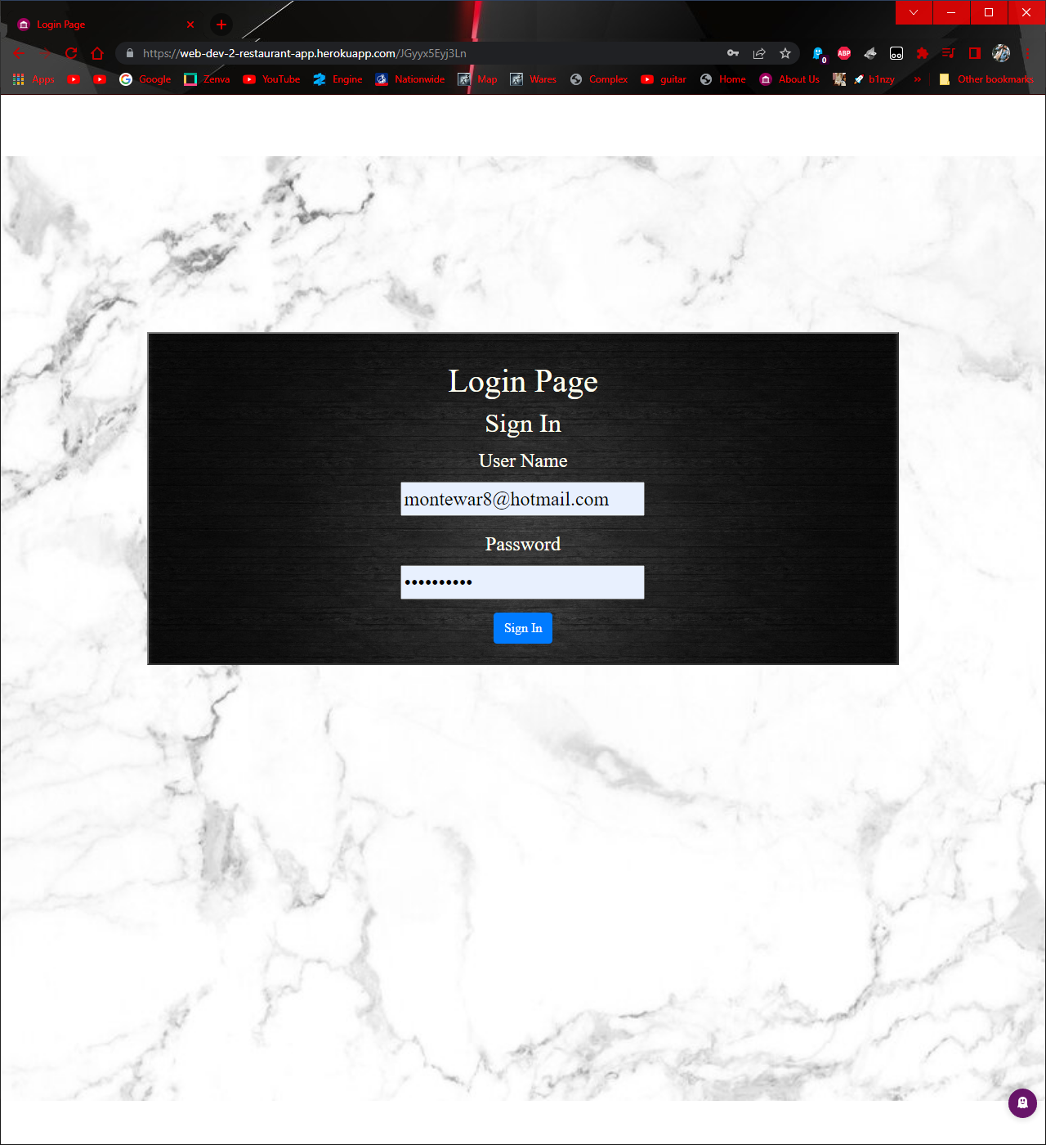

Figure /JGyyx5Eyj3Ln

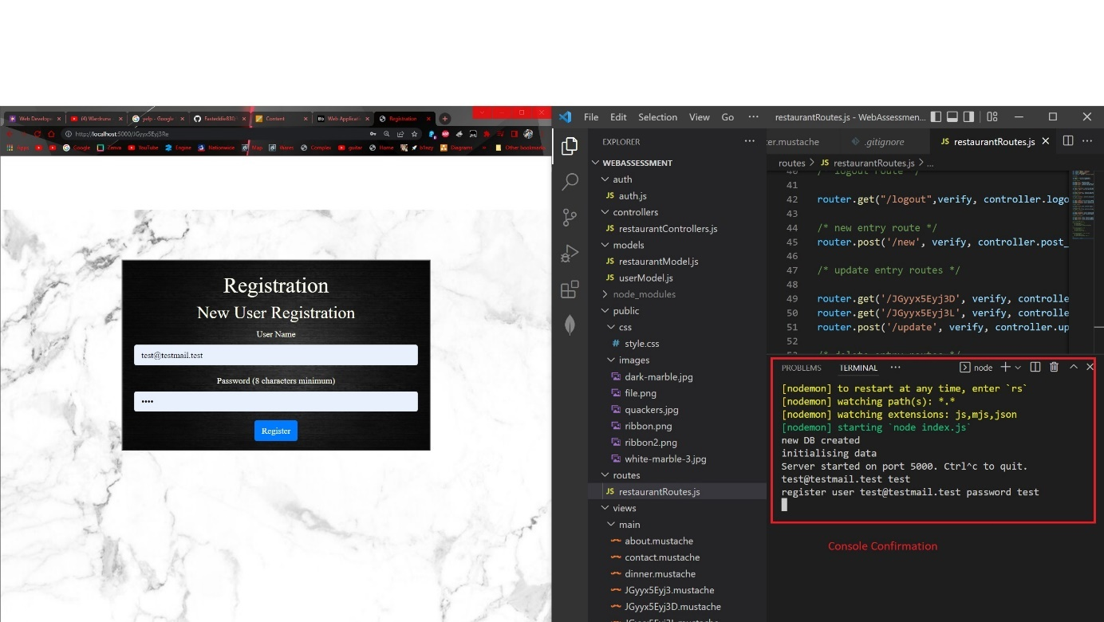

Figure click register on staff portal

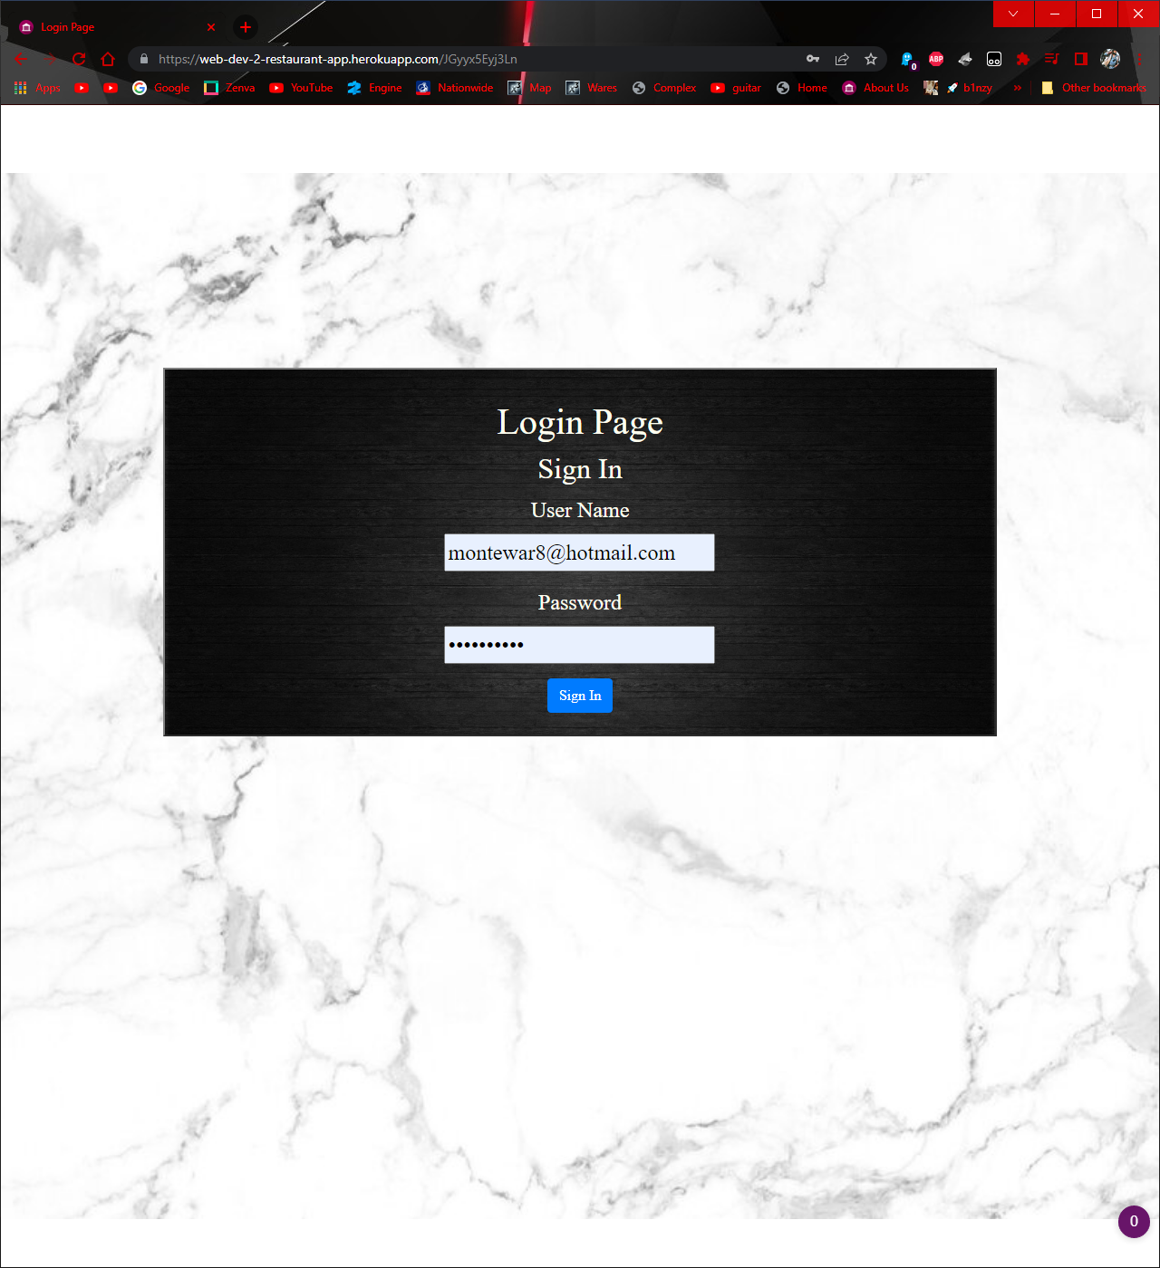

Figure click login on staff portal

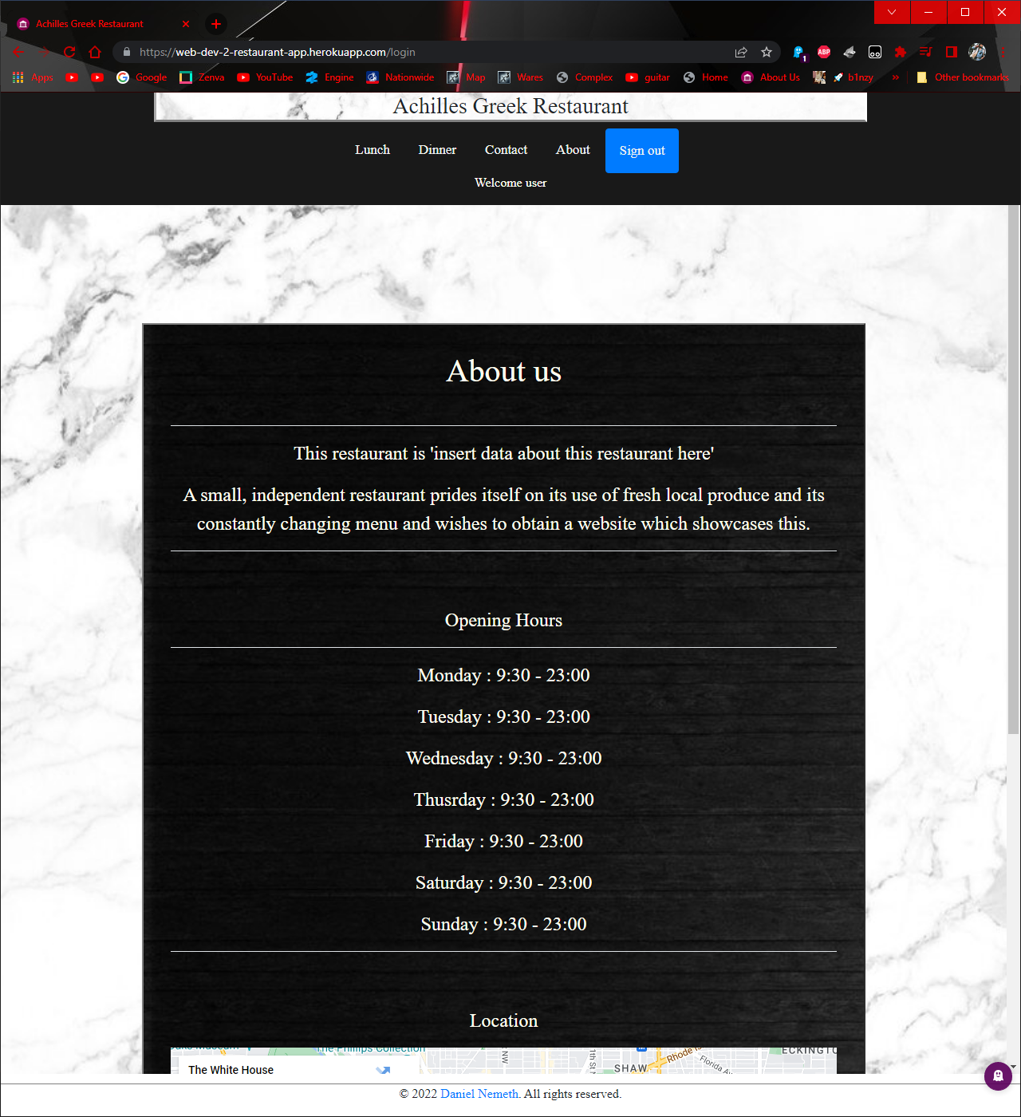

Figure Logging in landing

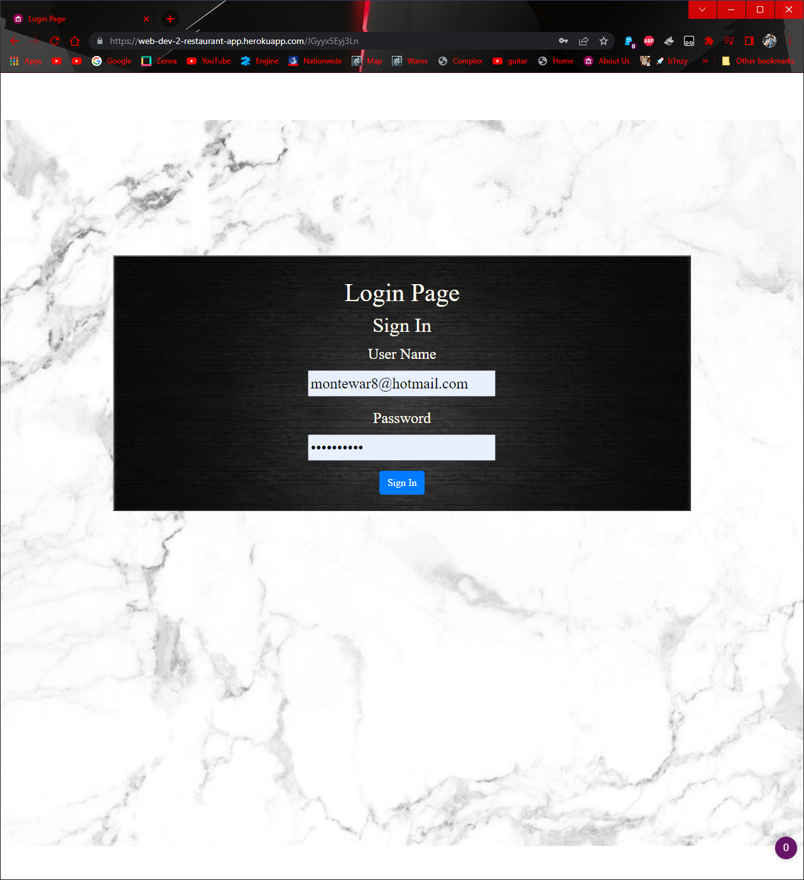

Figure Registering non-existing user



Figure registering existing user



Figure login without credentials



Figure login with incorrect credentials

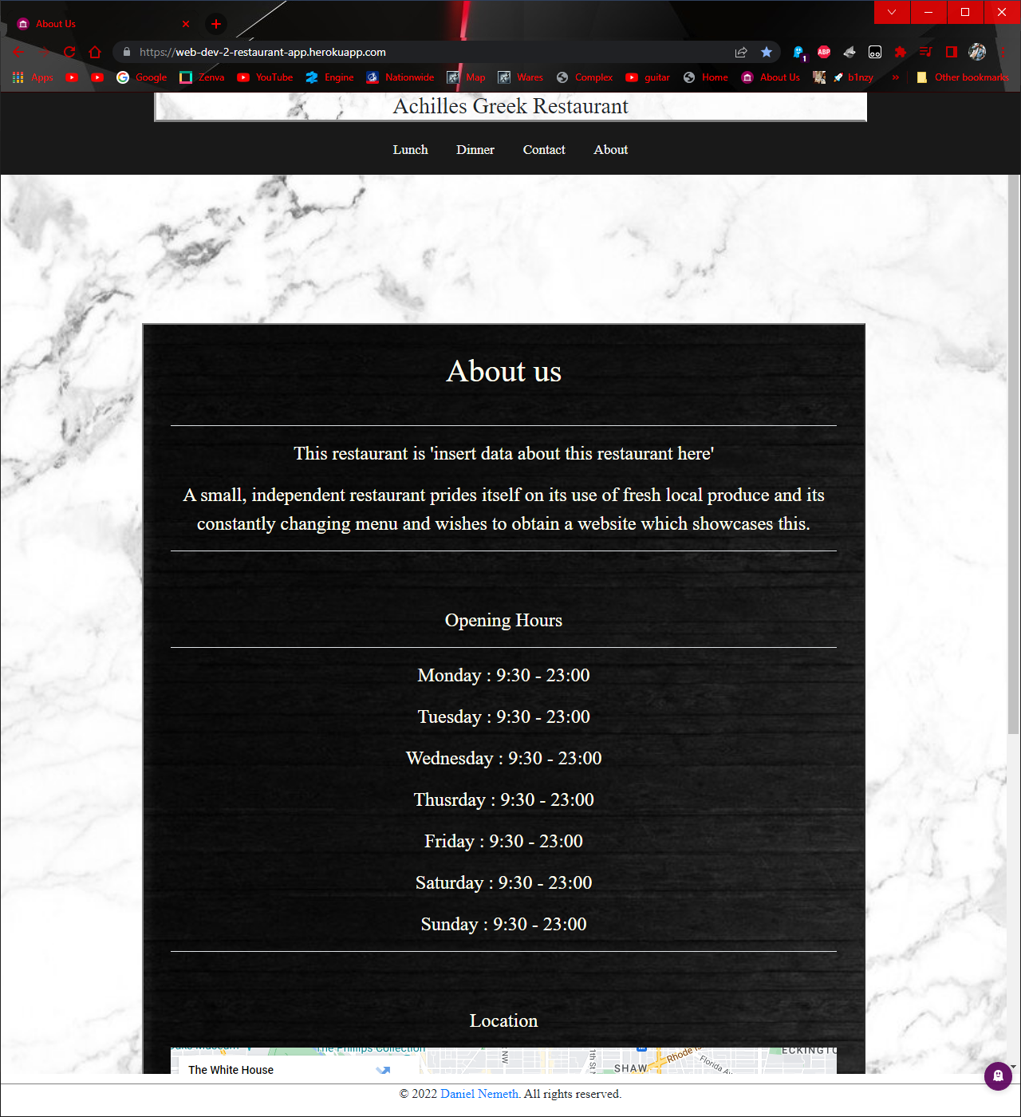

Figure sign out of website

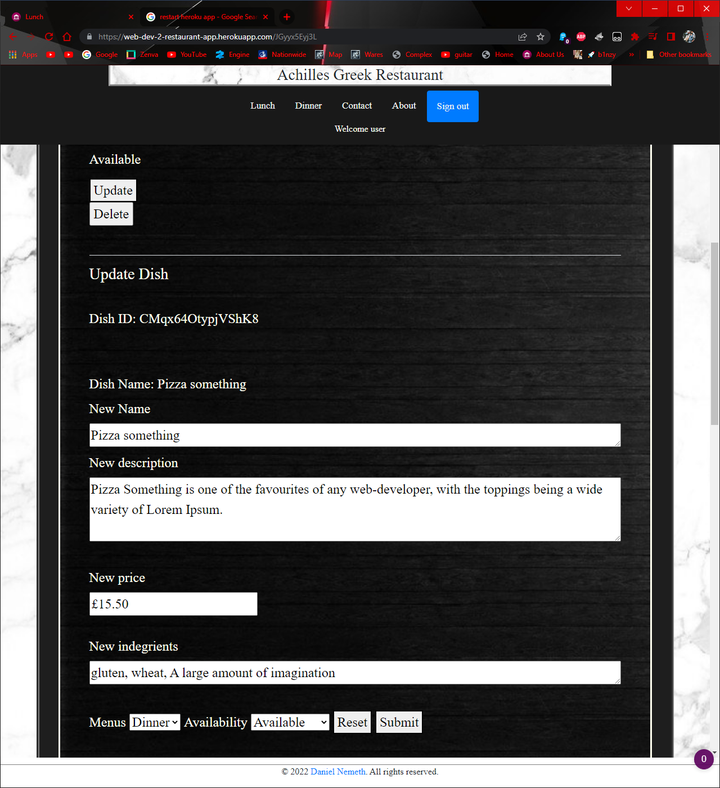

Figure Update button and fields

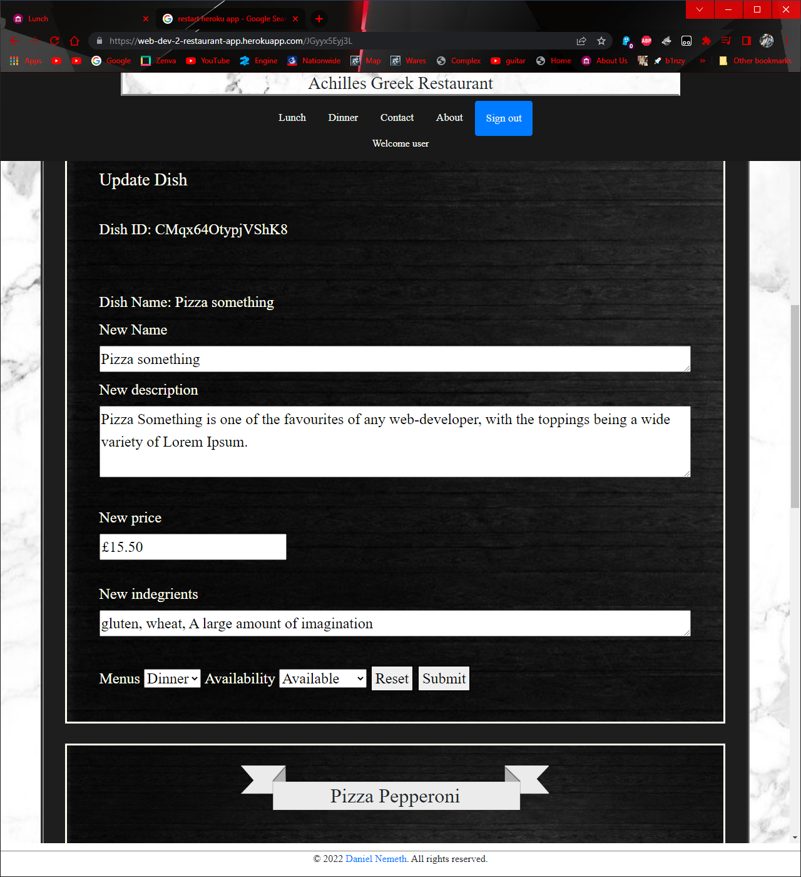

Figure change menu 1

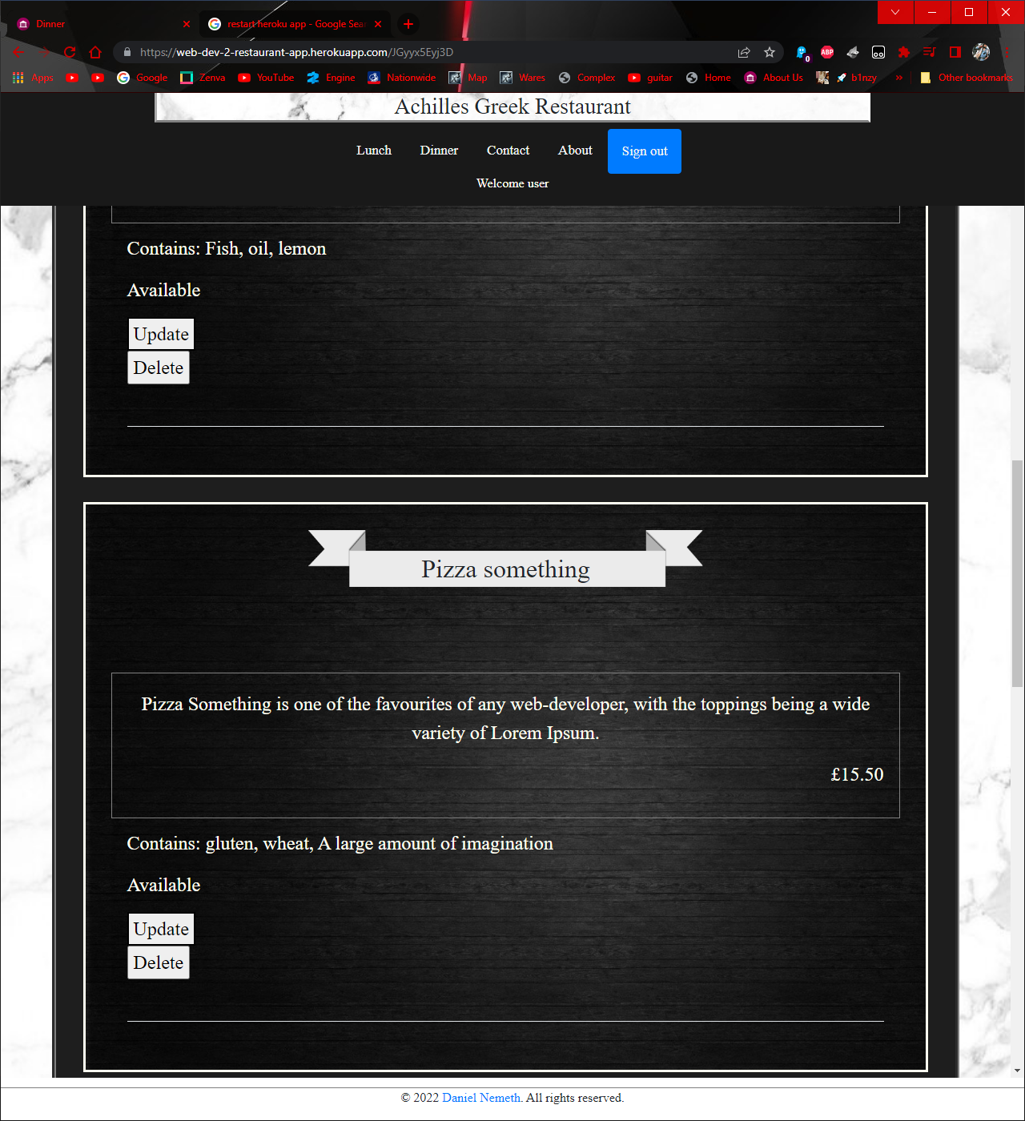

Figure change menu 2: on top the link changed from JGyyx5Eyj3L (lunch menu page) to JGyyx5Eyj3D (dinner menu page)

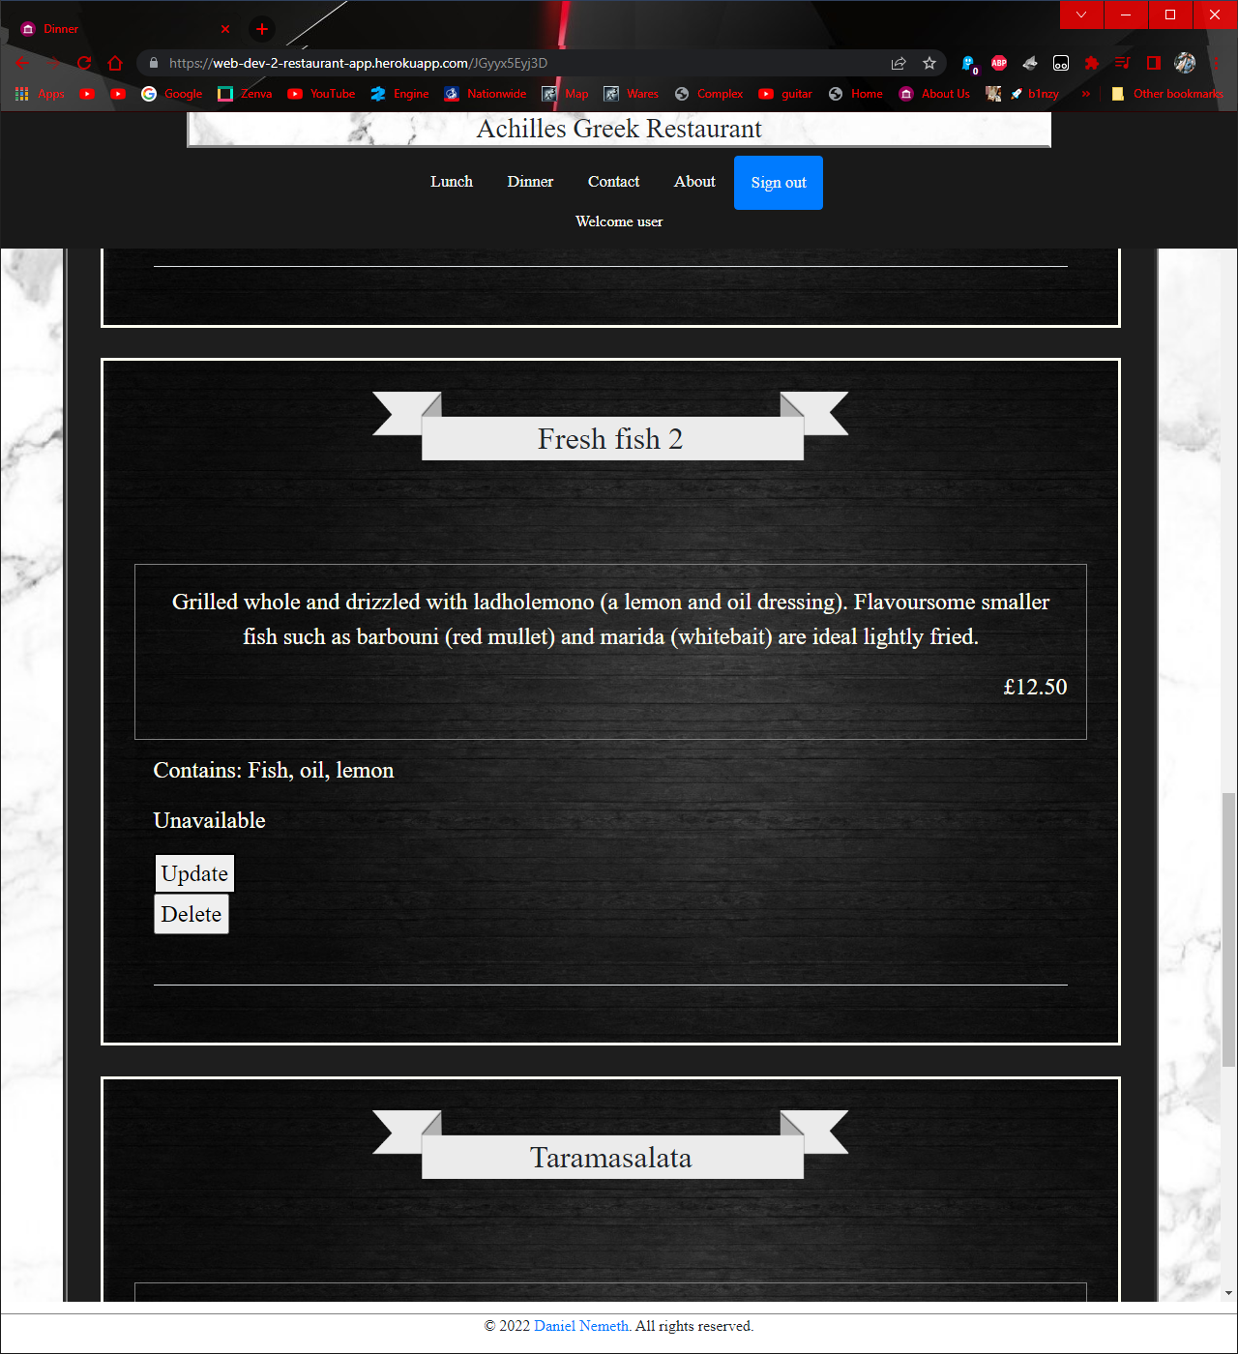

Figure Fresh fish 2 unavailable shows in admin

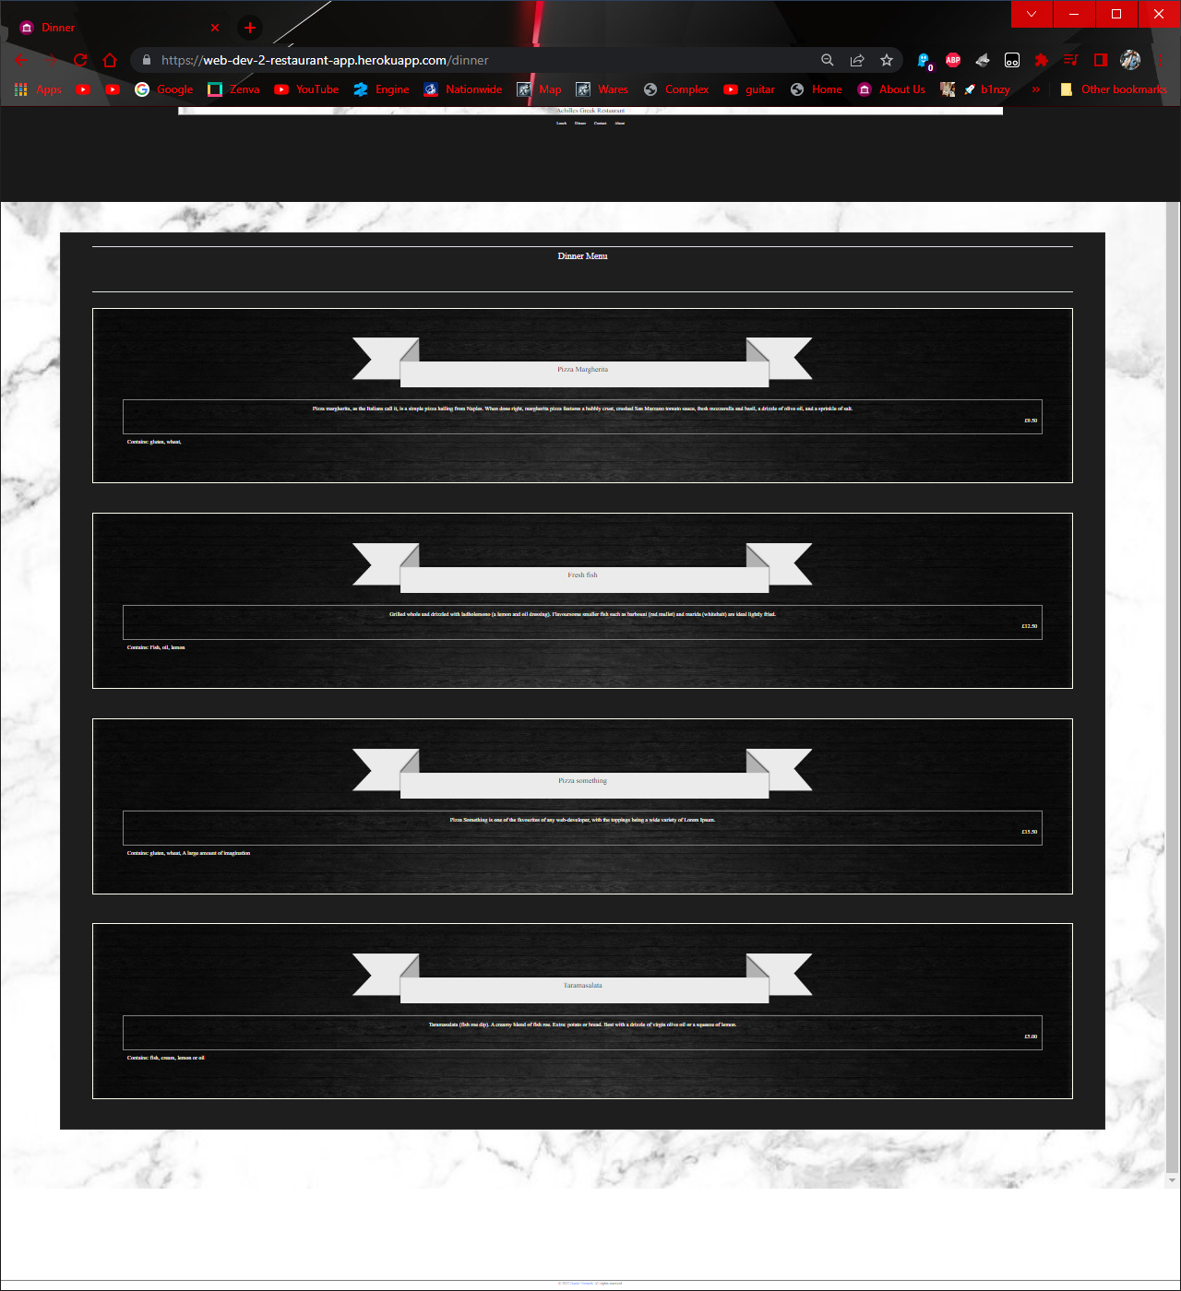

Figure fresh fish 2 doesn't show for users

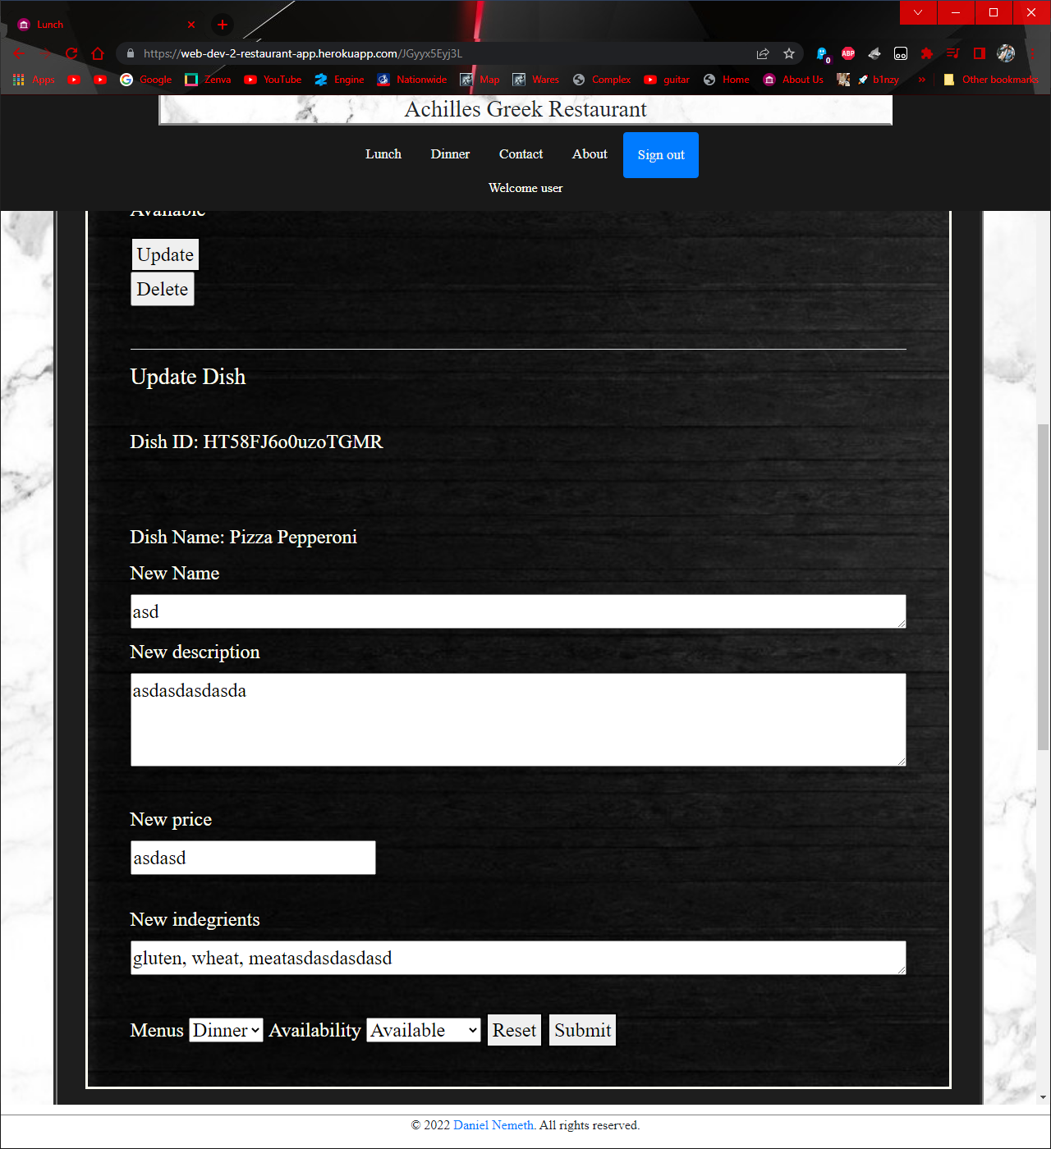

Figure reset form 1

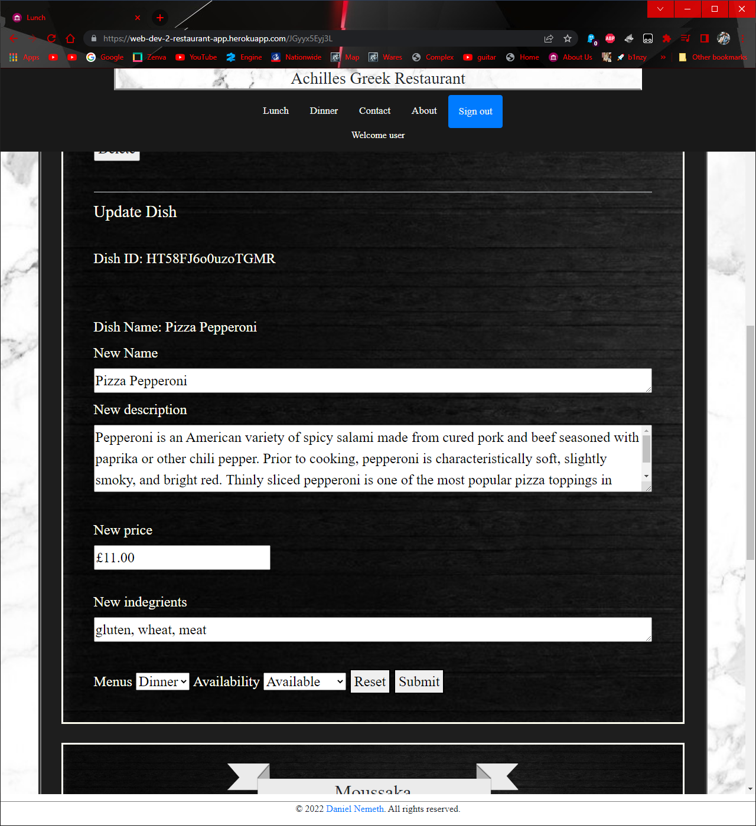

Figure reset form 2: on reset, fields load up the default values saved in database

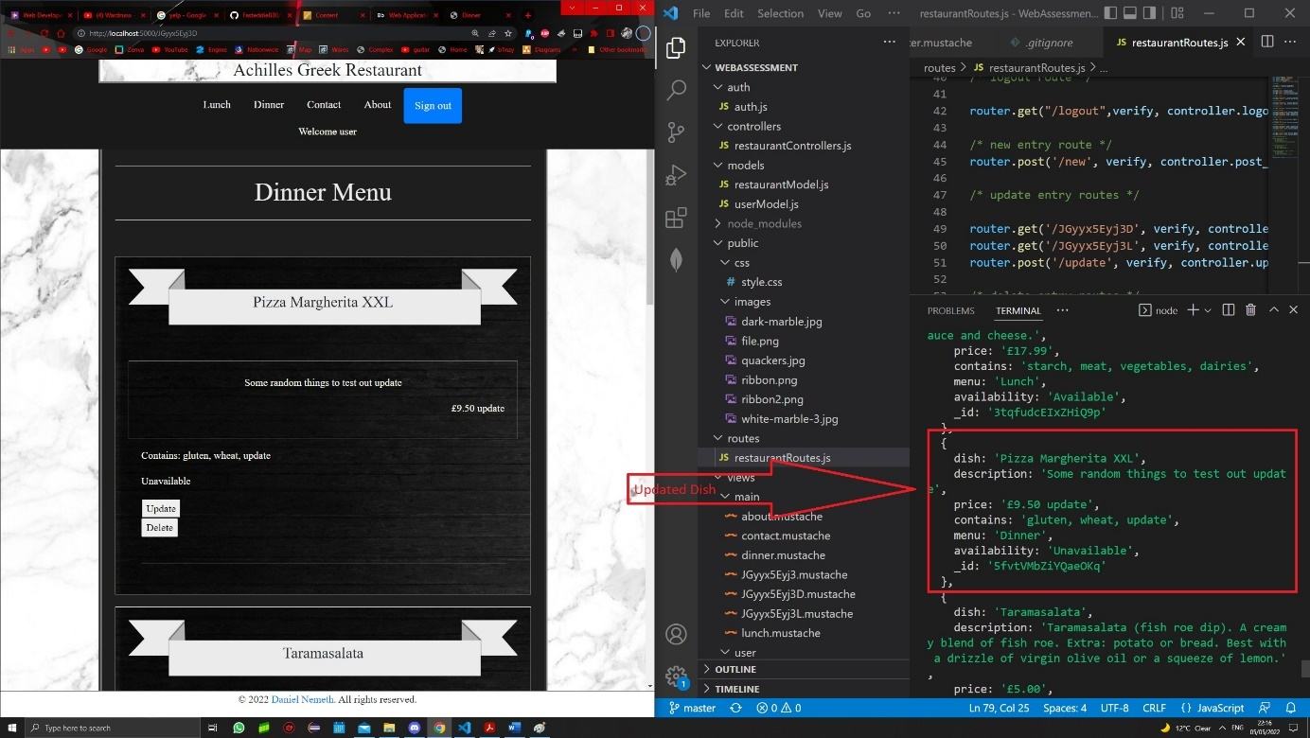

Figure update before

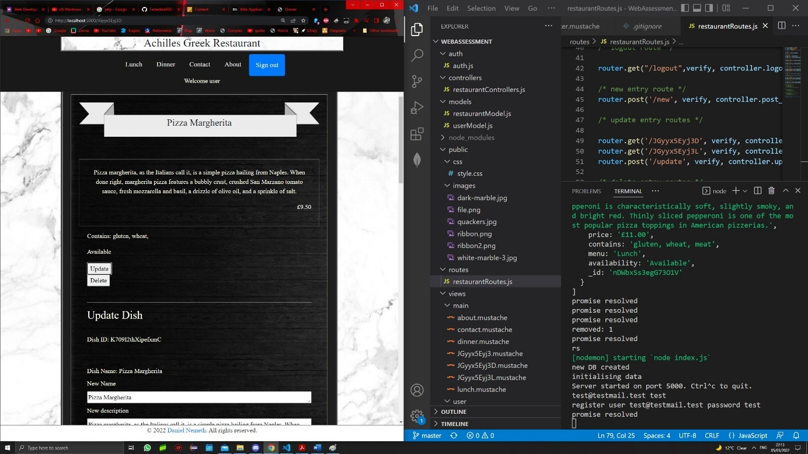

Figure update after

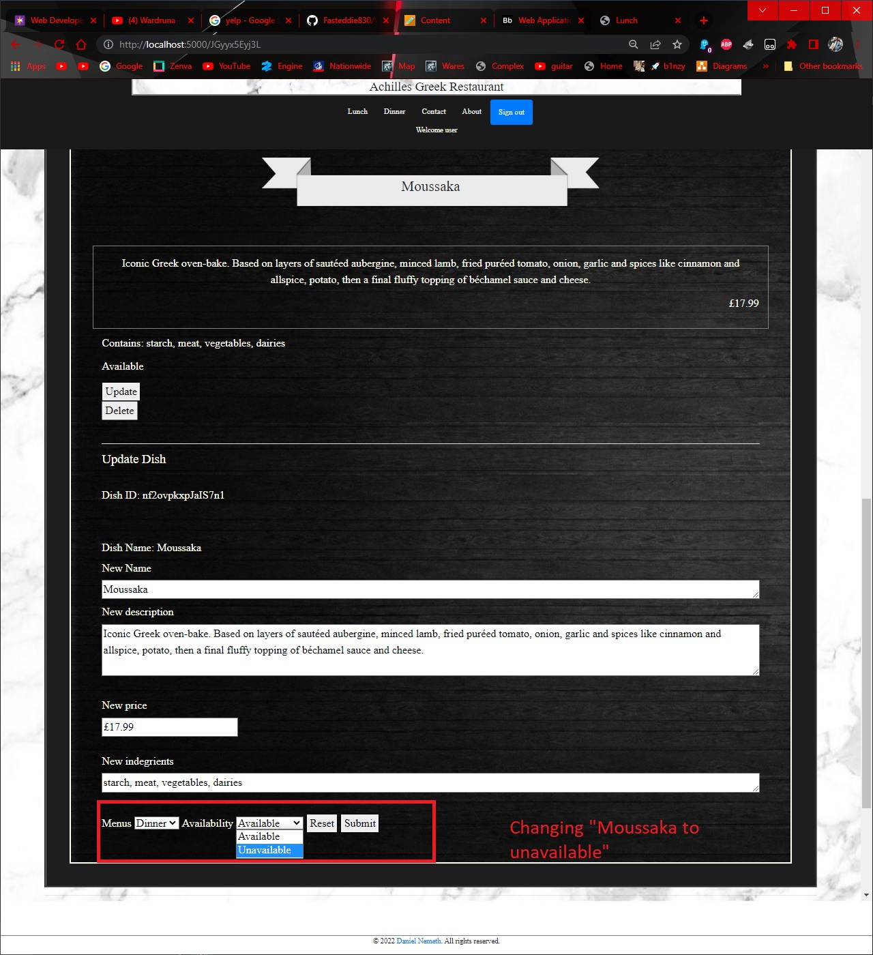

Figure Availability 1

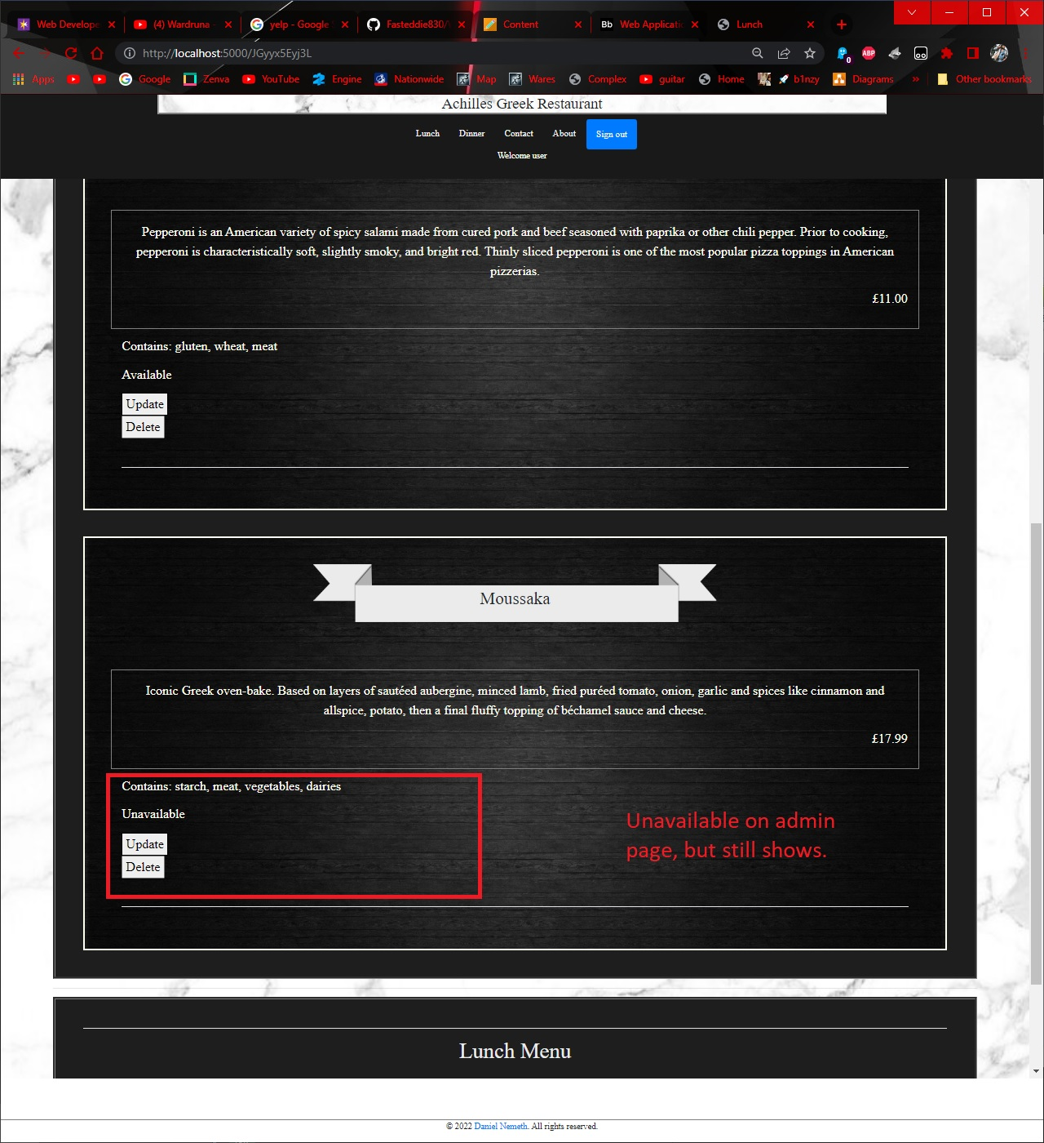

Figure Availability 2

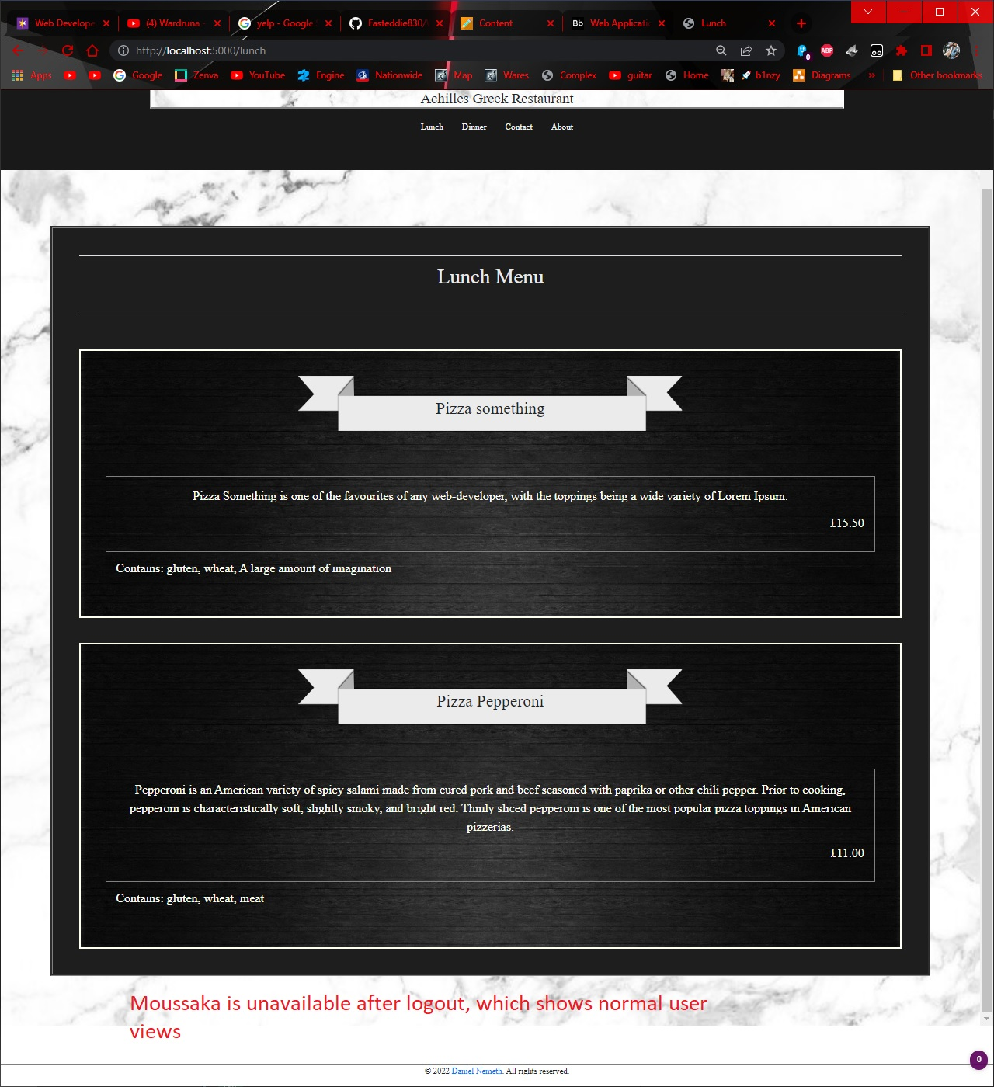

Figure Availability 3

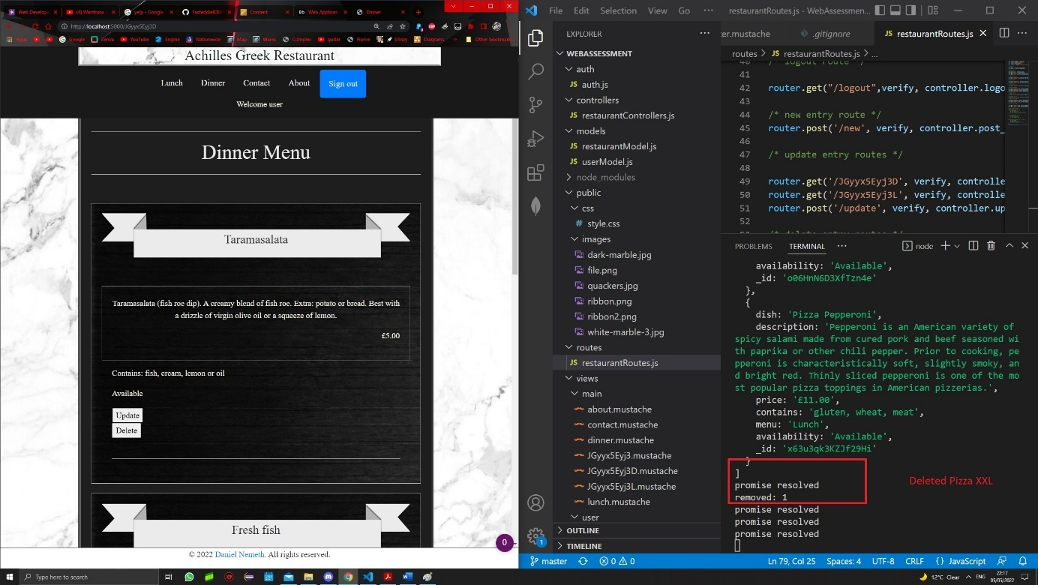

Figure Delete

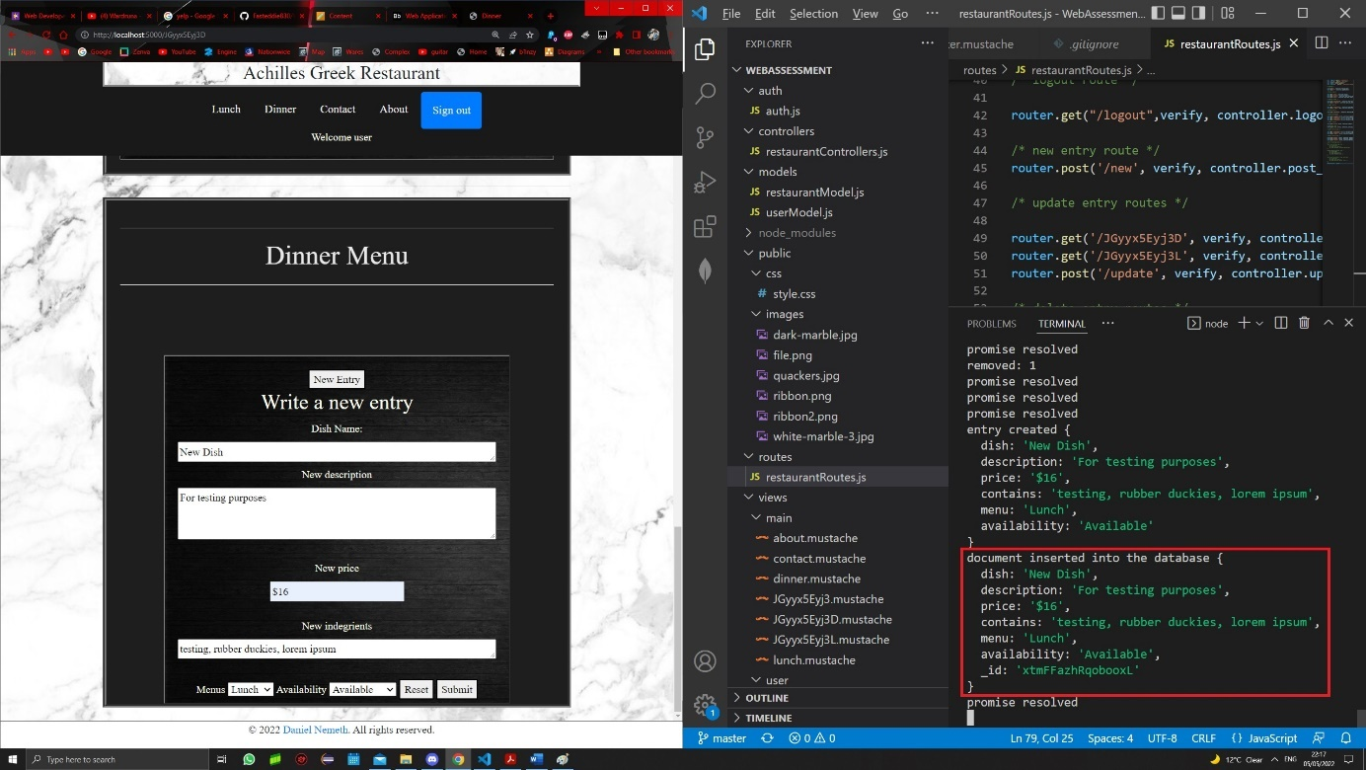

Figure new entry 1

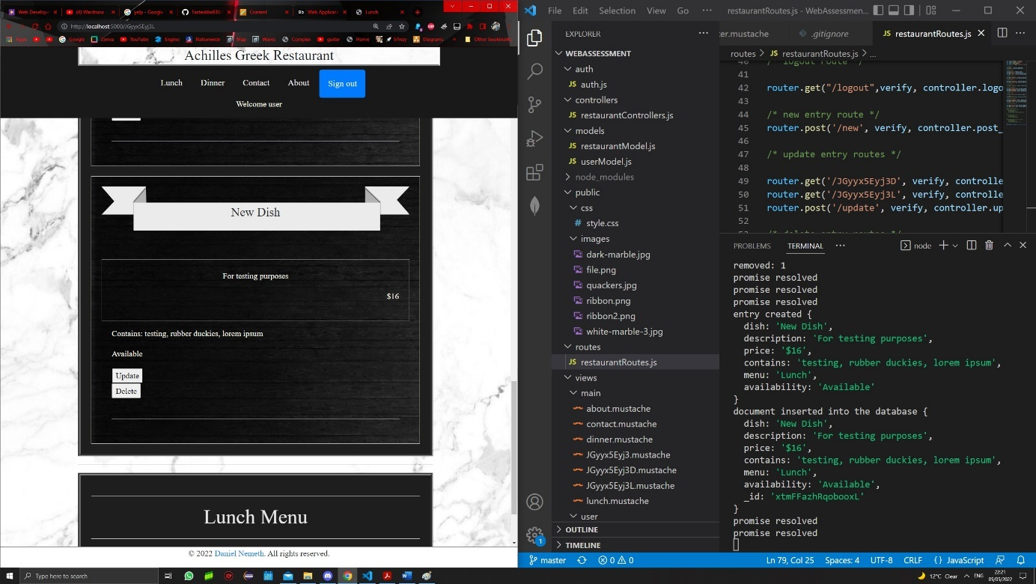

Figure new entry 2

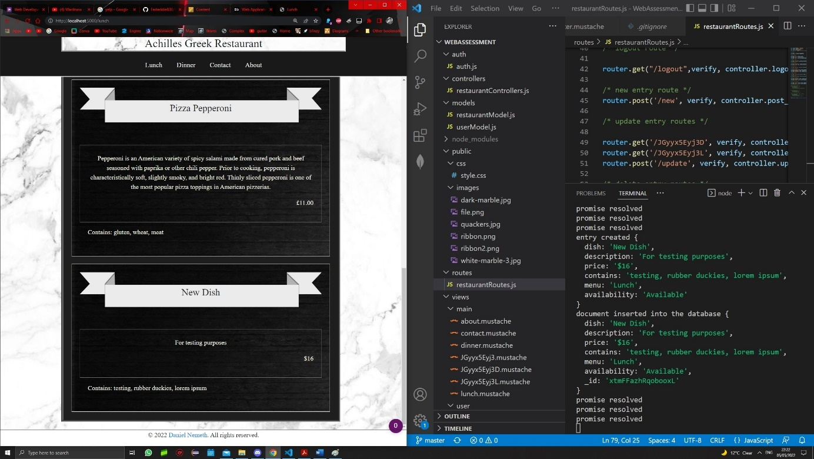

Figure new entry for regular users

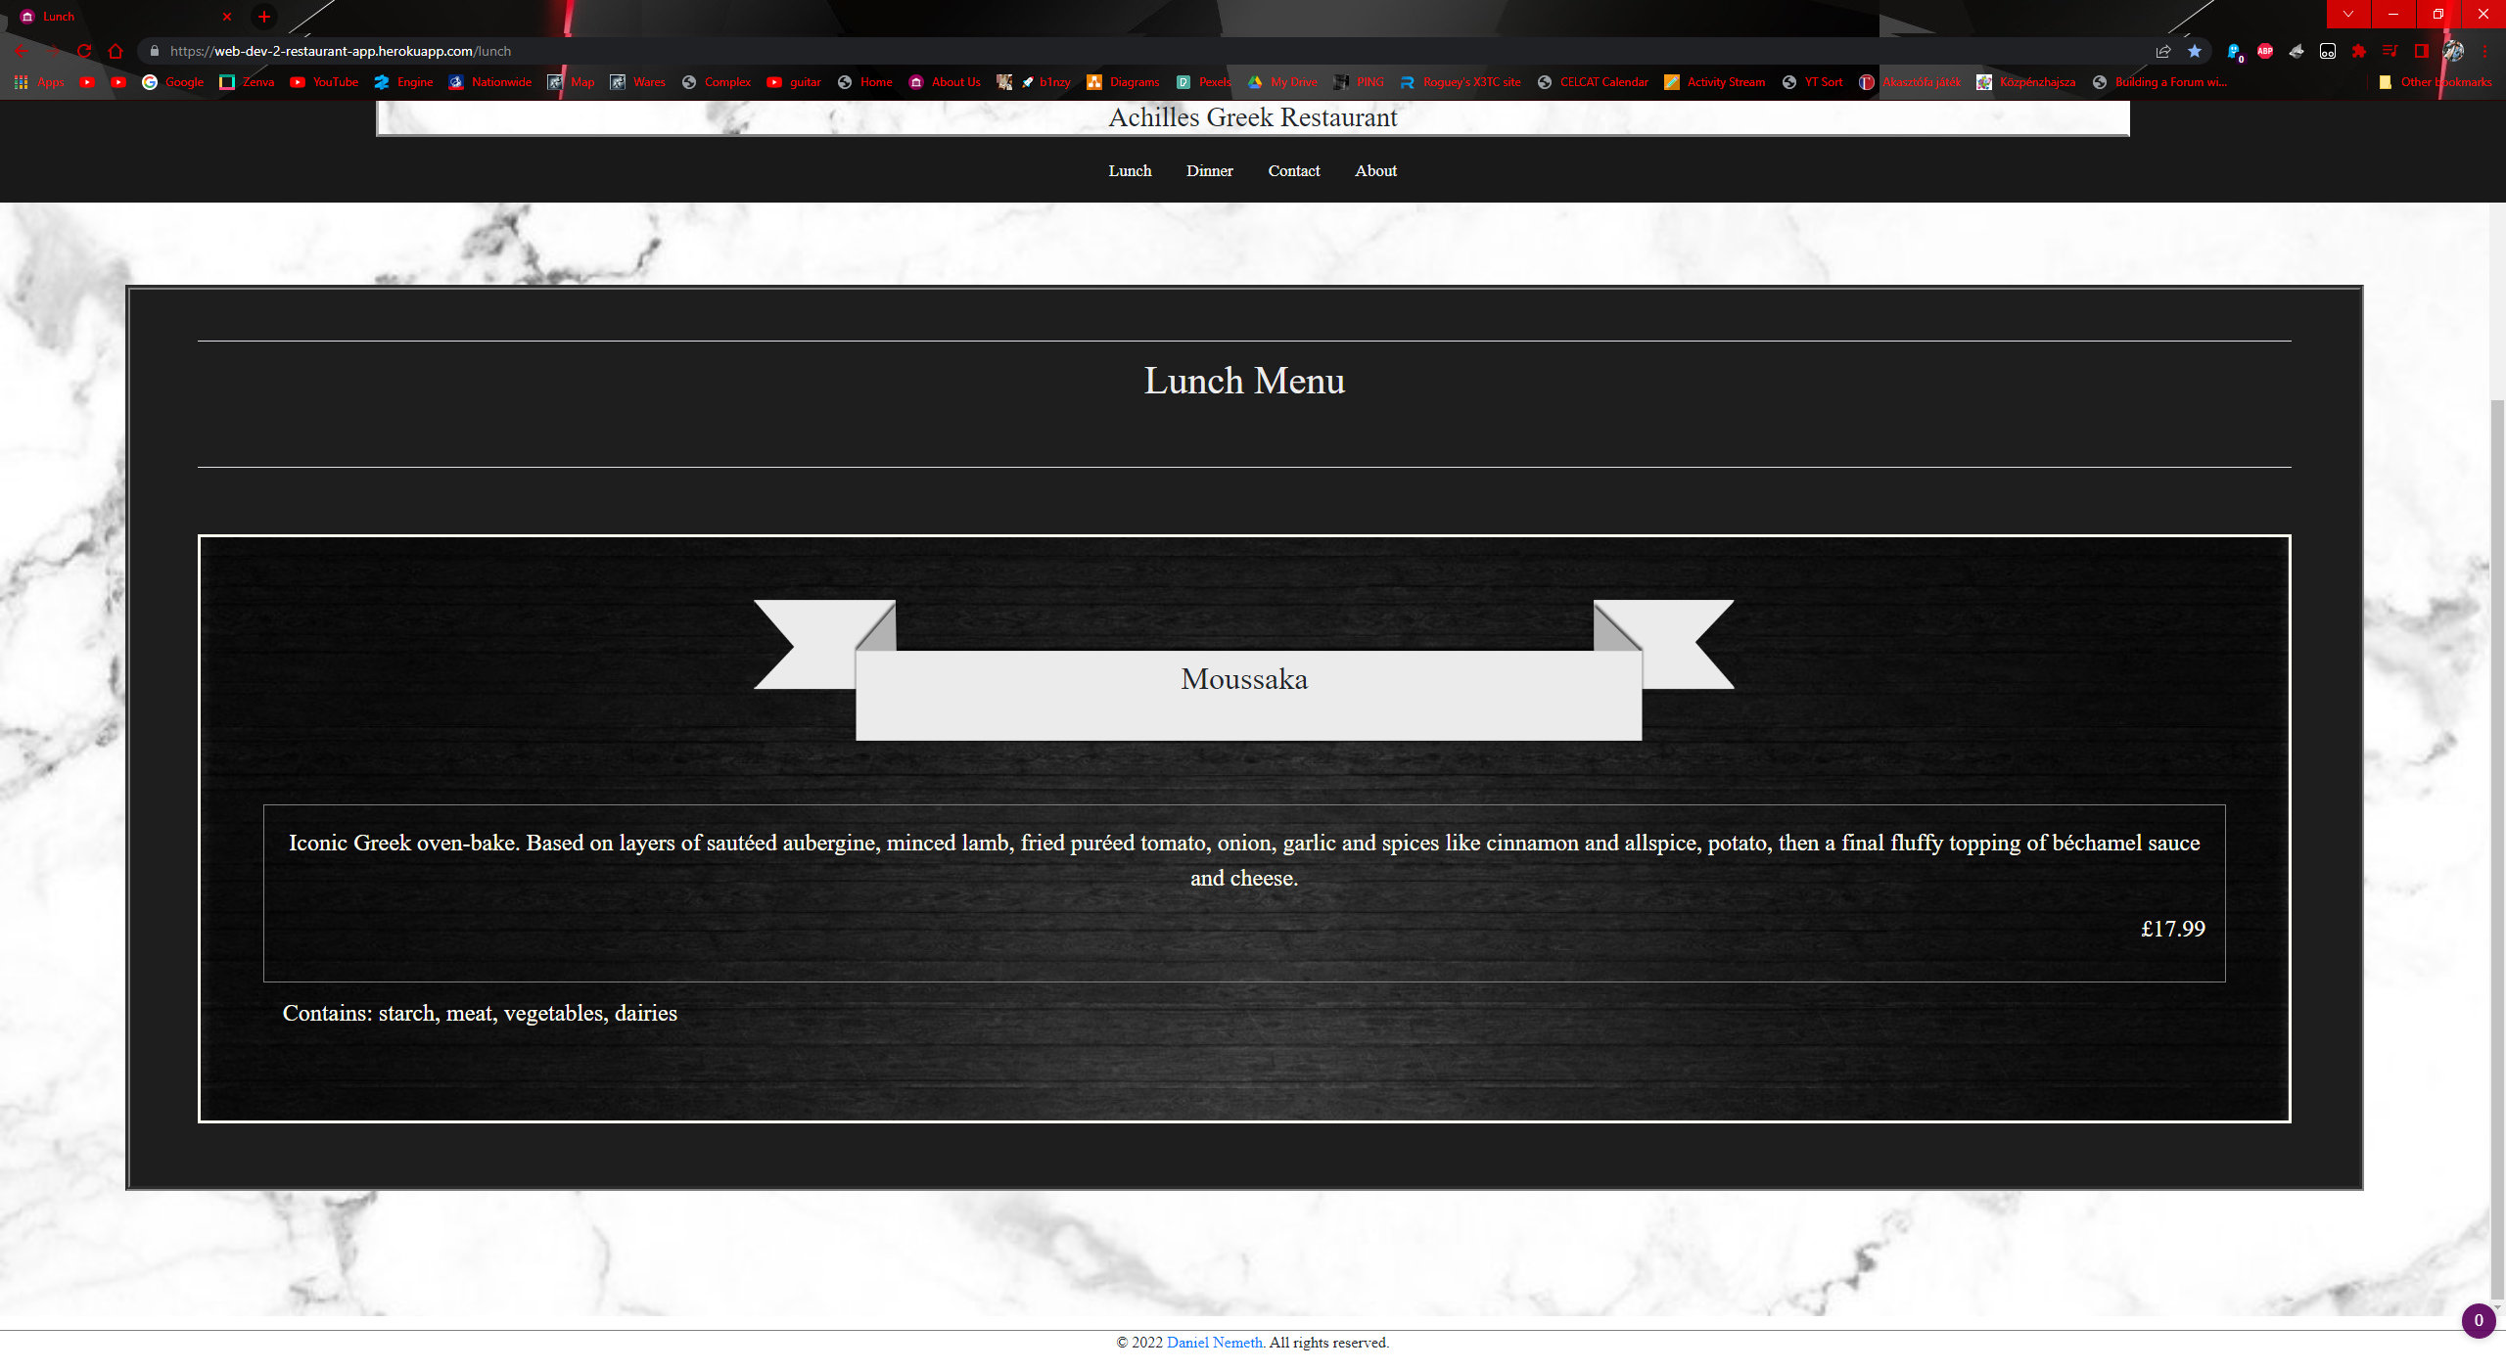

Figure about pc view

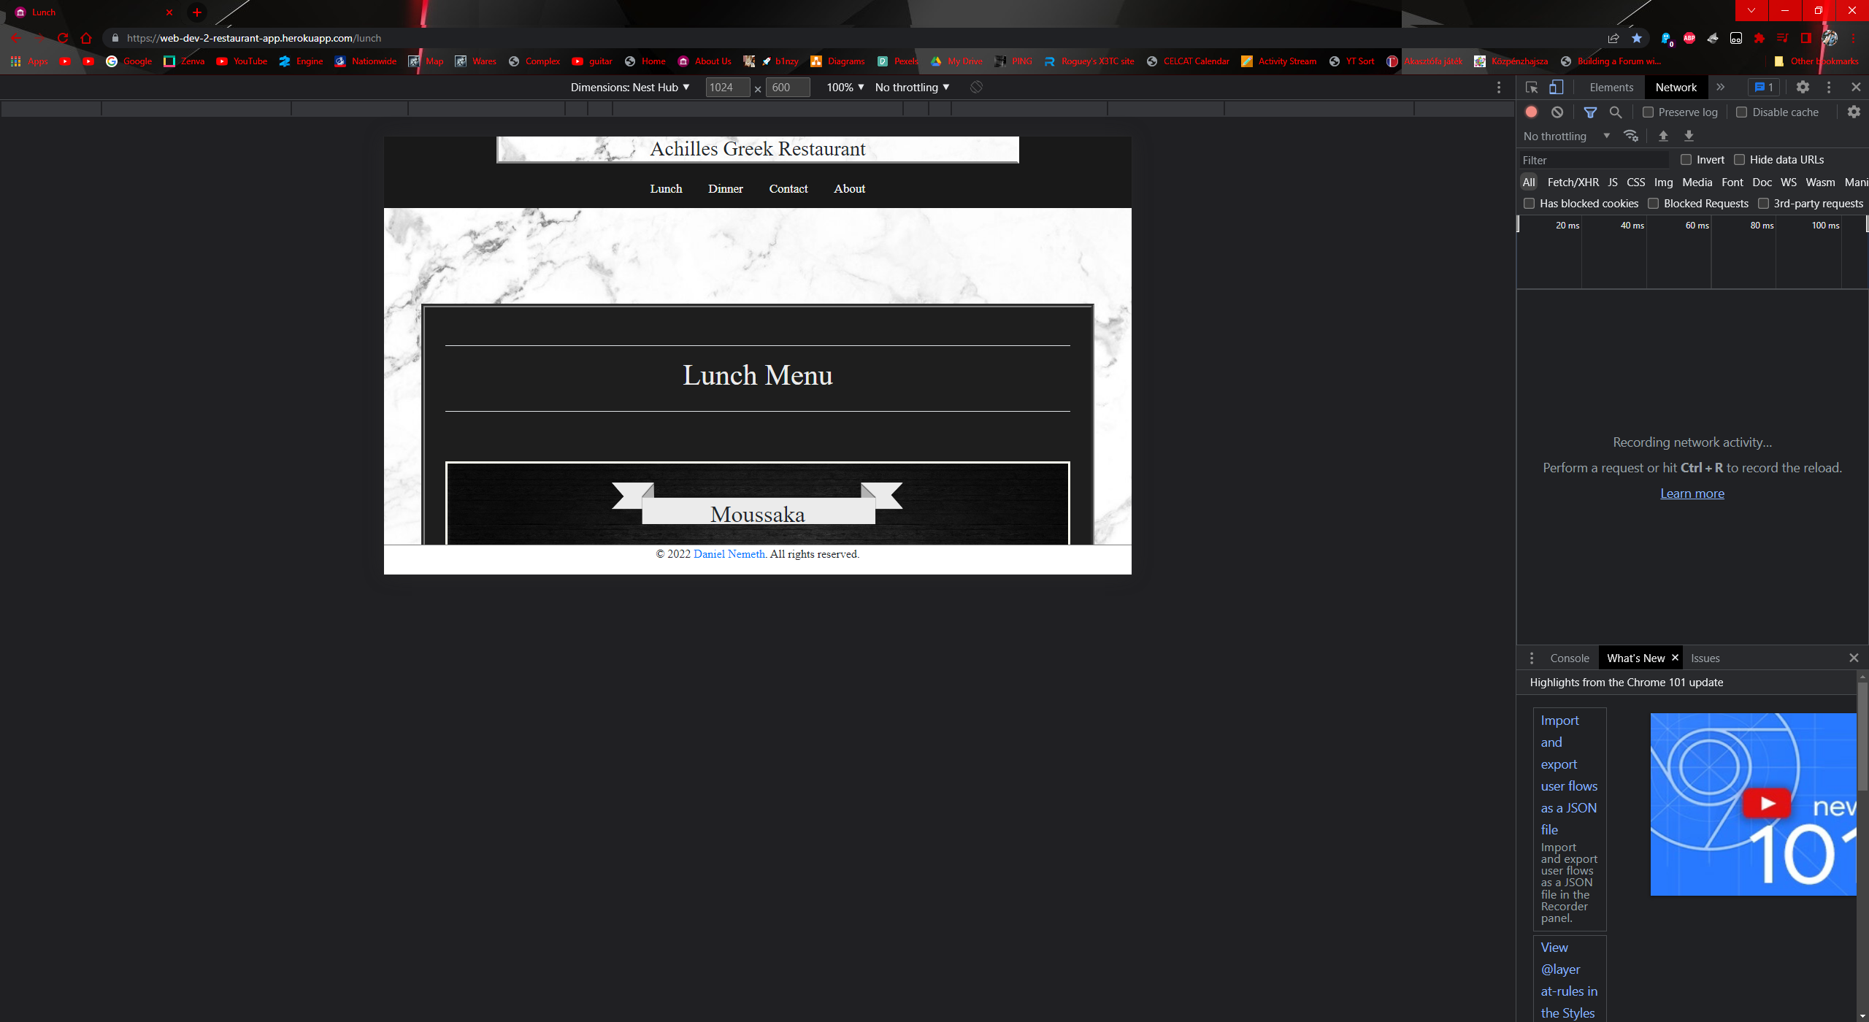

Figure about tablet view

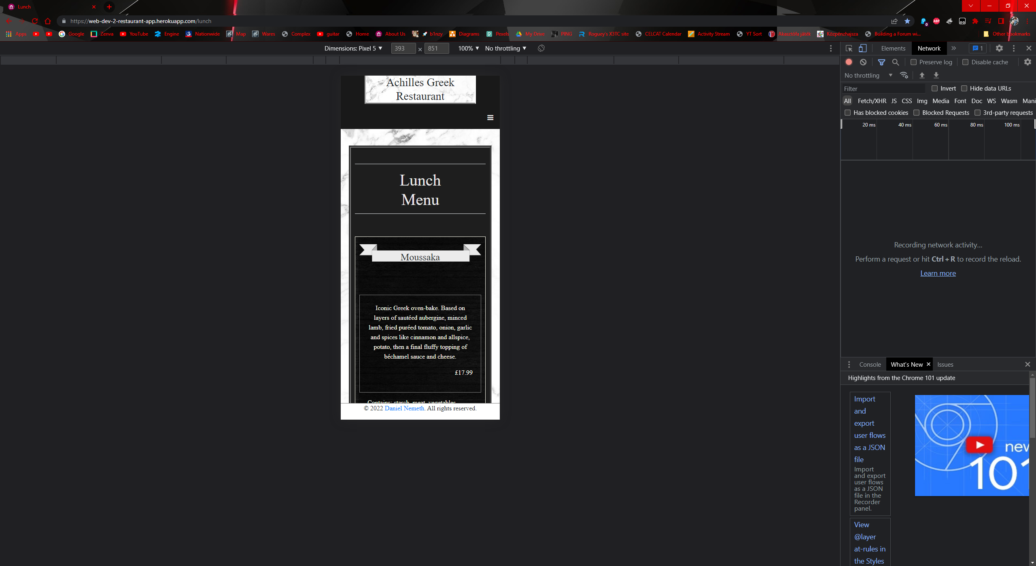

Figure about phone view

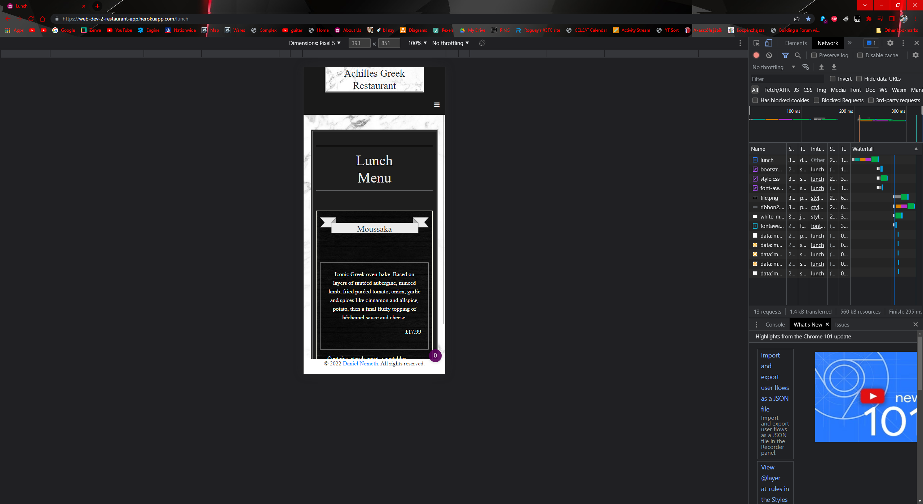

Figure lunch phone view

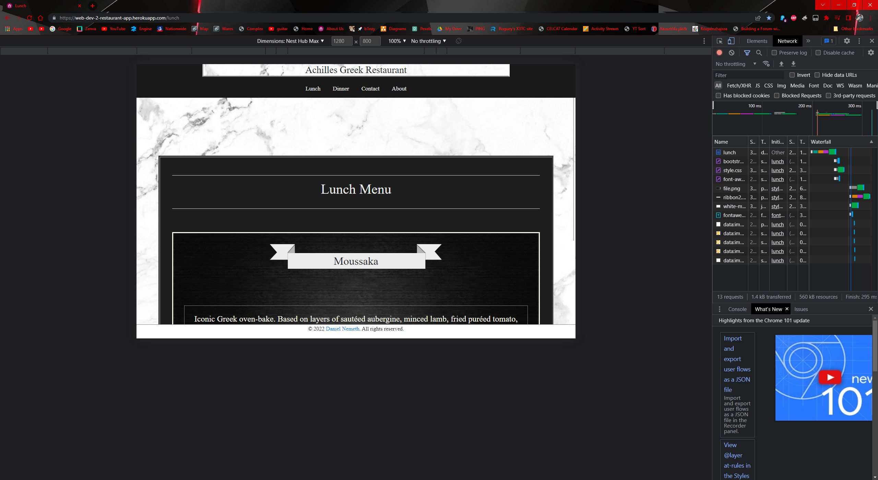

Figure lunch tablet view

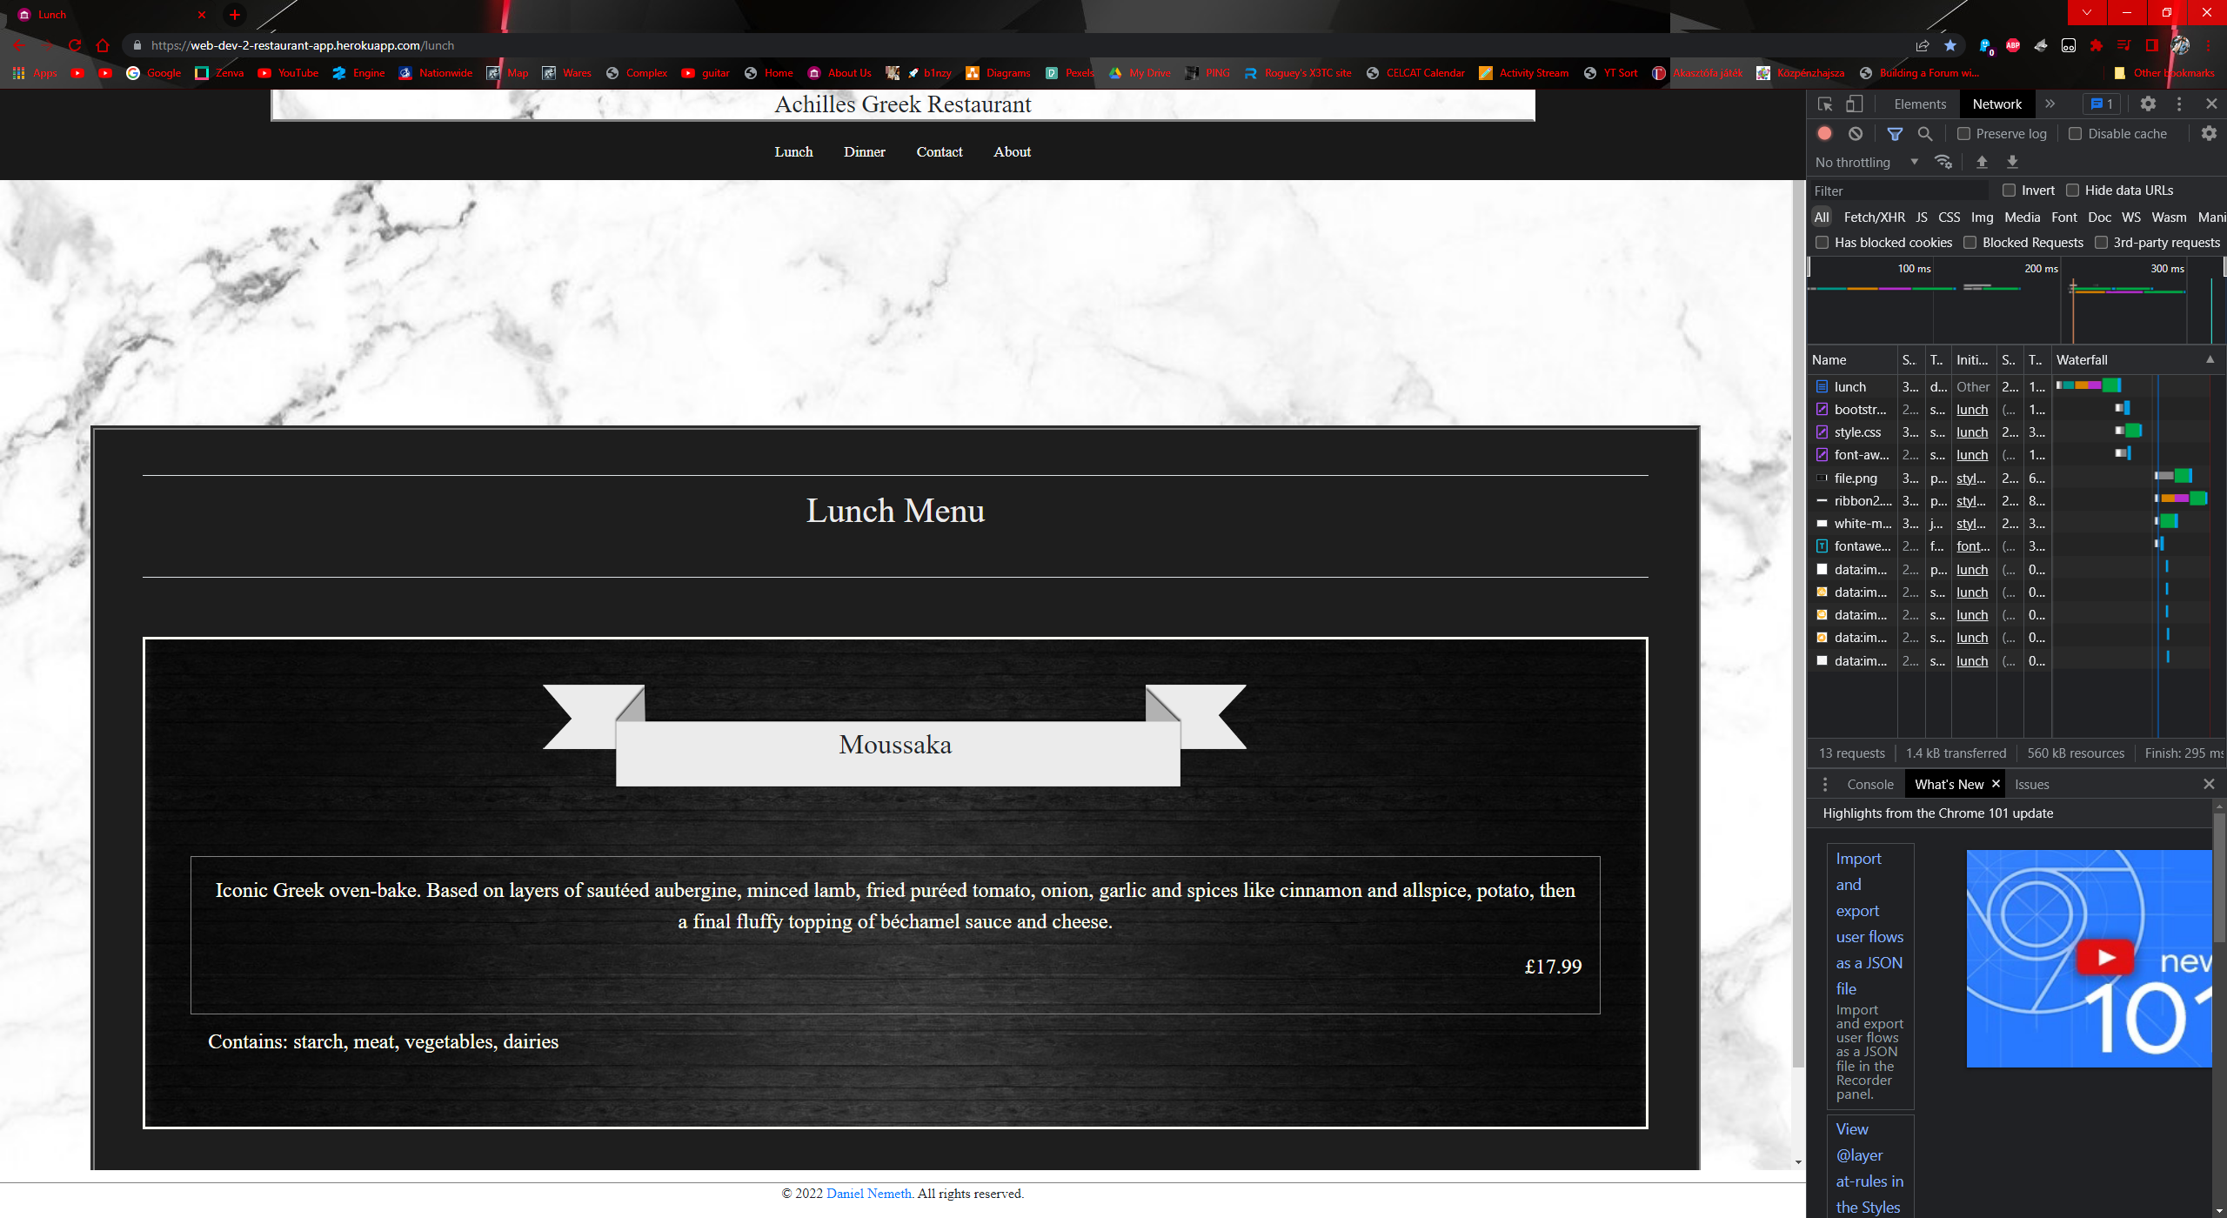

Figure lunch large screen view

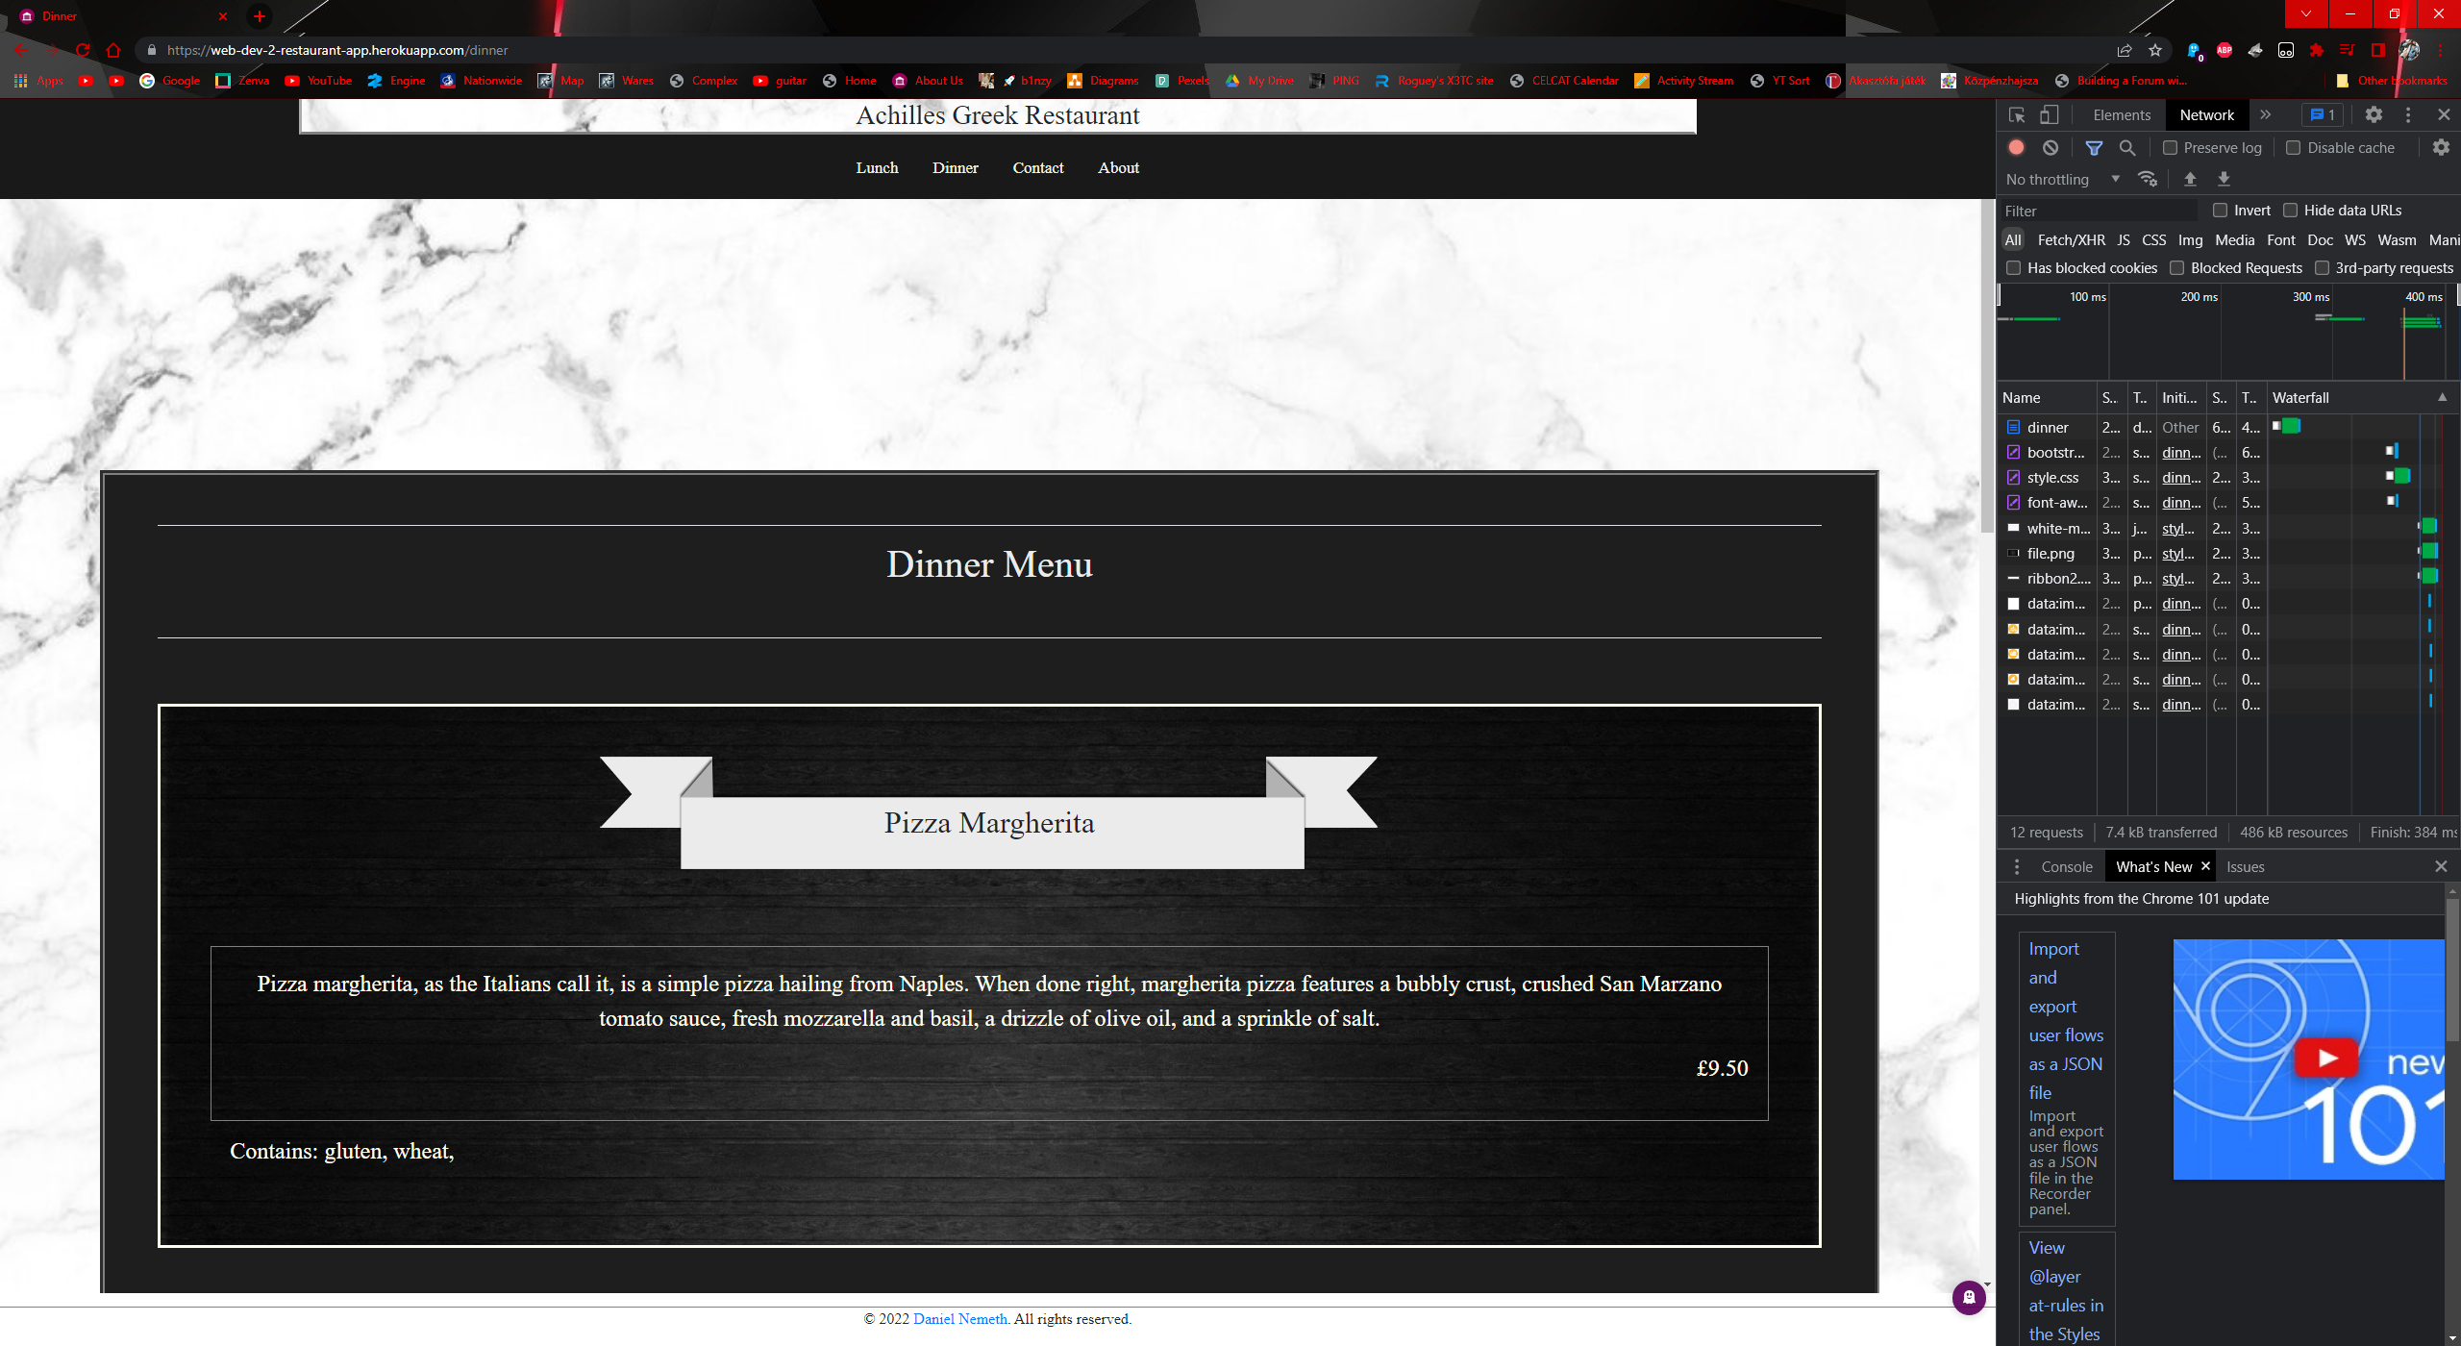

Figure dinner large screen

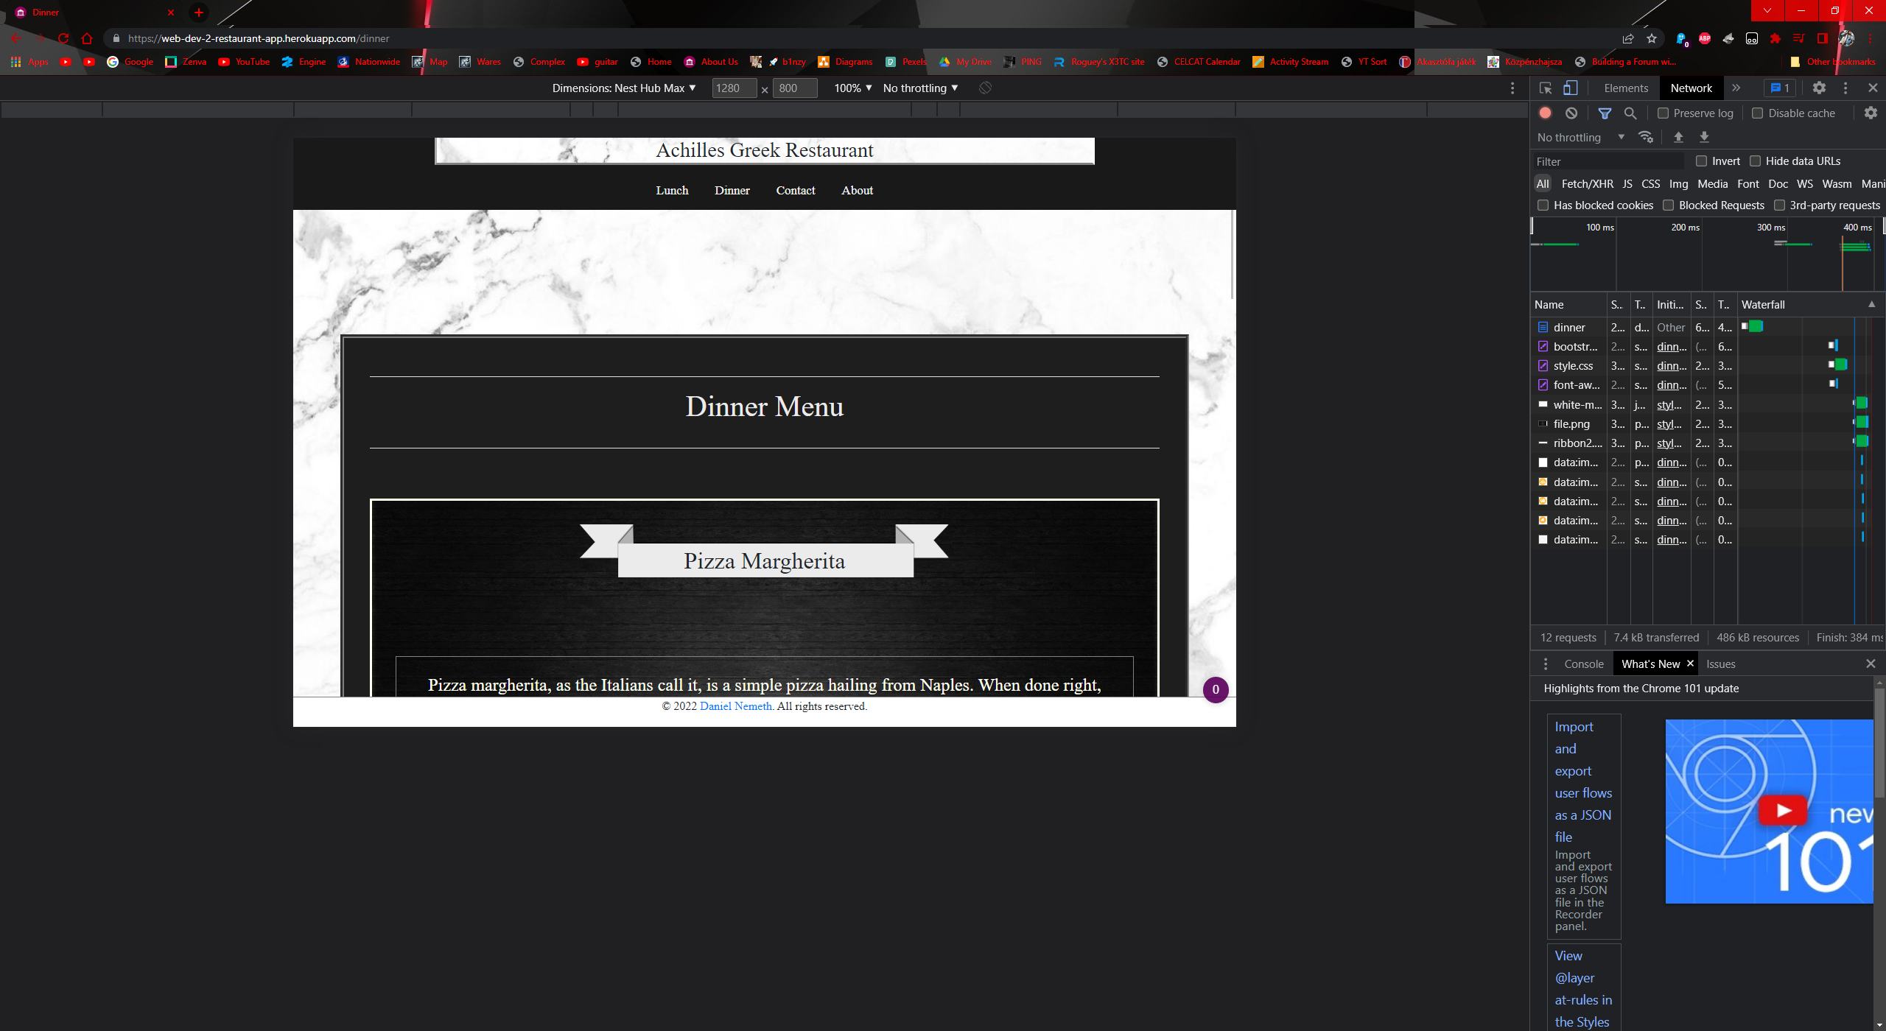

Figure dinner tablet screen

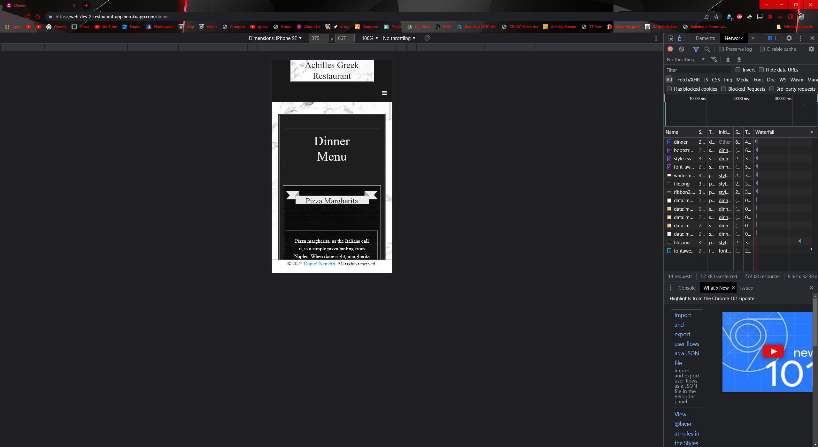

Figure dinner phone view

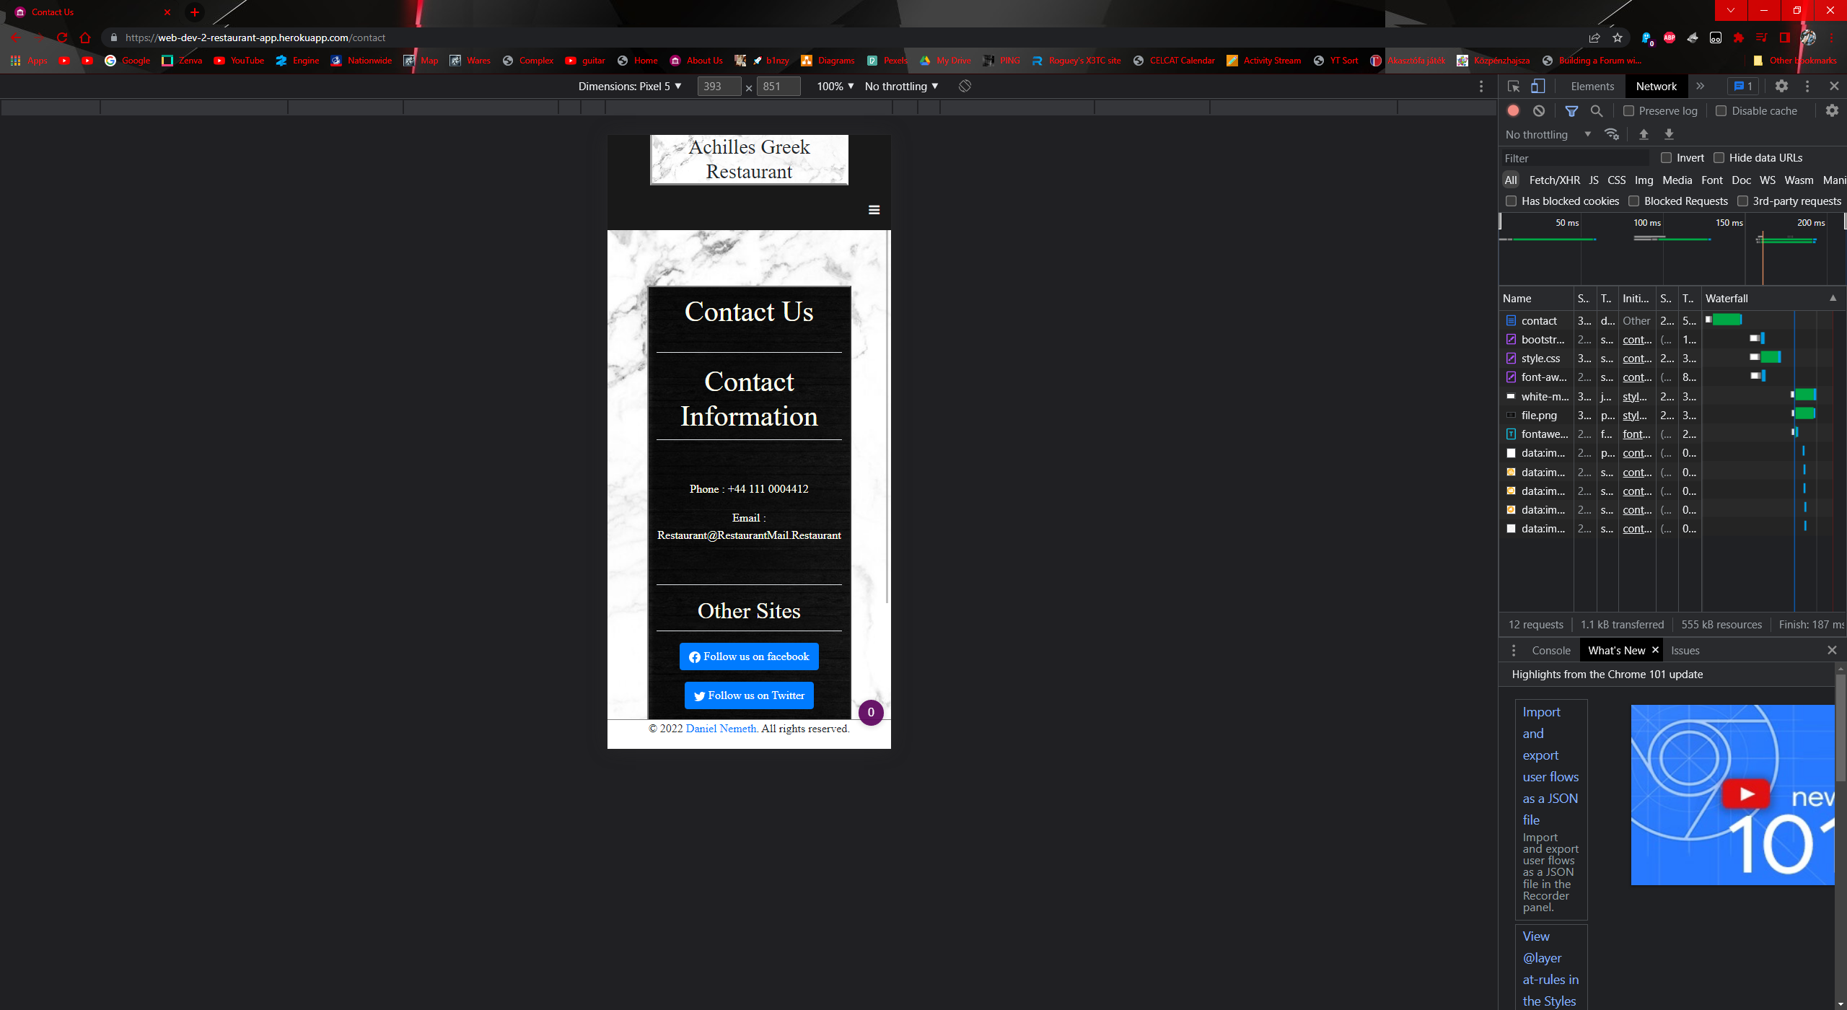

Figure contact phone view

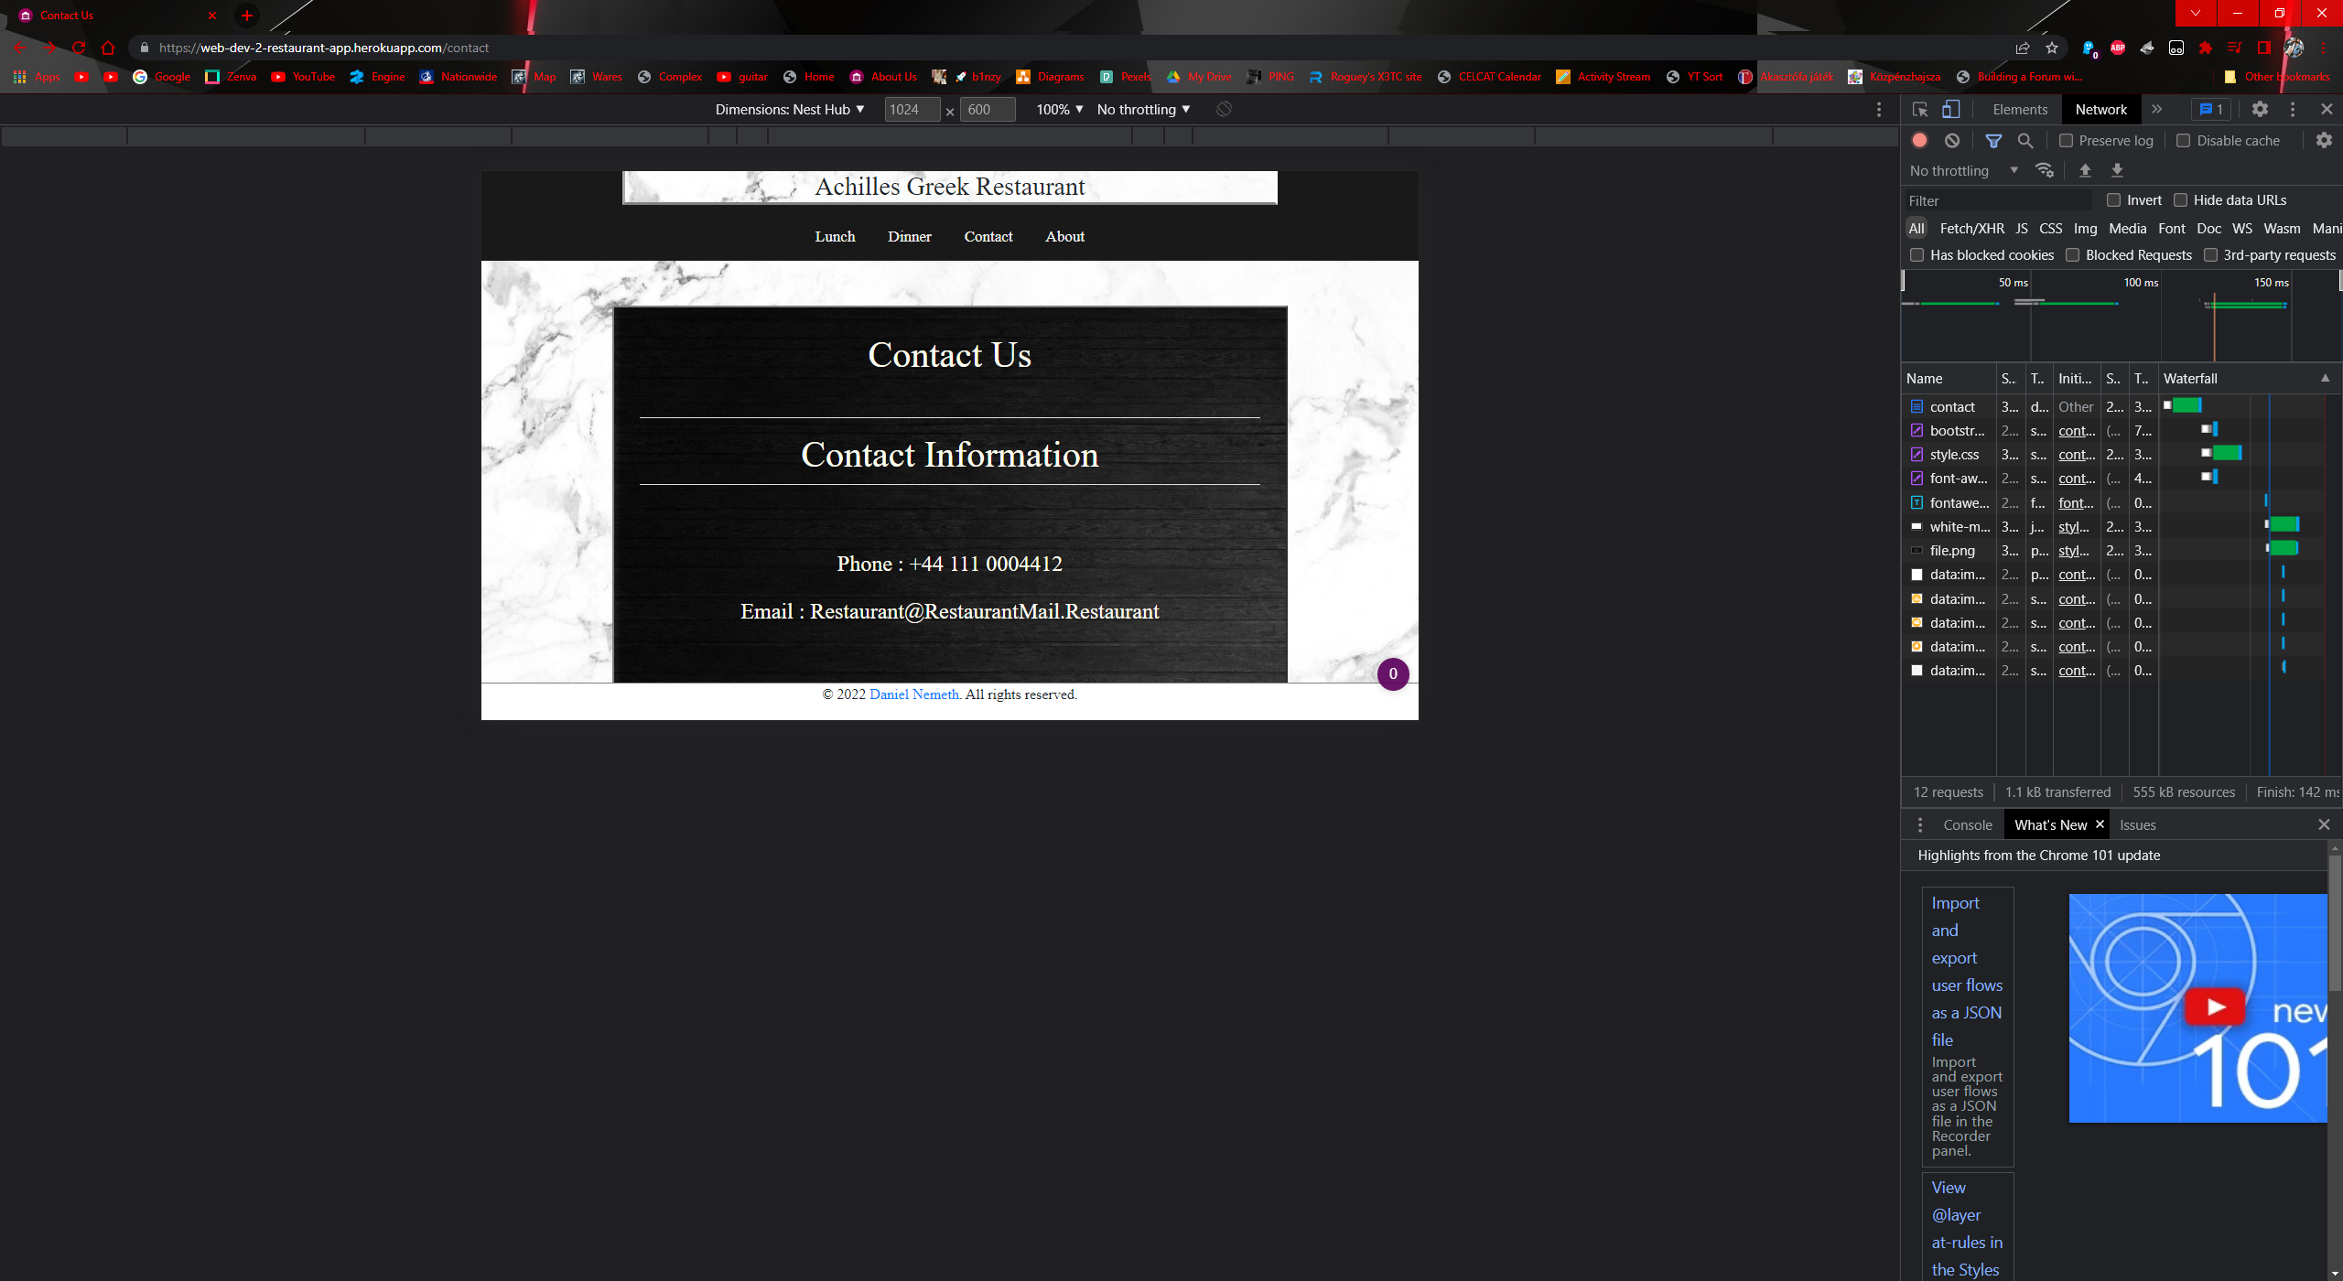

Figure contact tablet view

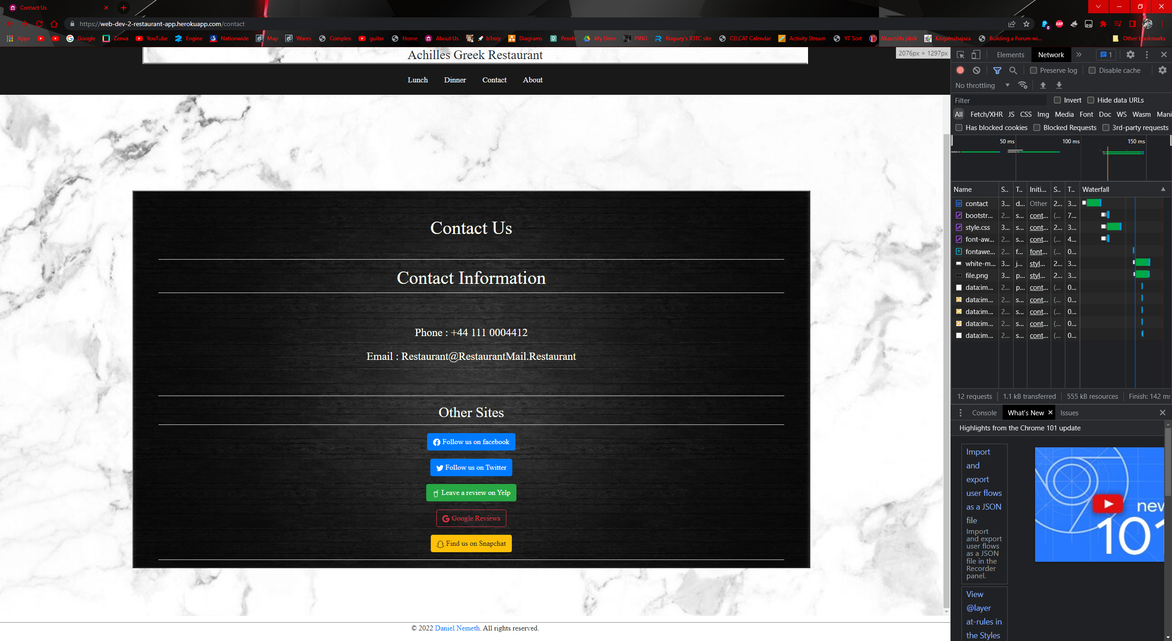

Figure contact large screen view

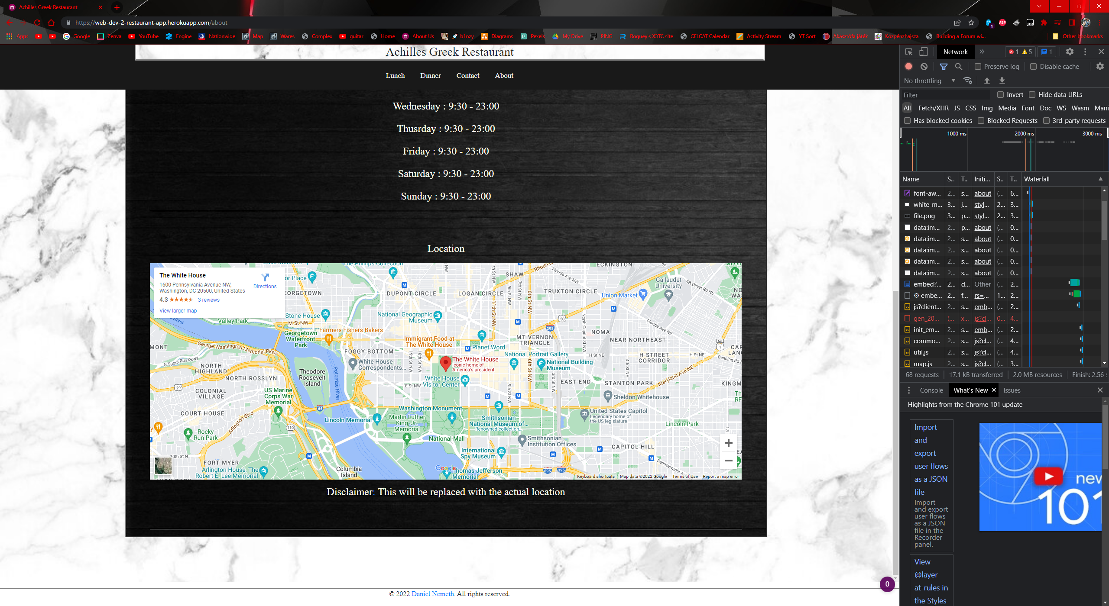

Figure about large screen view

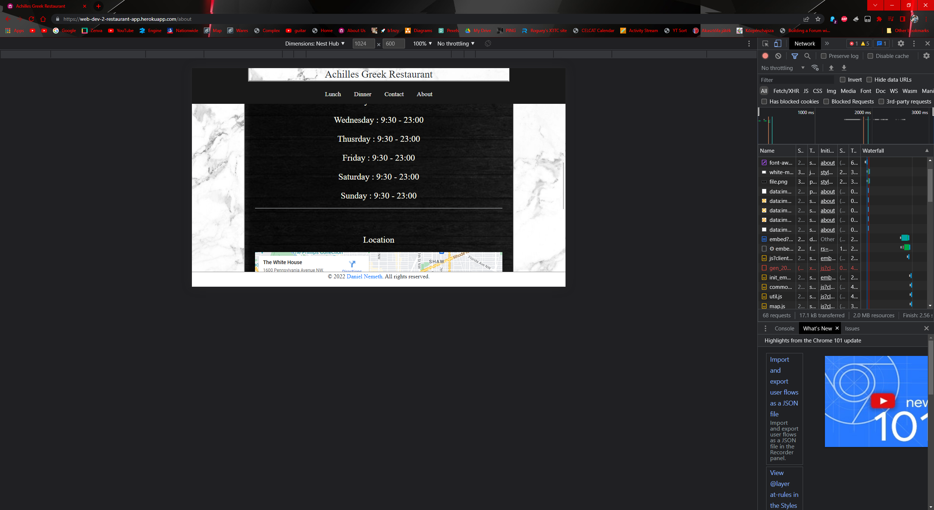

Figure about tablet view

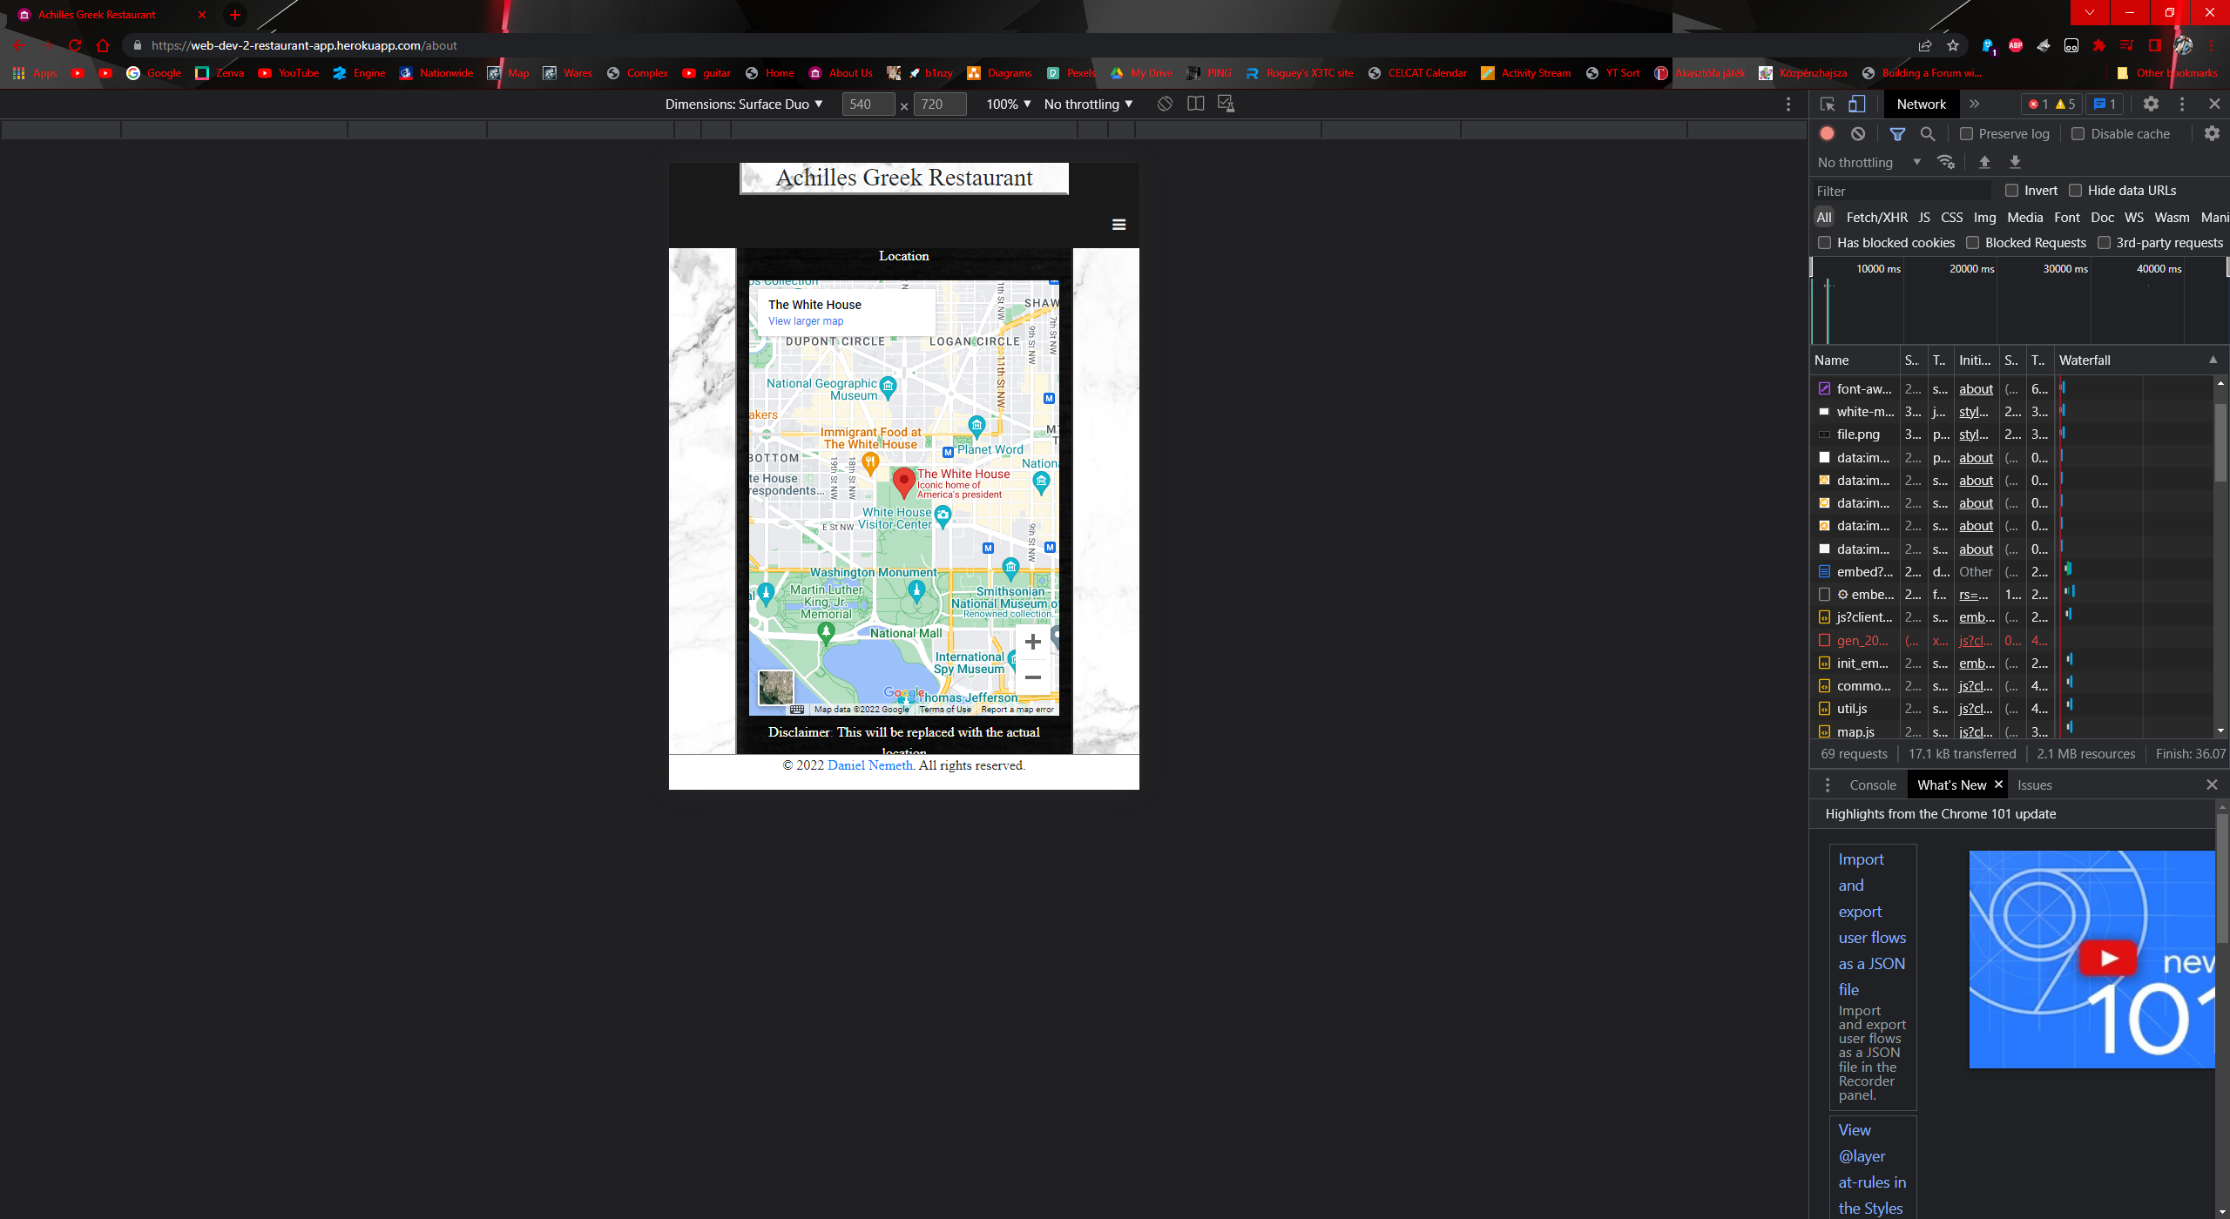

Figure about phone view

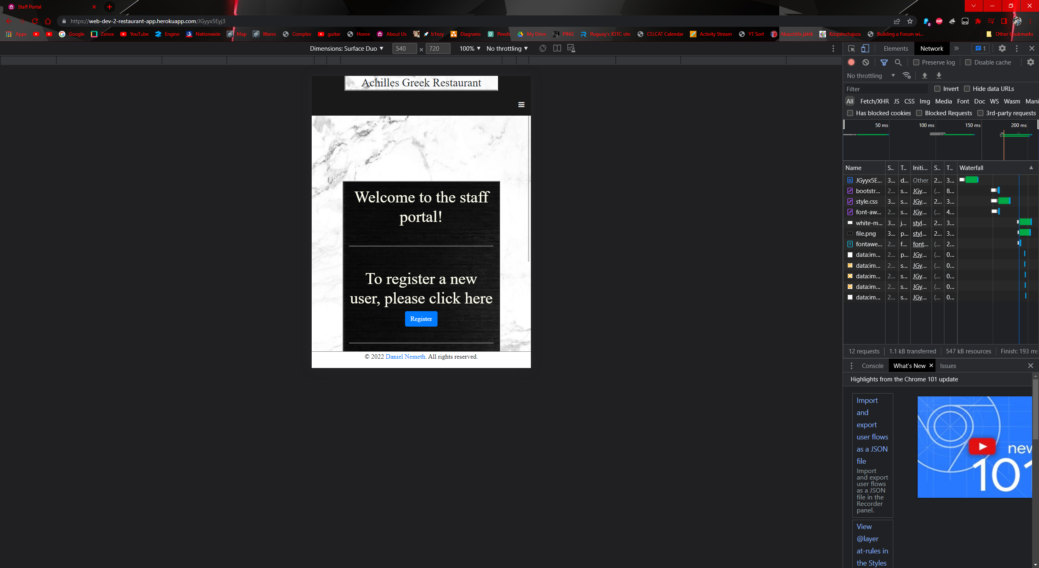

Figure staff phone view

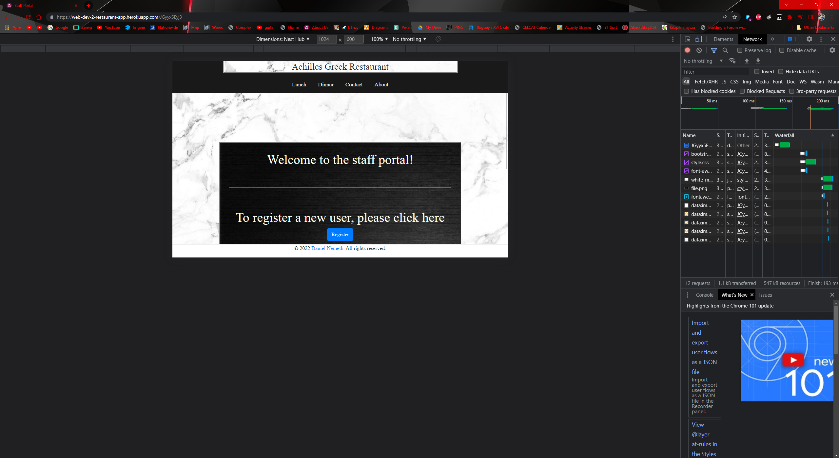

Figure staff tablet view

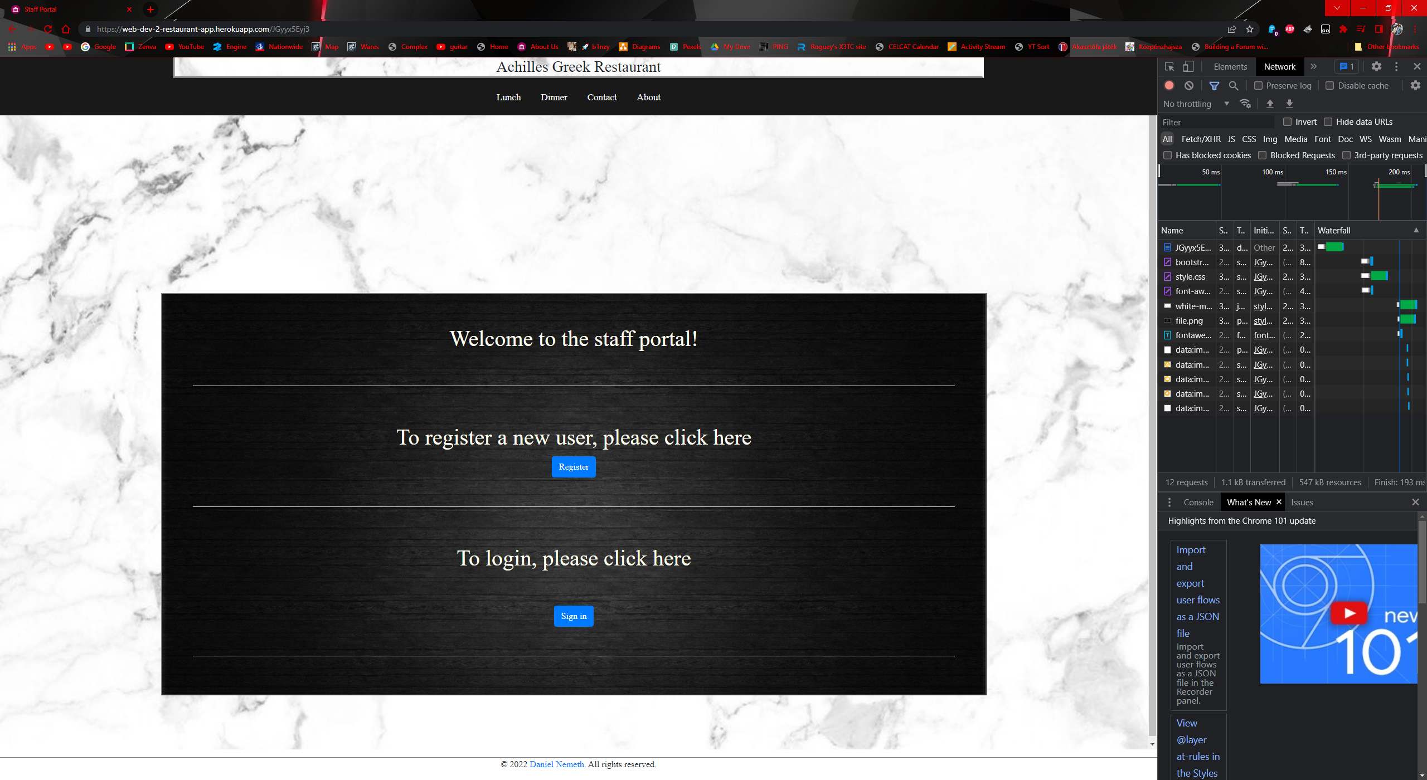

Figure staff large view

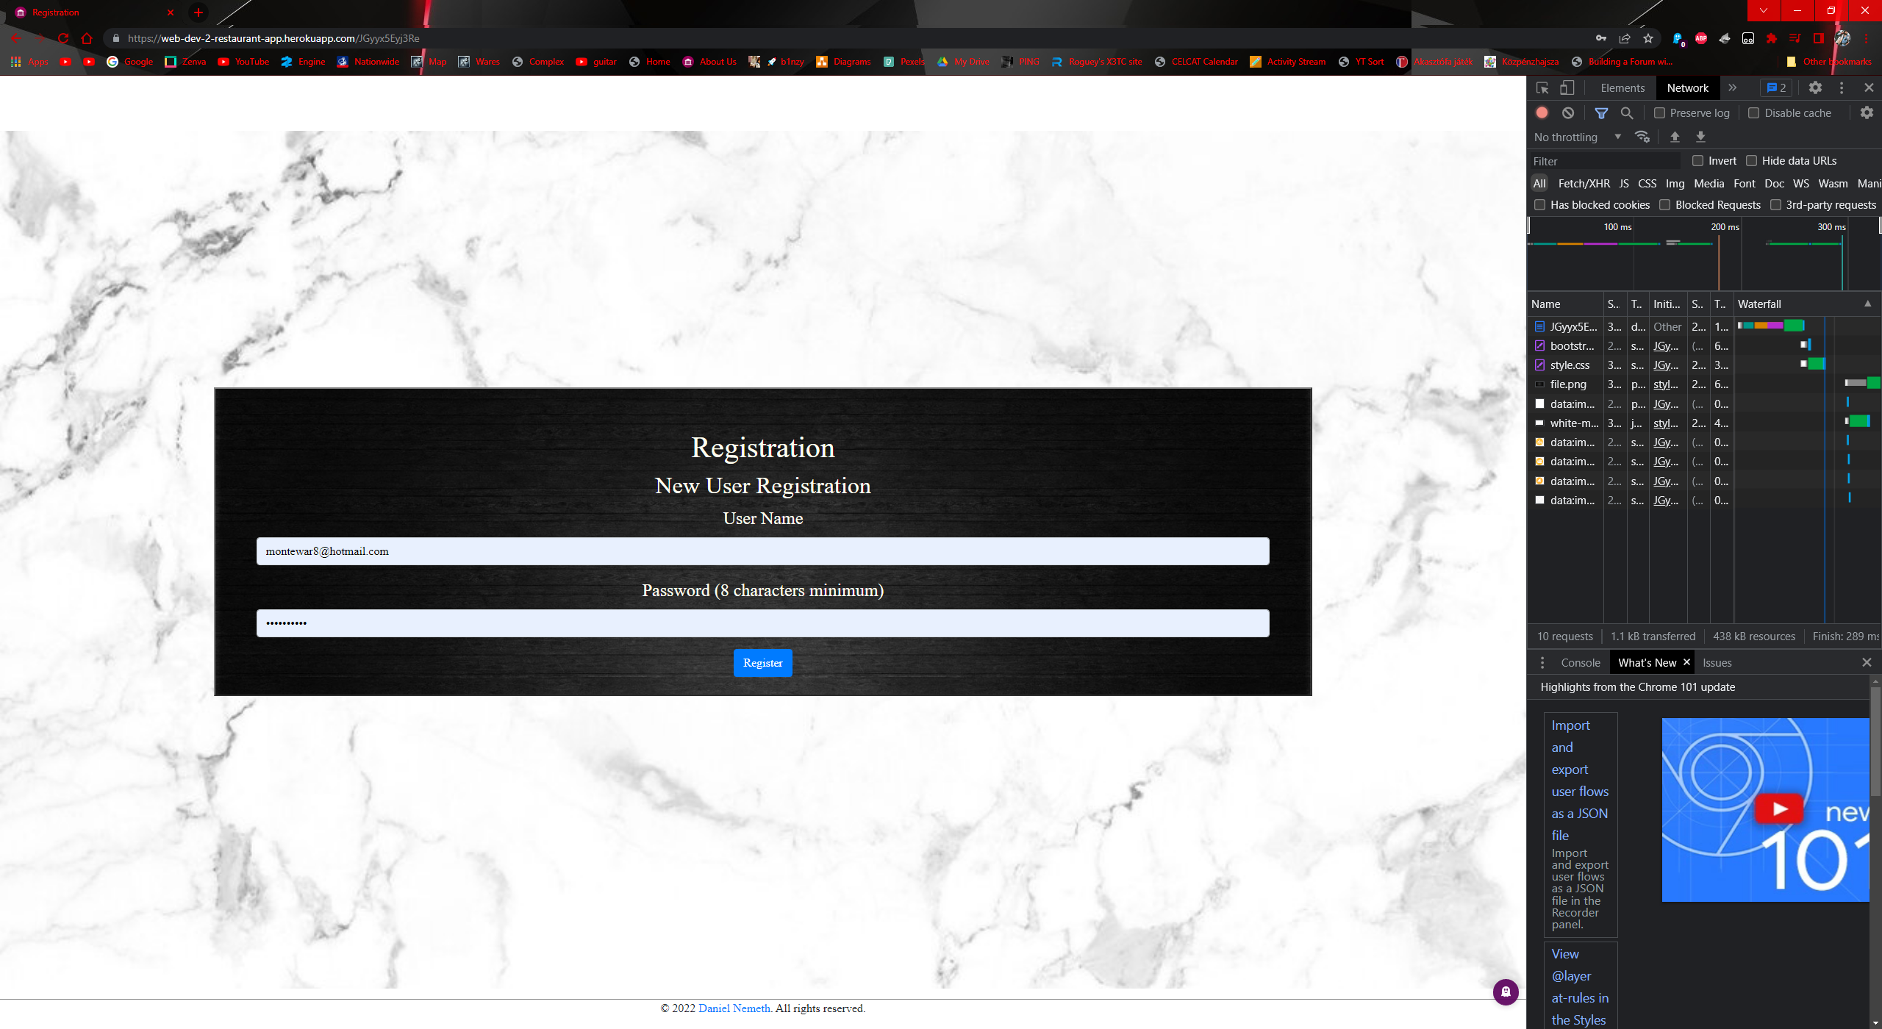

Figure register full view

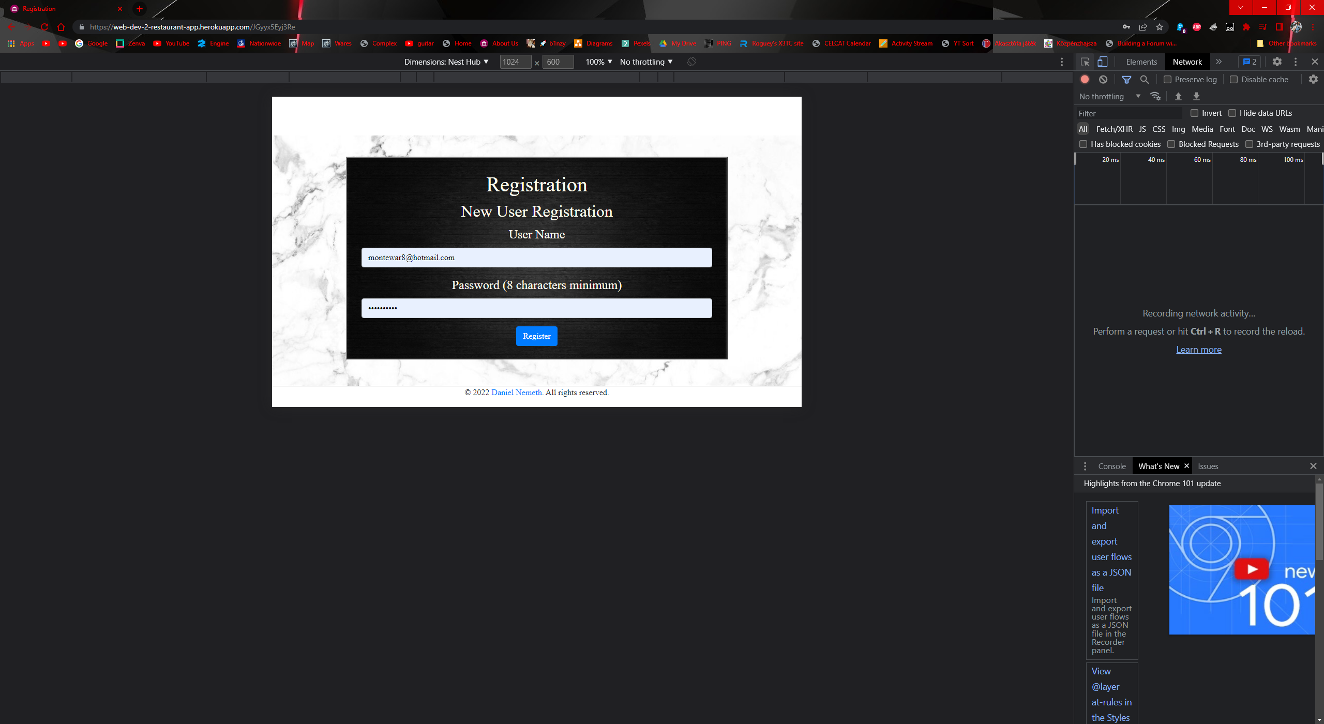

Figure register tablet view

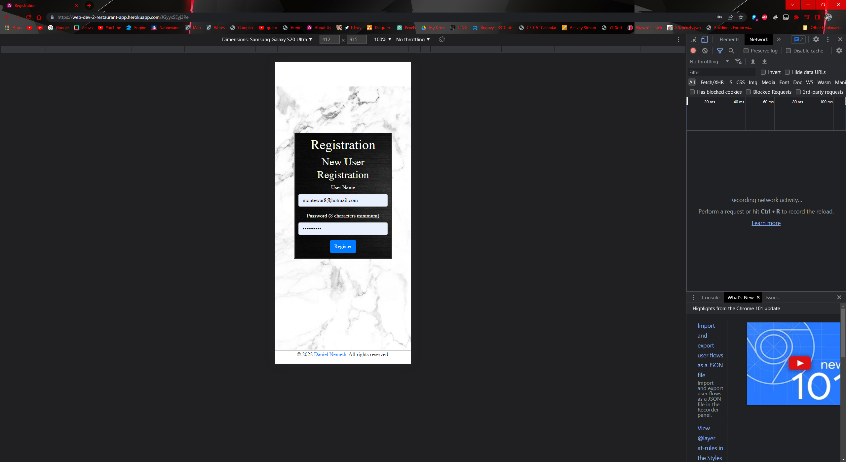

Figure register phone view

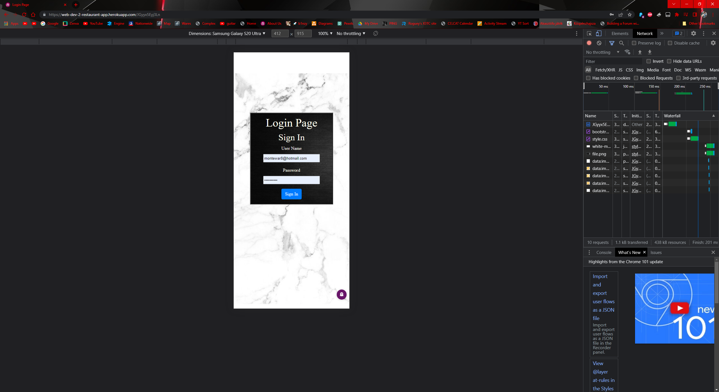

Figure login phone view

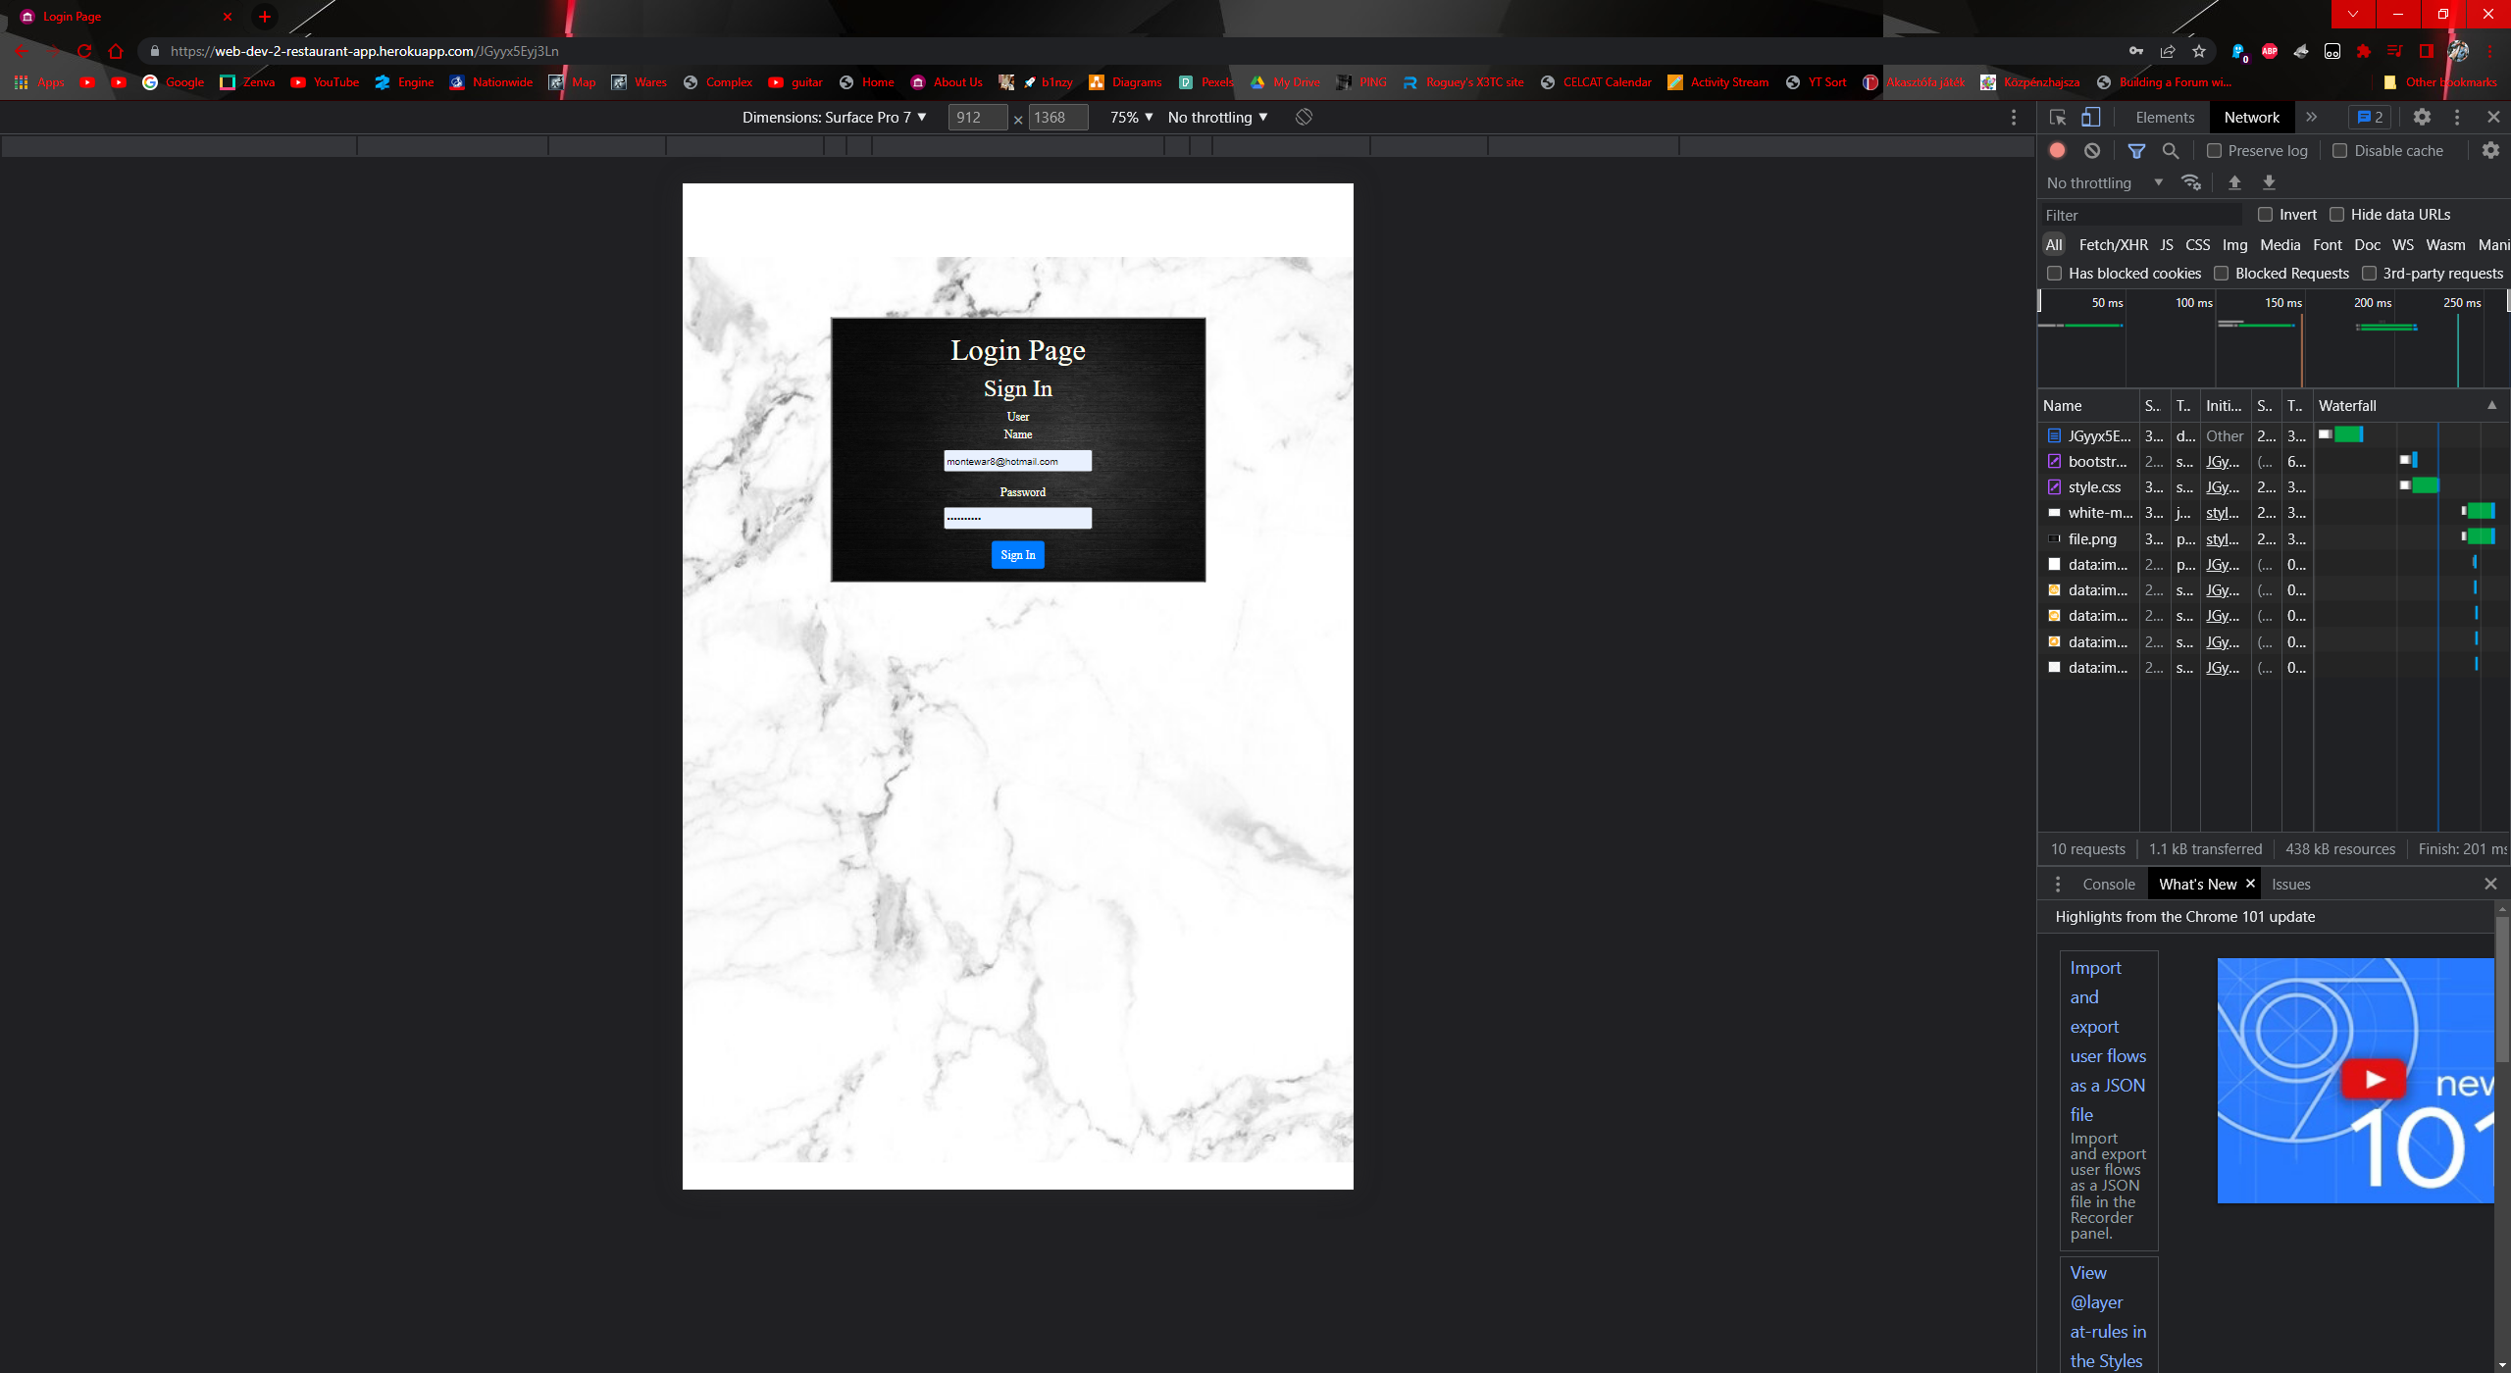

Figure login tablet view

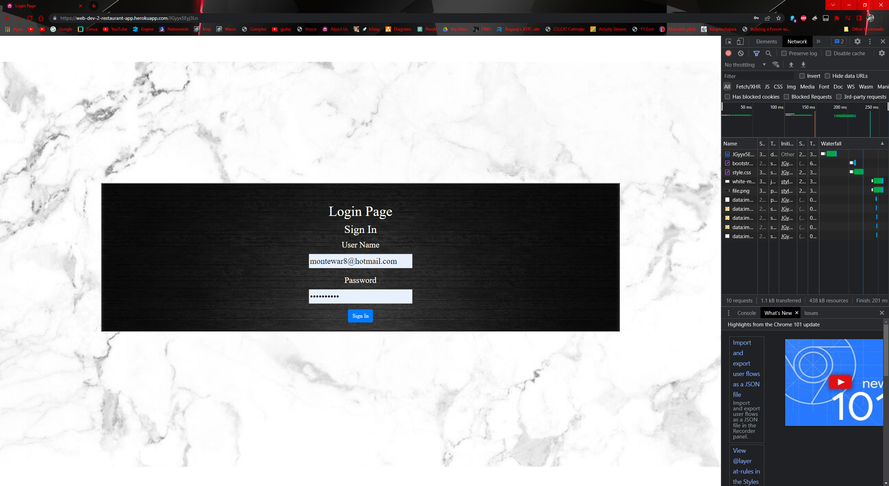

Figure login full view

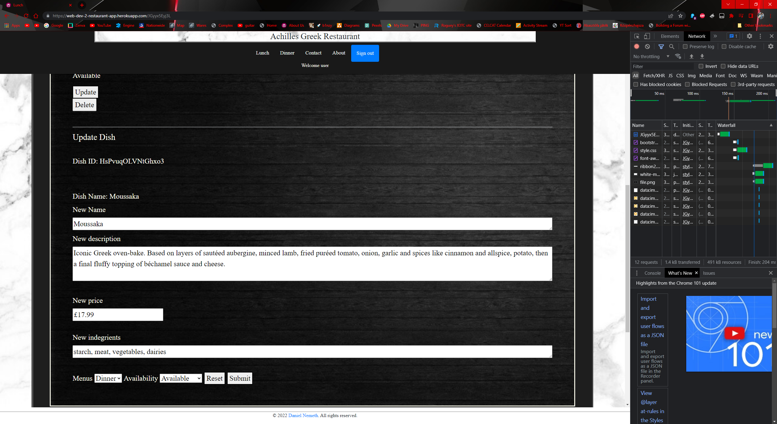

Figure form full view

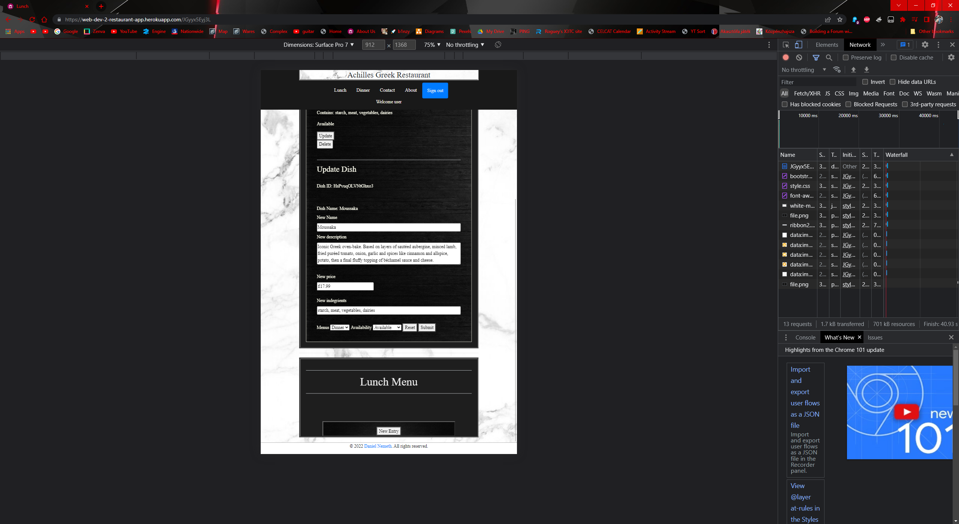

Figure form tablet view

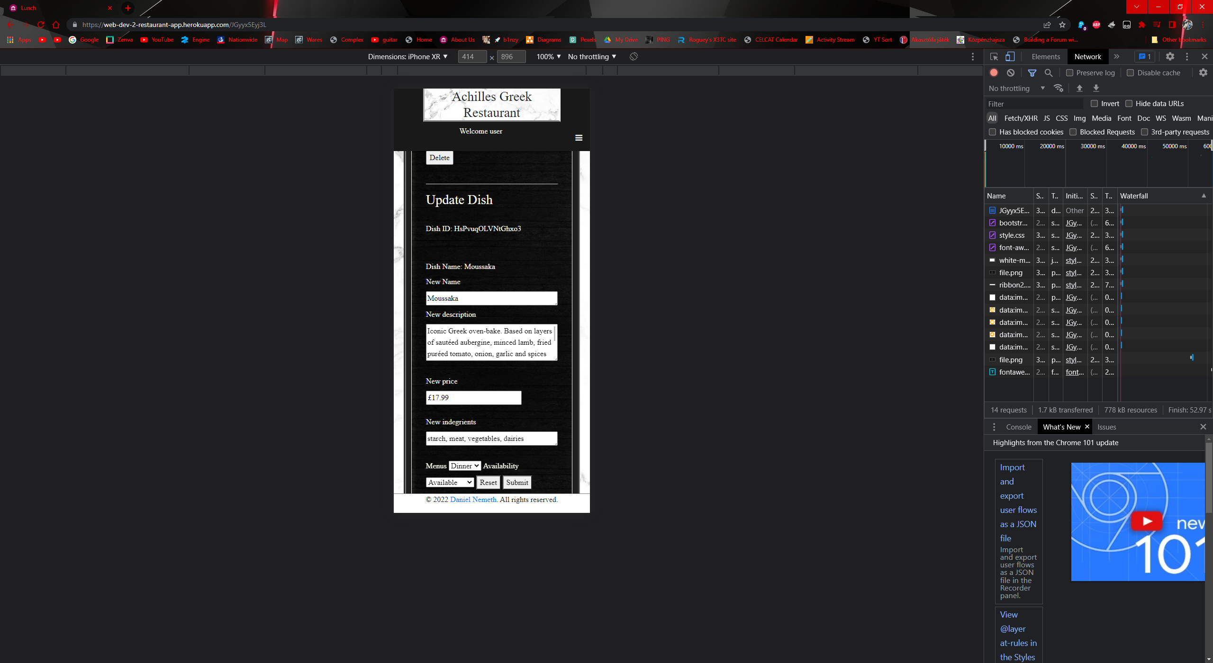

Figure form phone view

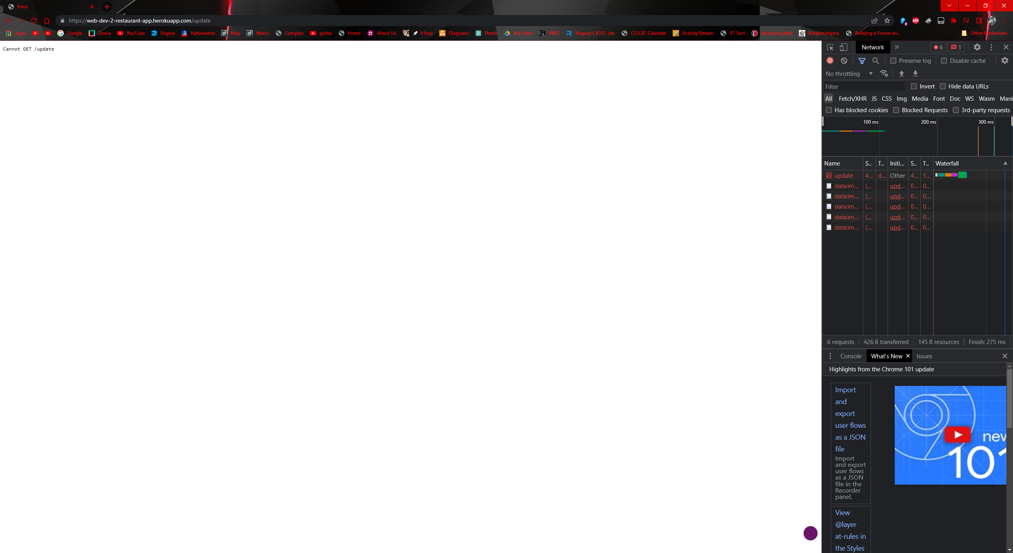

Figure /update

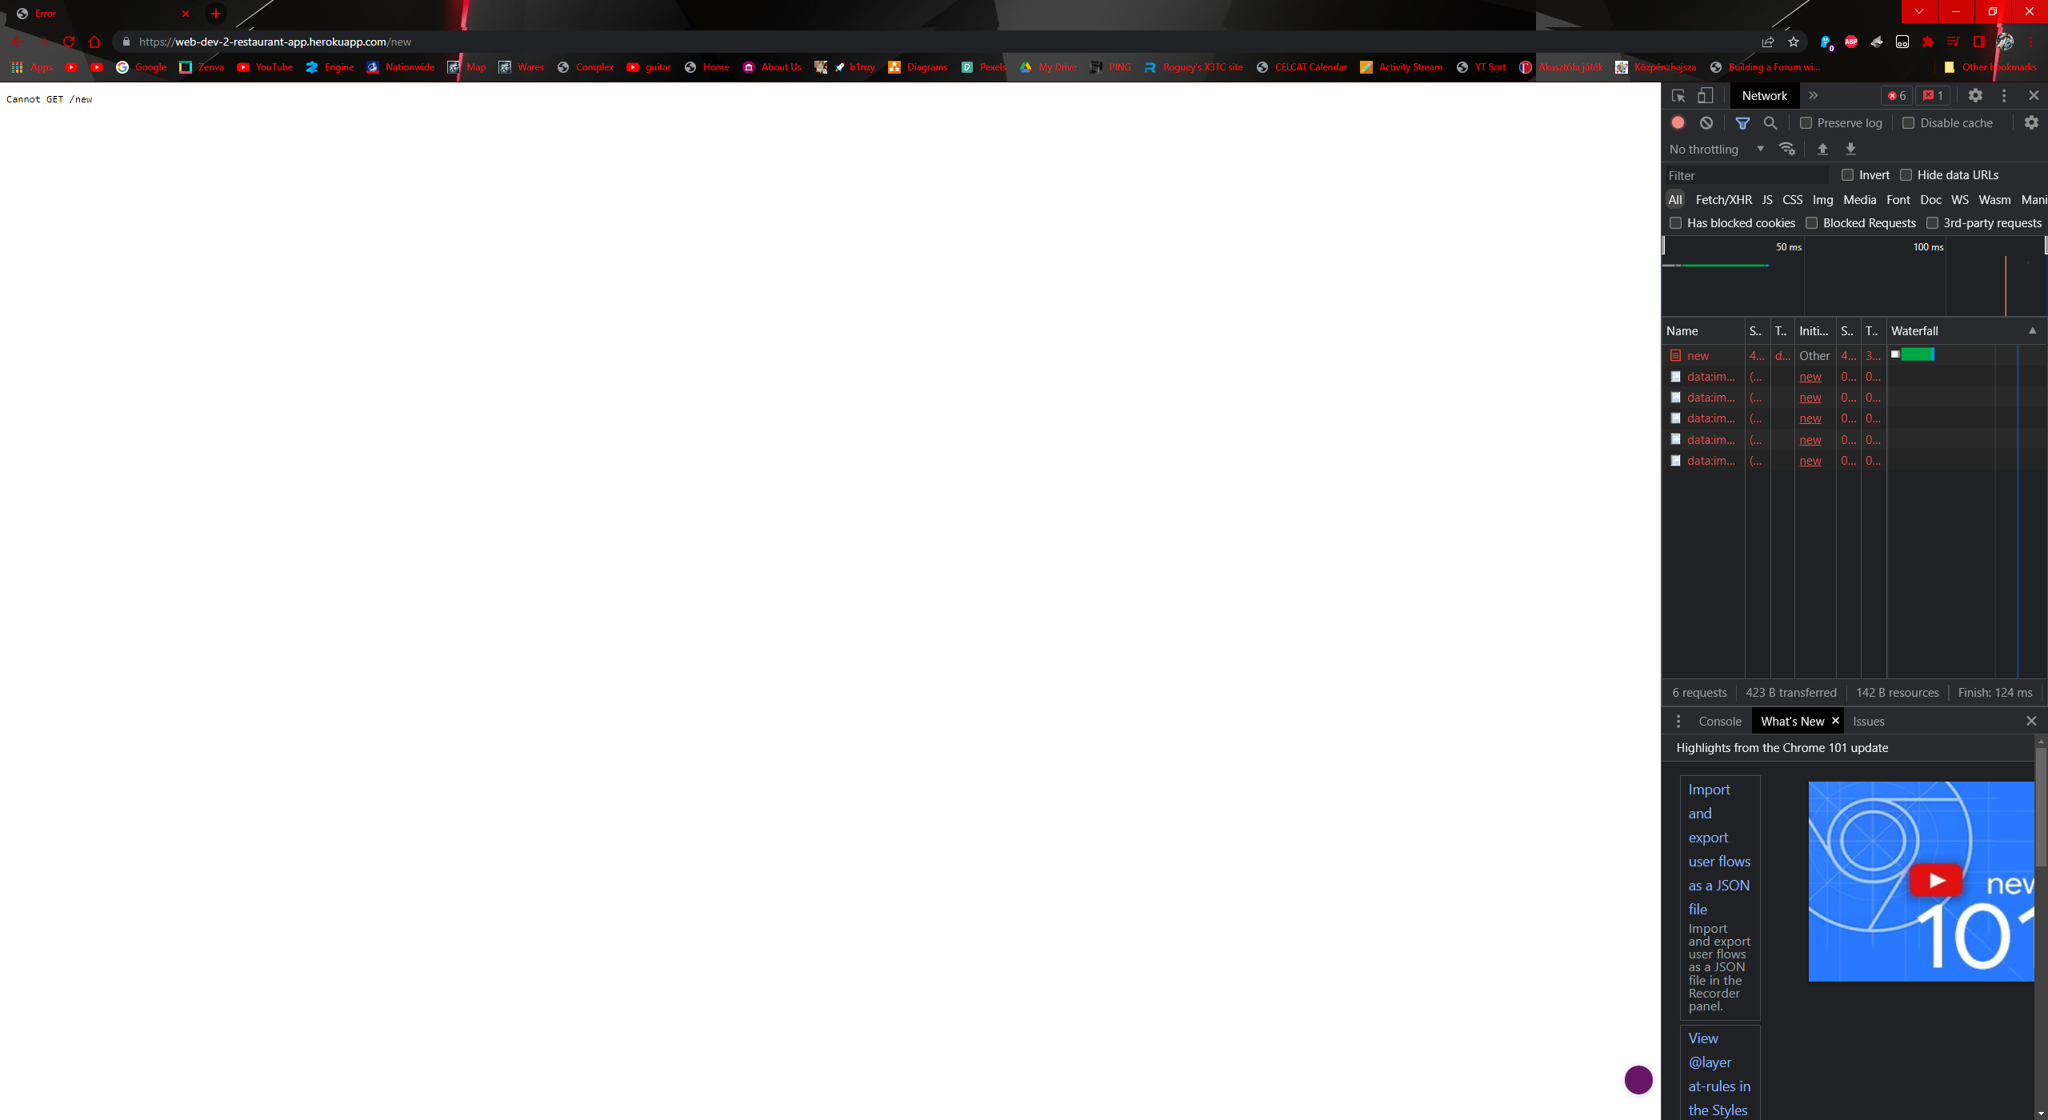

Figure /new

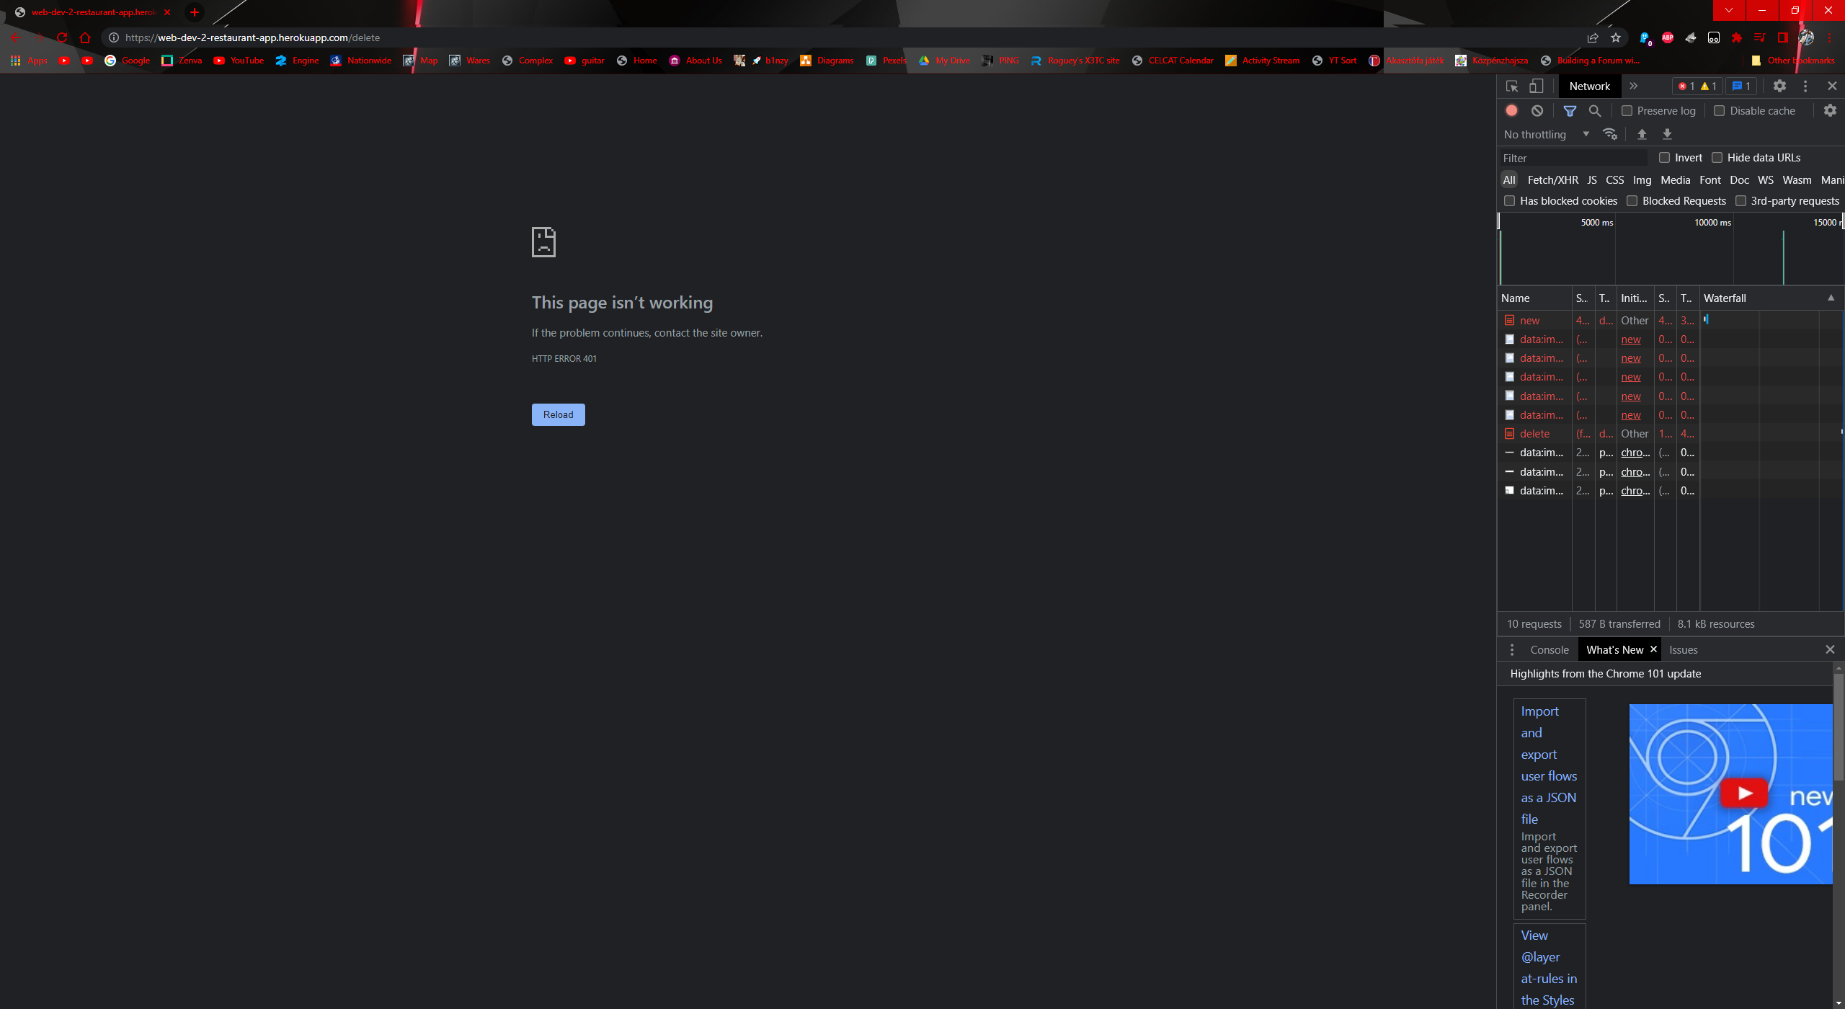

Figure /delete

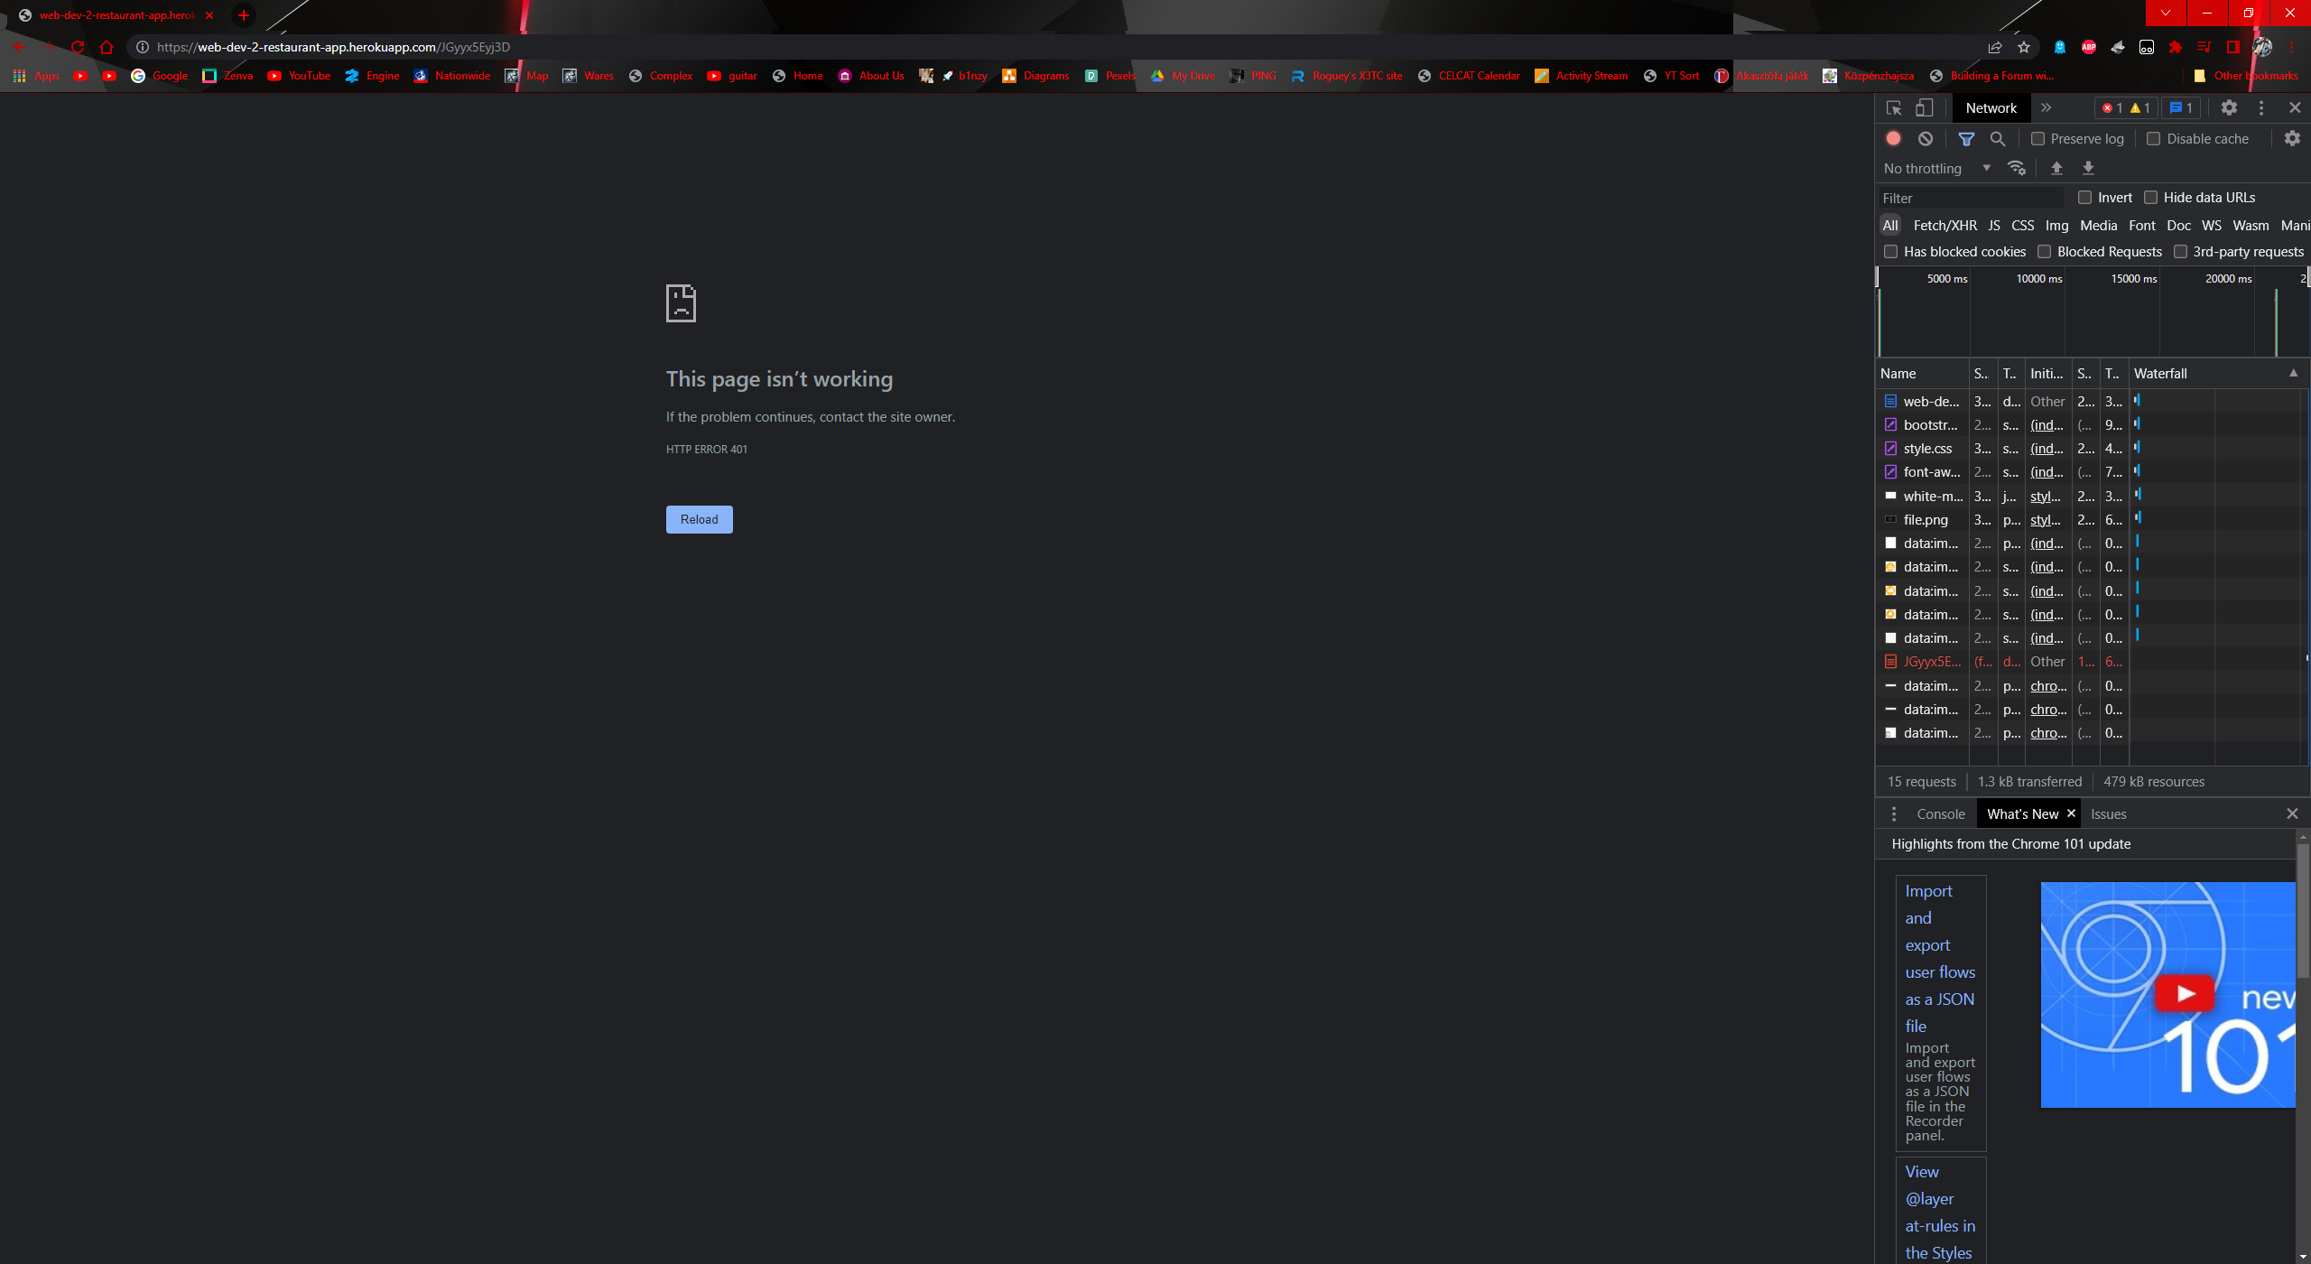

Figure /JGyyx5Eyj3D without login

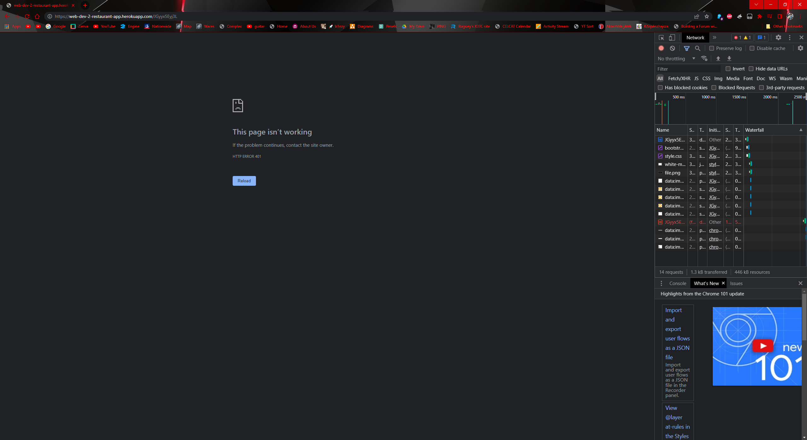

Figure /JGyyx5Eyj3L without login

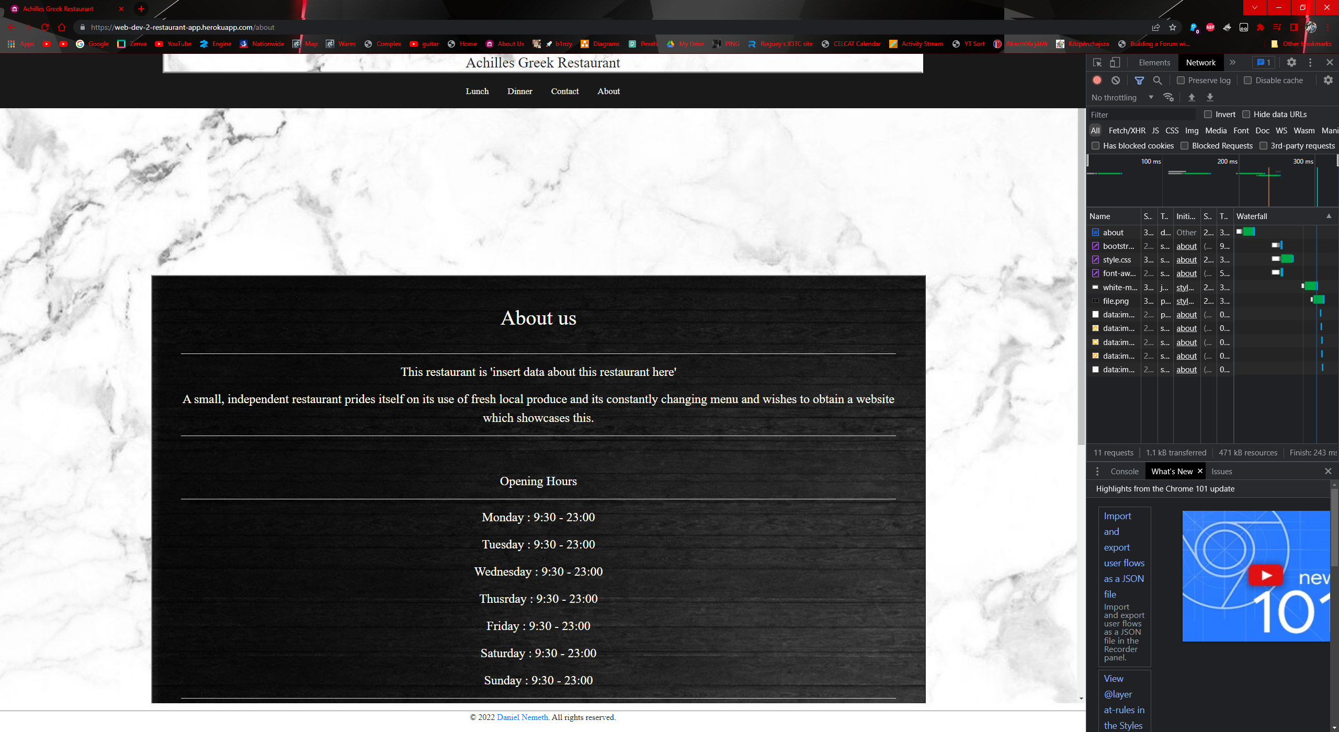

Figure about after login

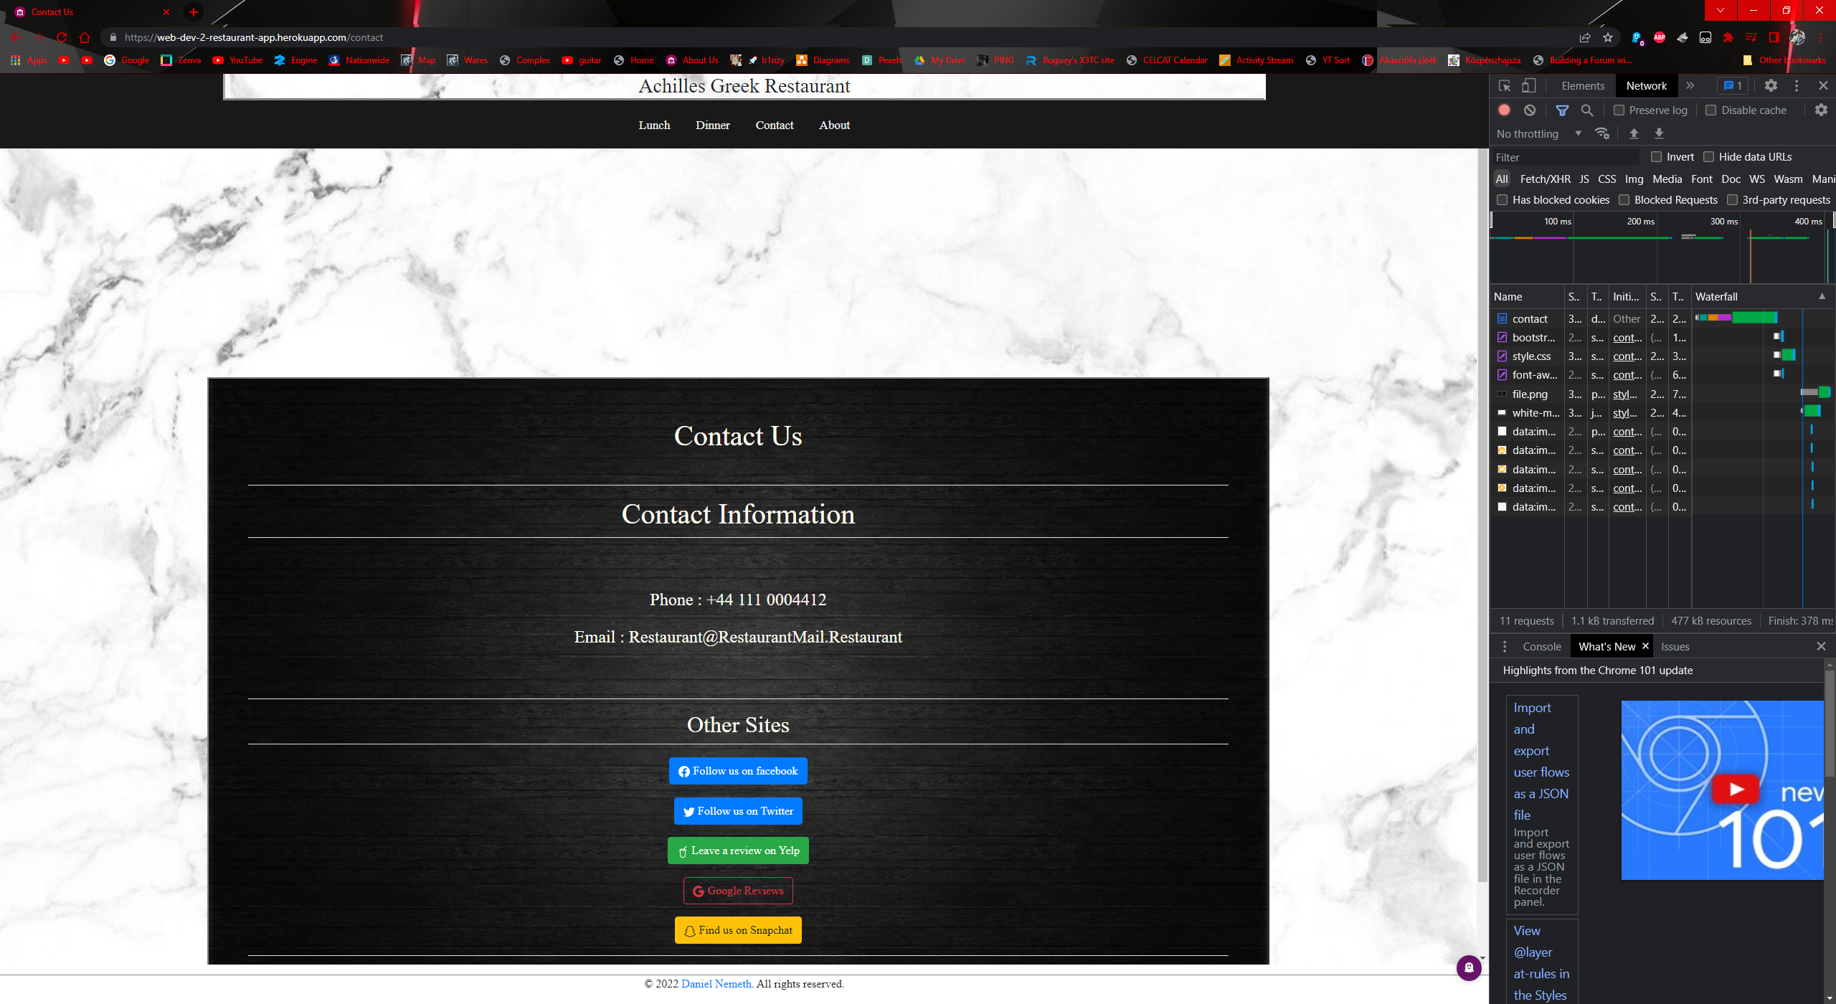

Figure contact after login

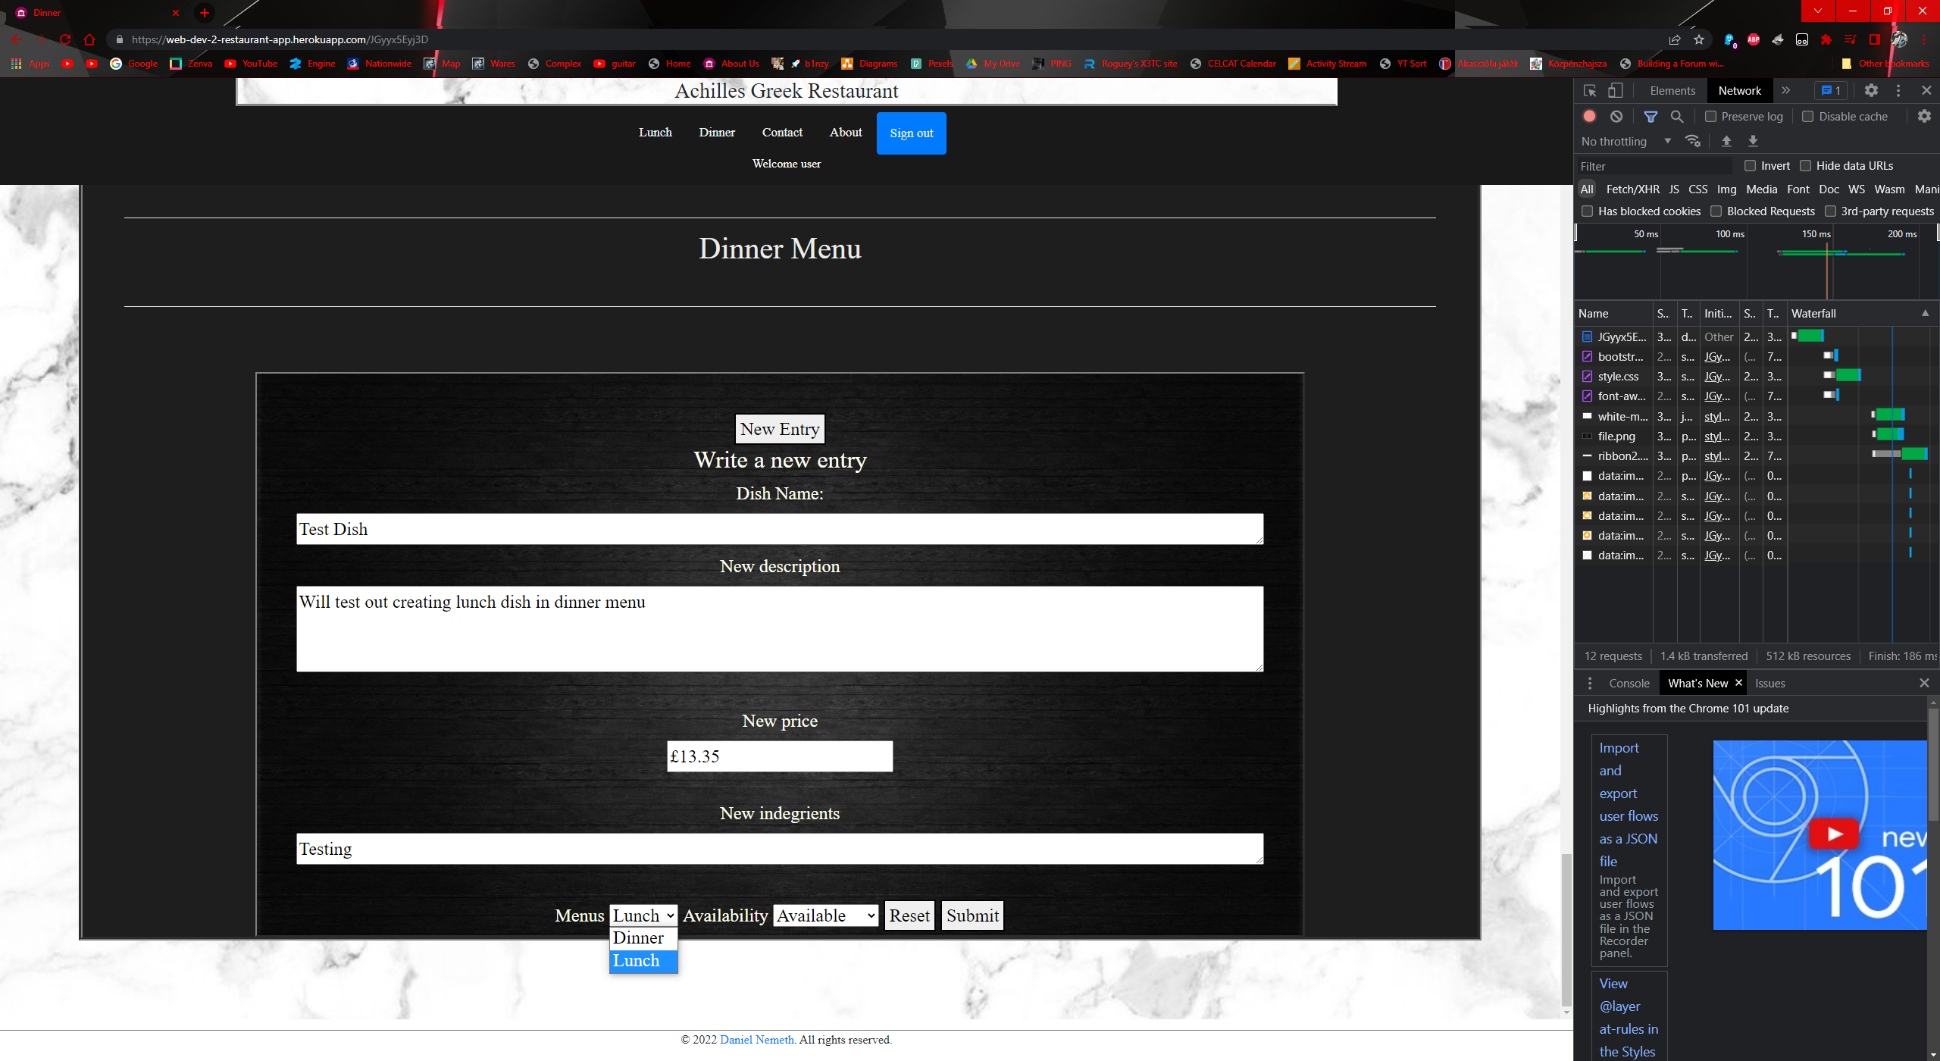

Figure creating dish to other menu 1

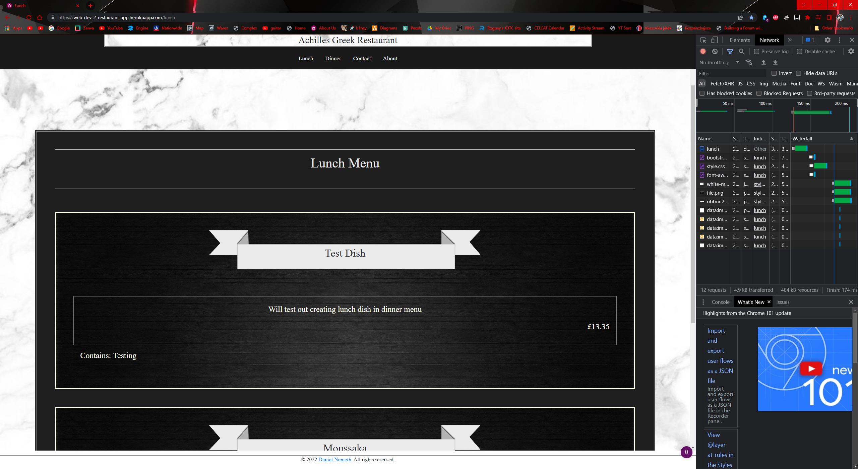

Figure creating dish to other menu 2